

**AMERICAN INTERNATIONAL**

**UNIVERSITY BANGLADESH (AIUB)**

**FACULTY OF SCIENCE & TECHNOLOGY DEPARTMENT OF**

**ELECTRICAL AND ELECTRONICS ENGINEERING**

**Spring 2024-2025**

**DIGITAL LOGIC AND CIRCUITS LABORATORY**

**Section: D Group: 03**

**LAB REPORT NAME:**

Implementation of Asynchronous and synchronous counters using flip-flops.

**Supervised By:**

**S M TANVIR HASSAN SHOVON**

**Submitted By:**

|  |  |  |
| --- | --- | --- |
| **SL** | **Student ID** | **Student Name** |
| **1.** | 23-50856-1 | Basudeb Kundu |

**Submition Date:13.05.2025**

**Title**: Implementation of Asynchronous and synchronous counters using flip-flops.

# Theory and Methodology:

**Asynchronous counter** A three-bit asynchronous down counter is shown in Figure 1. The external clock is connected to the clock input of the first flip-flop (FF0) only. FF0 changes state at the falling edge of each clock pulse, while FF1 changes only when triggered by the falling edge of the Q output of FF0. Due to the inherent propagation delay in flip-flops, the transition of the input clock pulse and the transition of the Q output of FF0 do not occur simultaneously. As a result, the flip-flops are not triggered at the same time, leading to asynchronous operation.

Figure 1 illustrates a three-bit counter capable of counting from 7 to 0. The clock inputs of the three flip-flops are connected in cascade. The T input of each flip-flop is connected to a constant logic 1, ensuring that each flip-flop toggles its state at every negative edge of its clock signal. The primary purpose of this circuit is to count the number of pulses occurring on the primary input, labeled as Clock. Since the first flip-flop’s clock input is directly connected to the Clock signal, it toggles with each falling edge of the clock. The subsequent flip-flops receive their clock input from the Q output of the preceding flip-flop, toggling their state whenever the preceding flip-flop transitions from Q = 1 to Q = 0.

The timing diagram for this counter is shown in Figure 1. The value of Q0 toggles once every clock cycle, with a slight delay due to the propagation delay through the flip-flop. Since FF1 is triggered by Q0, the value of Q1 changes after the falling edge of Q0. Similarly, Q2 changes after the falling edge of Q1. Observing the values of Q2Q1Q0 as the count, the timing diagram indicates a counting sequence of 7, 6, 5, 4, 3, 2, 1, 0, and then repeating. This circuit functions as a modulo-8 counter. Since it decrements the count, it is referred to as a down counter.

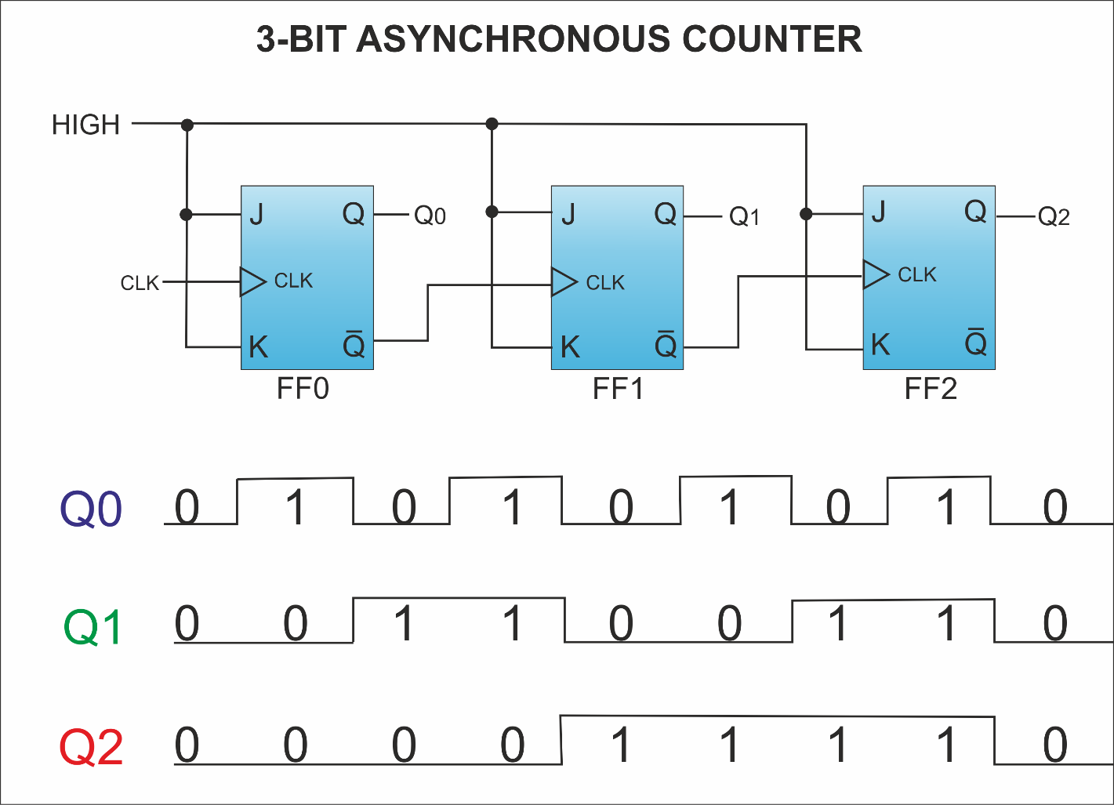

# Figure 1: 3-bit Asynchronous counter and its timing diagram

# Synchronous counter

In synchronous counters, the clock inputs of all the flip-flops are connected together and are triggered by the input pulses. Thus, all the flip-flops change state simultaneously (in parallel). The most important advantage of synchronous counters is that there is no cumulative time delay because all flip-flops are triggered in parallel. Thus, the maximum operating frequency for this counter will be significantly higher than for the corresponding ripple counter.

Table 9.1 shows the contents of a four-bit up-counter for eight consecutive clock cycles, assuming that the count is initially 0. Observing the pattern of bits in each row of the table, it is apparent that bit Q0 changes on each clock cycle. Bit Q1 changes only when Q0 = 1. Bit Q2 changes only when both Q1 and Q0 are equal to 1. In general, for an n-bit up-counter, a given flip-flop changes its state only when all the preceding flip-flops are in the state Q = 1.

A **2-bit synchronous up counter** is a sequential circuit that counts in an increasing binary sequence from 00 to 11 (0 to 3 in decimal) with each clock pulse. Unlike an asynchronous counter, where the clock signal propagates through each flip-flop sequentially, a synchronous counter applies the clock signal simultaneously to all flip-flops, ensuring synchronized state transitions and eliminating propagation delay issues.

**Working Principle:**

The counter consists of two **JK flip-flops**, which toggle their states based on predefined logic conditions. In a synchronous counter, all flip-flops share a common clock signal, allowing simultaneous state transitions.

1. **Initial State (00)**: At the start, both flip-flops are reset (Q1 = 0, Q0 = 0).
2. **Clock Pulse 1**: The least significant bit (LSB) flip-flop (FF0) toggles, changing the state from **00 → 01**.
3. **Clock Pulse 2**: FF0 toggles again, and FF1 toggles as well when Q0 = 1 (previous state), changing the state from **01 → 10**.
4. **Clock Pulse 3**: FF0 toggles once more, but FF1 remains unchanged, changing the state from **10 → 11**.
5. **Clock Pulse 4**: Both flip-flops toggle, resetting the counter back to **00**, completing one counting cycle.

**State Transition Table:**

|  |  |  |
| --- | --- | --- |
| **Clock Pulse** | **QA (MSB)** | **QB (LSB)** |
| 0 | 0 | 0 |
| 1 | 0 | 1 |
| 2 | 1 | 0 |
| 3 | 1 | 1 |
| 4 | 0 | 0 |

**Logic Diagram Explanation:**

* The **JK flip-flops** operate in toggle mode when both J and K inputs are set to '1'.
* The LSB (Q0) always toggles on every clock pulse.
* The MSB (Q1) toggles when Q0 transitions from 1 to 0.
* This ensures a proper binary count sequence.

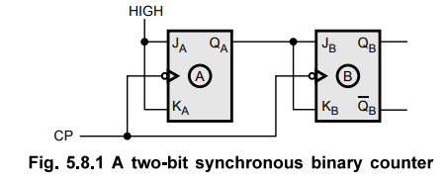

Fig 2: 2- Bit Synchronous Up Counter

# Pin Configuration of 74LS76 and 7408

There are 2 J-K Flip Flops in one IC. Here is the pin configuration of the IC 74LS76:

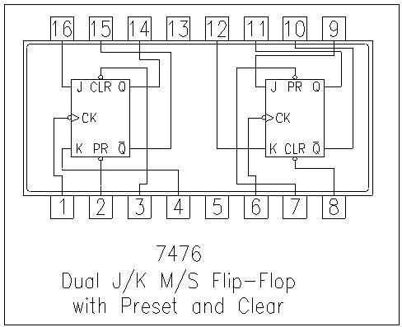

Figure 3: IC 74LS76

IC 7408 contains 4 AND gates in it. The pin configuration is shown below:

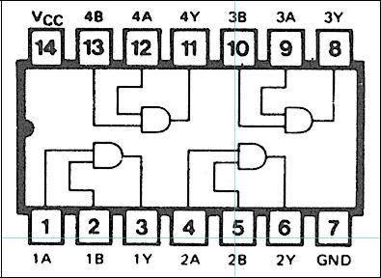

Figure 4: IC 7408

# Introduction:

Counters are combinations of flip-flops arranged so that they can remember how many clock pulses have been applied over some specified interval. The flip-flops are often interconnected so that only a portion of their available binary states can be supported. If there are N flip-flops being used in a counter, the number of states available is 2N. If the counter proceeds cyclically through K of these states, where K ≤ 2N, it is said to be a modulo K (or MOD K) counter. Some applications will require a separate output to indicate each of the counters states, alternatively, other applications may require only one output pulse every Kth state.

Counters are classified into two broad categories according to the way they are clocked: **asynchronous and synchronous.** In asynchronous counters, commonly called ripple counters, the first flip-flop is clocked by the external clock pulse and then each successive flip flop is clocked by the output of the preceding flip-flop. In synchronous counters, the clock input is connected to all of the flip-flops so that they are clocked simultaneously.

The objective of this experiment is designing of the following counters using J-K Flip-Flops (IC 74LS76)

1. n-bit Binary Asynchronous Counter
2. n-bit Binary Synchronous Counter

# Apparatus:

* IC 74LS76 (JK Flip Flop)
* IC 7408 (AND Gate)
* LED Lamps or Display
* Trainer Board
* Oscilloscope
* Connecting Wires

# Precautions:

# • Before the circuits are prepared, all ICs (74LS76 & 7408) should be checked to ensure they are functioning properly. • Proper biasing of JK Flip Flops must be ensured. • The preset and clear pins should be connected to Vcc. • As few wires as possible should be used, and loose connections must be avoided. • If an LED display is used, it should be properly biased. • For the clock pulse, the analog signal generator of the trainer board is recommended. A lower frequency should be selected so that the output changes slowly enough to allow for observation and accurate readings.

# Experimental Procedure:

**Part 1: 3-bit Asynchronous Counter**

1. The circuit should be designed on the breadboard as shown in Figure 9.5.
2. The trainer board’s signal generator should be used for the clock pulse, and the power supply should be used for biasing the Flip Flops.
3. The output can also be viewed on the oscilloscope by connecting the outputs to different channels.
4. The output results should be observed, recorded, and photographed for inclusion in the lab report.

# 2-bit Synchronous Counter

1. The circuit should be designed on the breadboard as shown in Figure 9.6.

2. The trainer board’s signal generator should be used for the clock pulse, and the power supply should be used for biasing the Flip Flops.

3. The output can also be viewed on the oscilloscope by connecting the outputs to the different channels.

4. The output results should be observed, and some pictures should be taken for the lab report.

Lab Measurement:

2 bit up

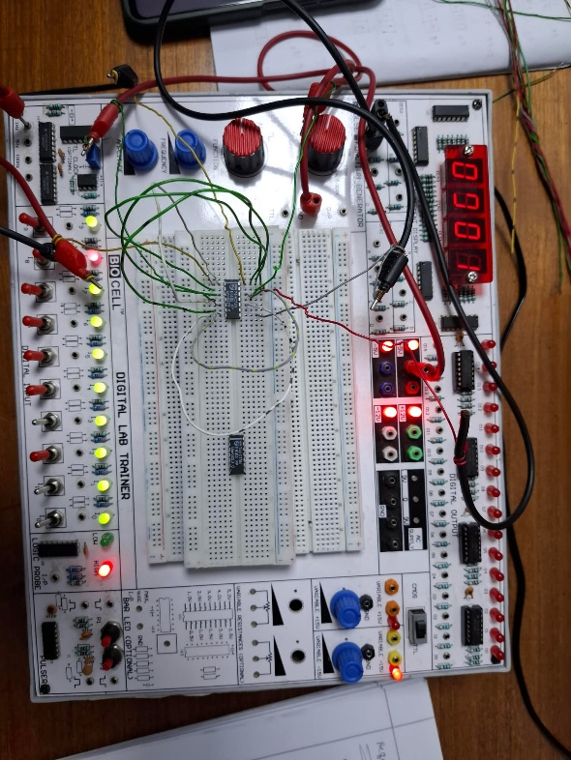

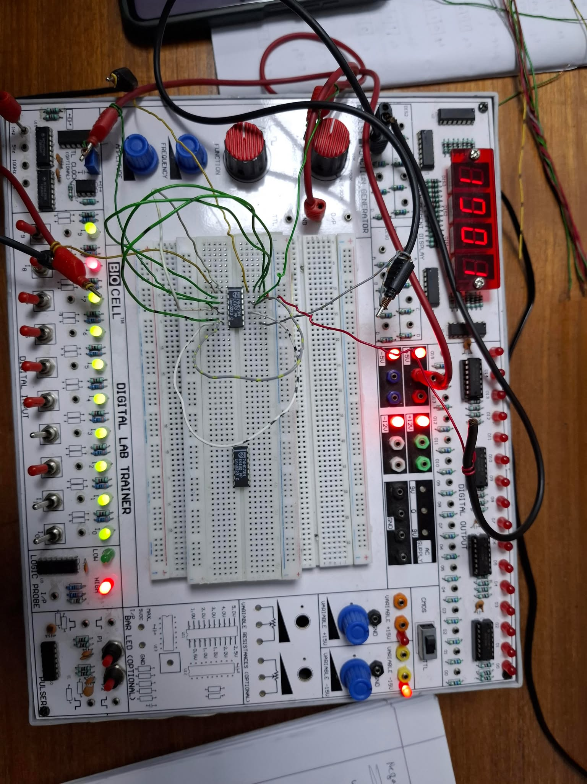

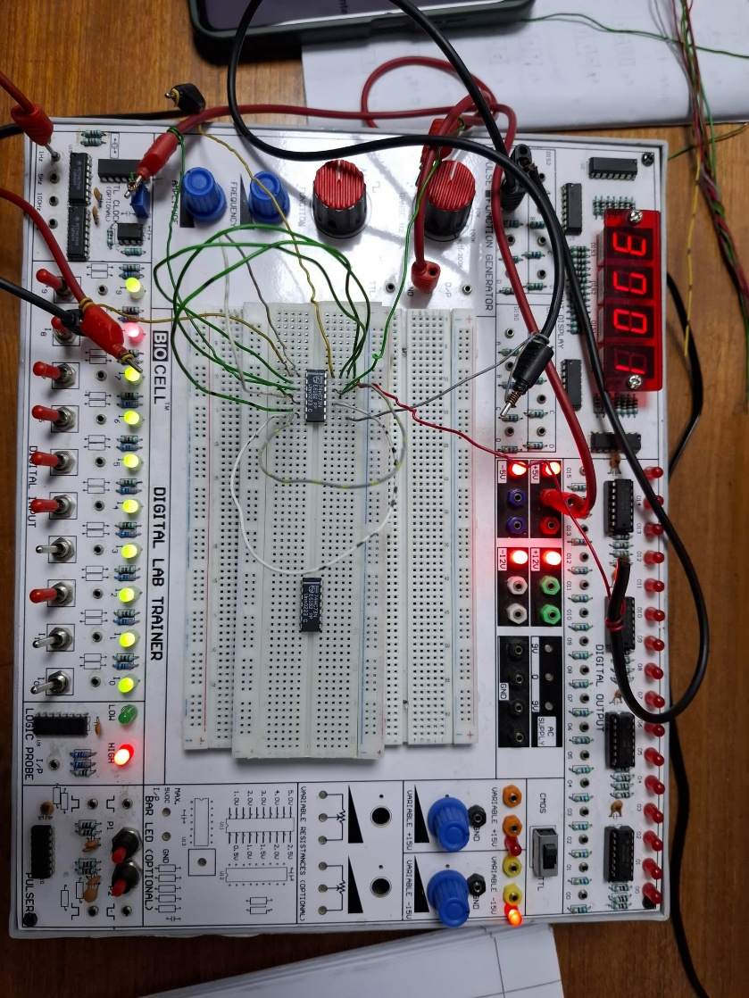

**2 bit down**

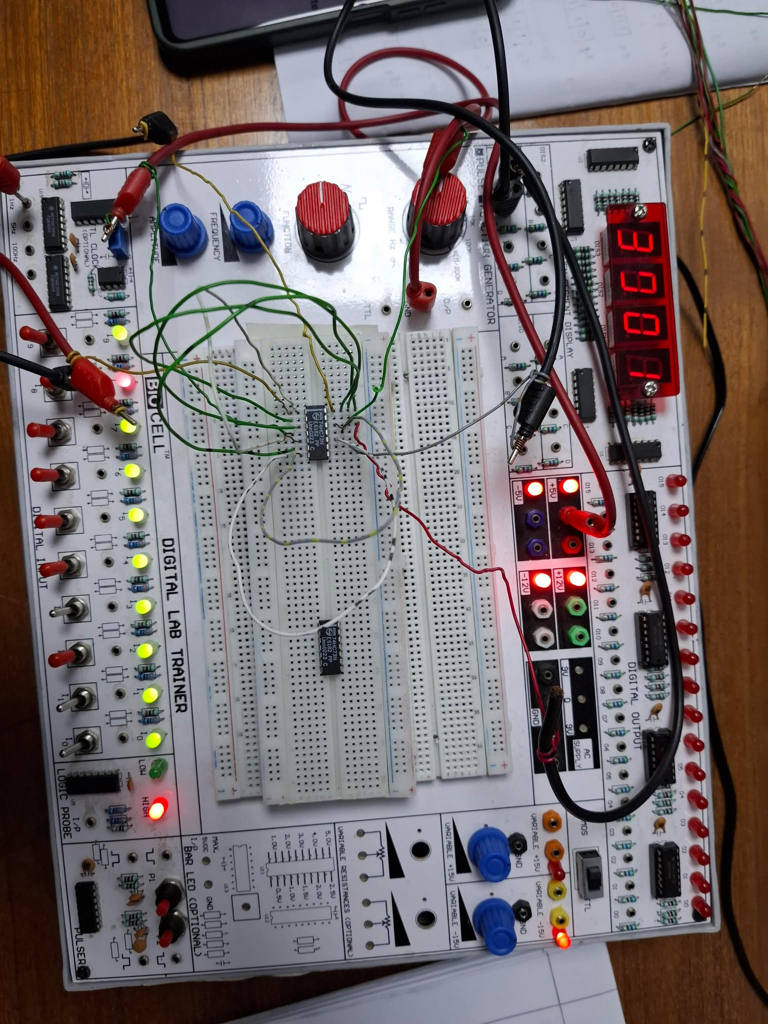

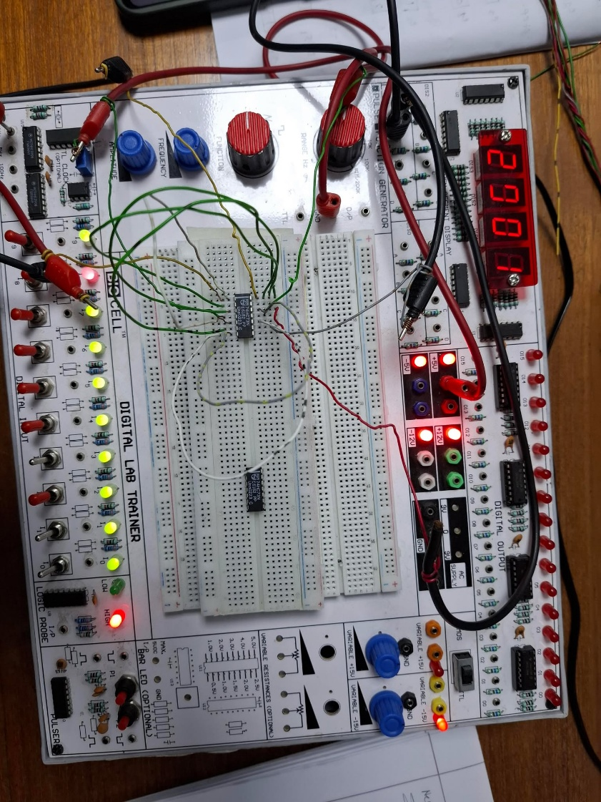

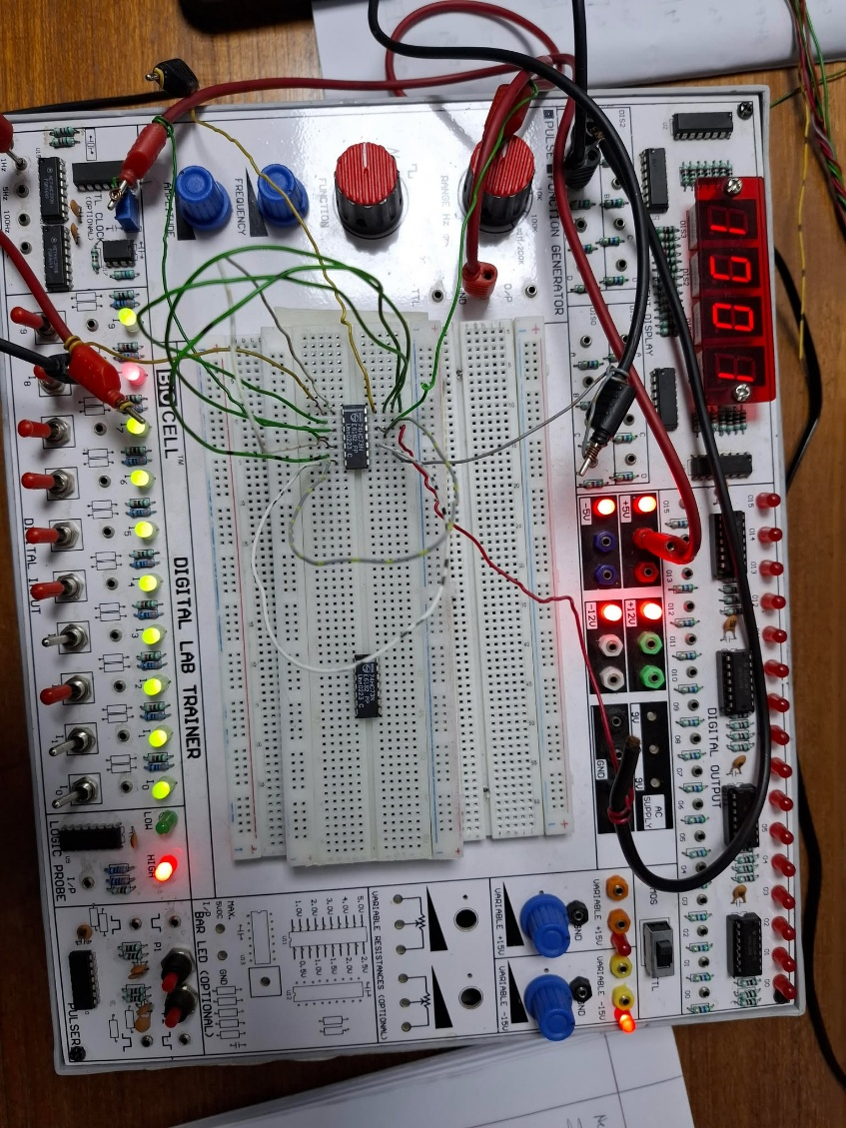

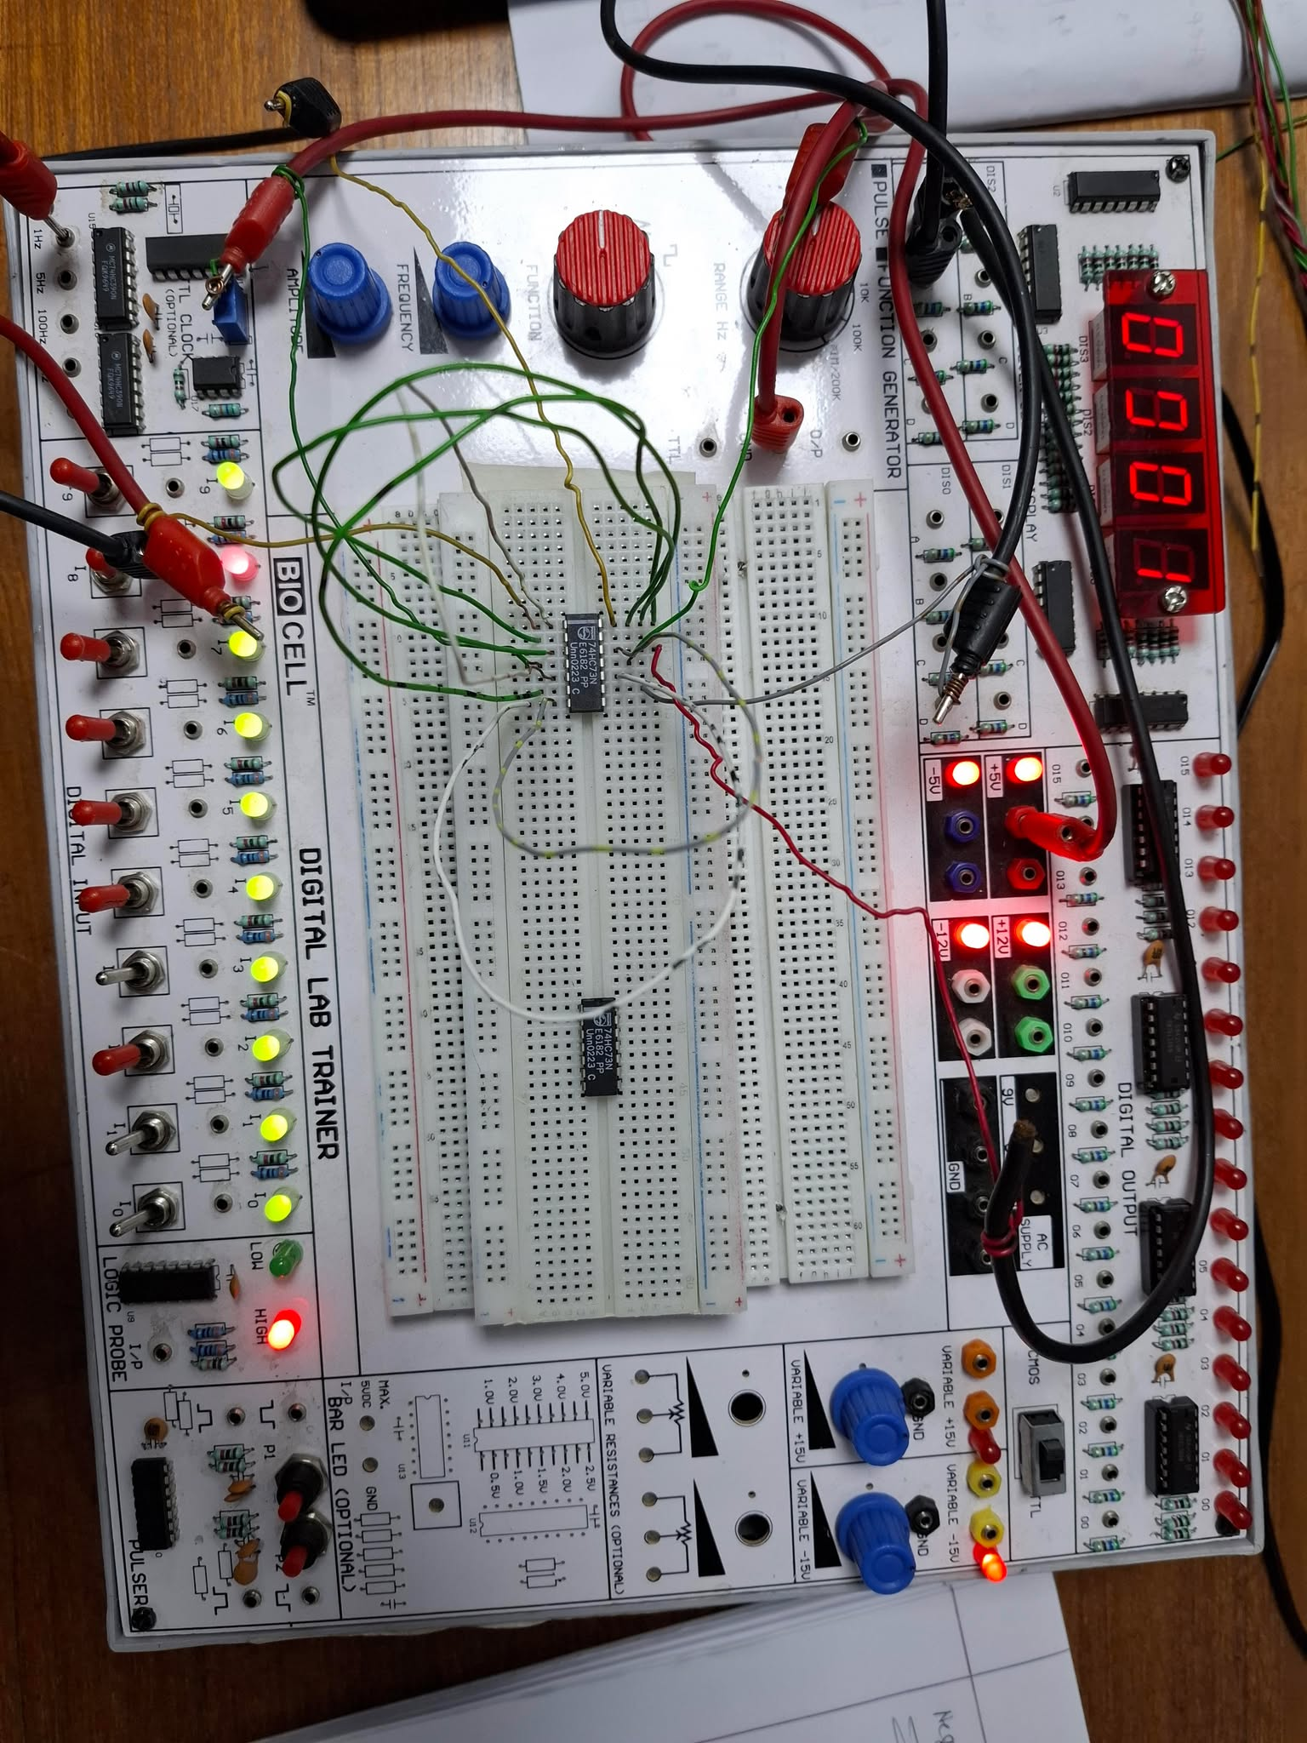

**3 Bit Down**

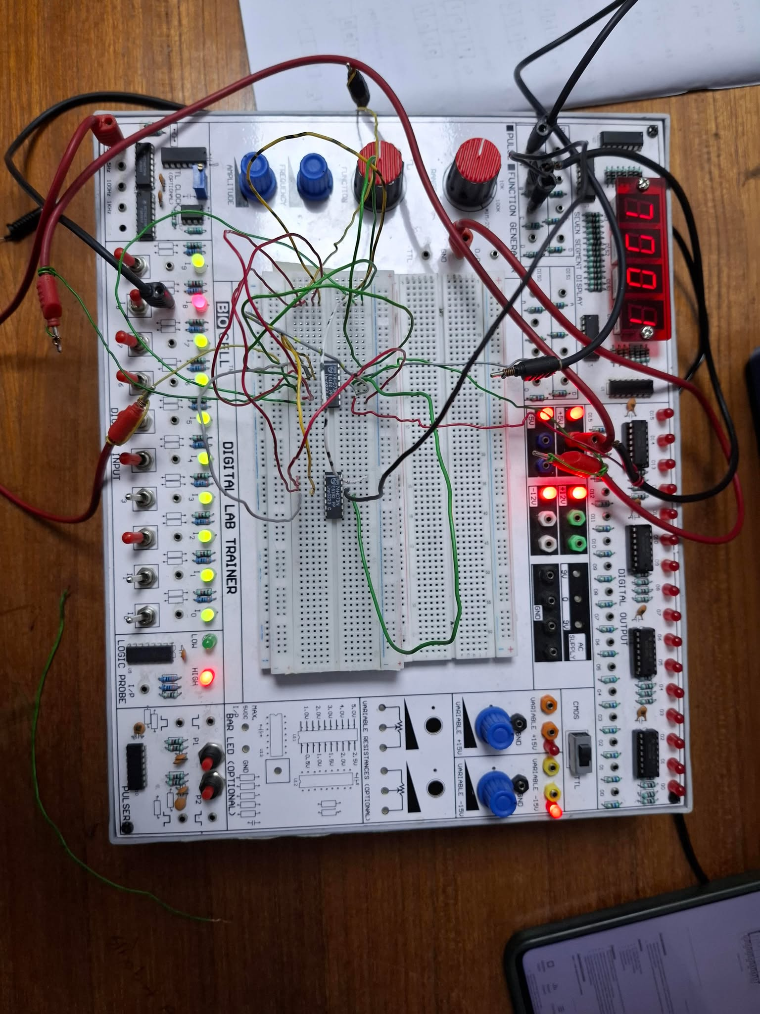

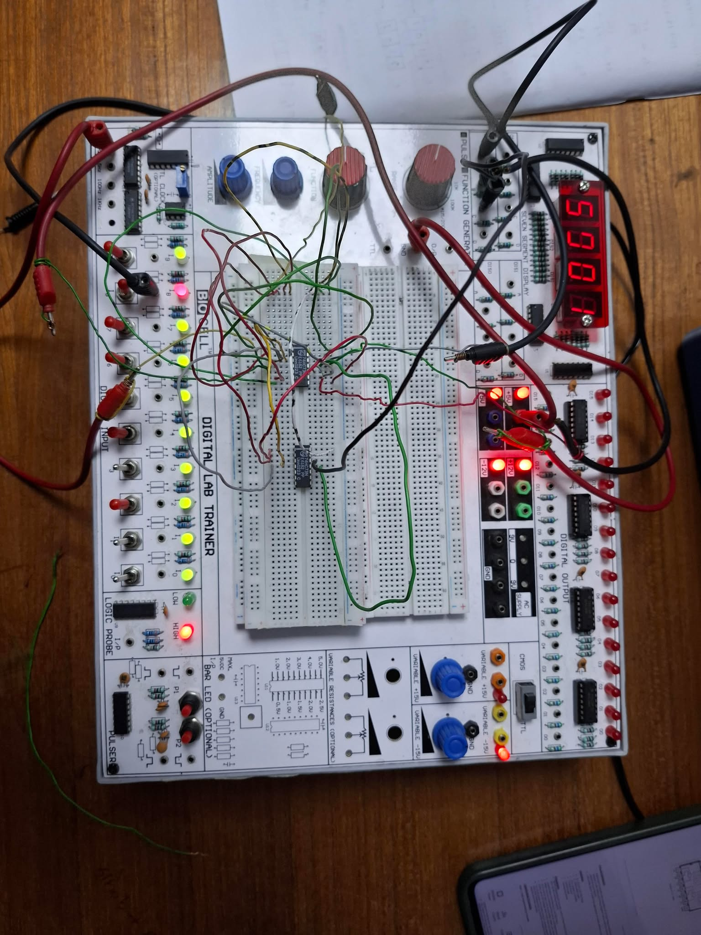

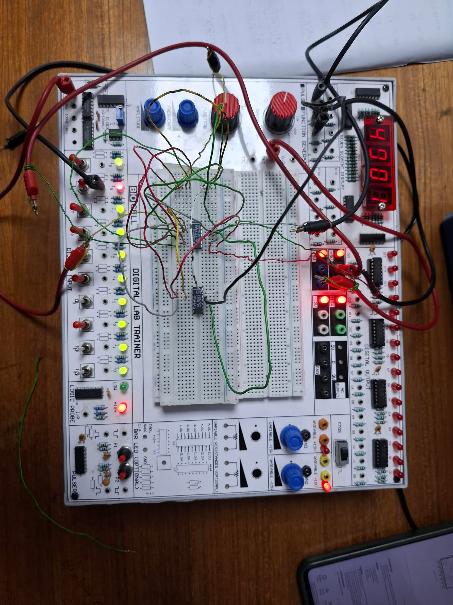

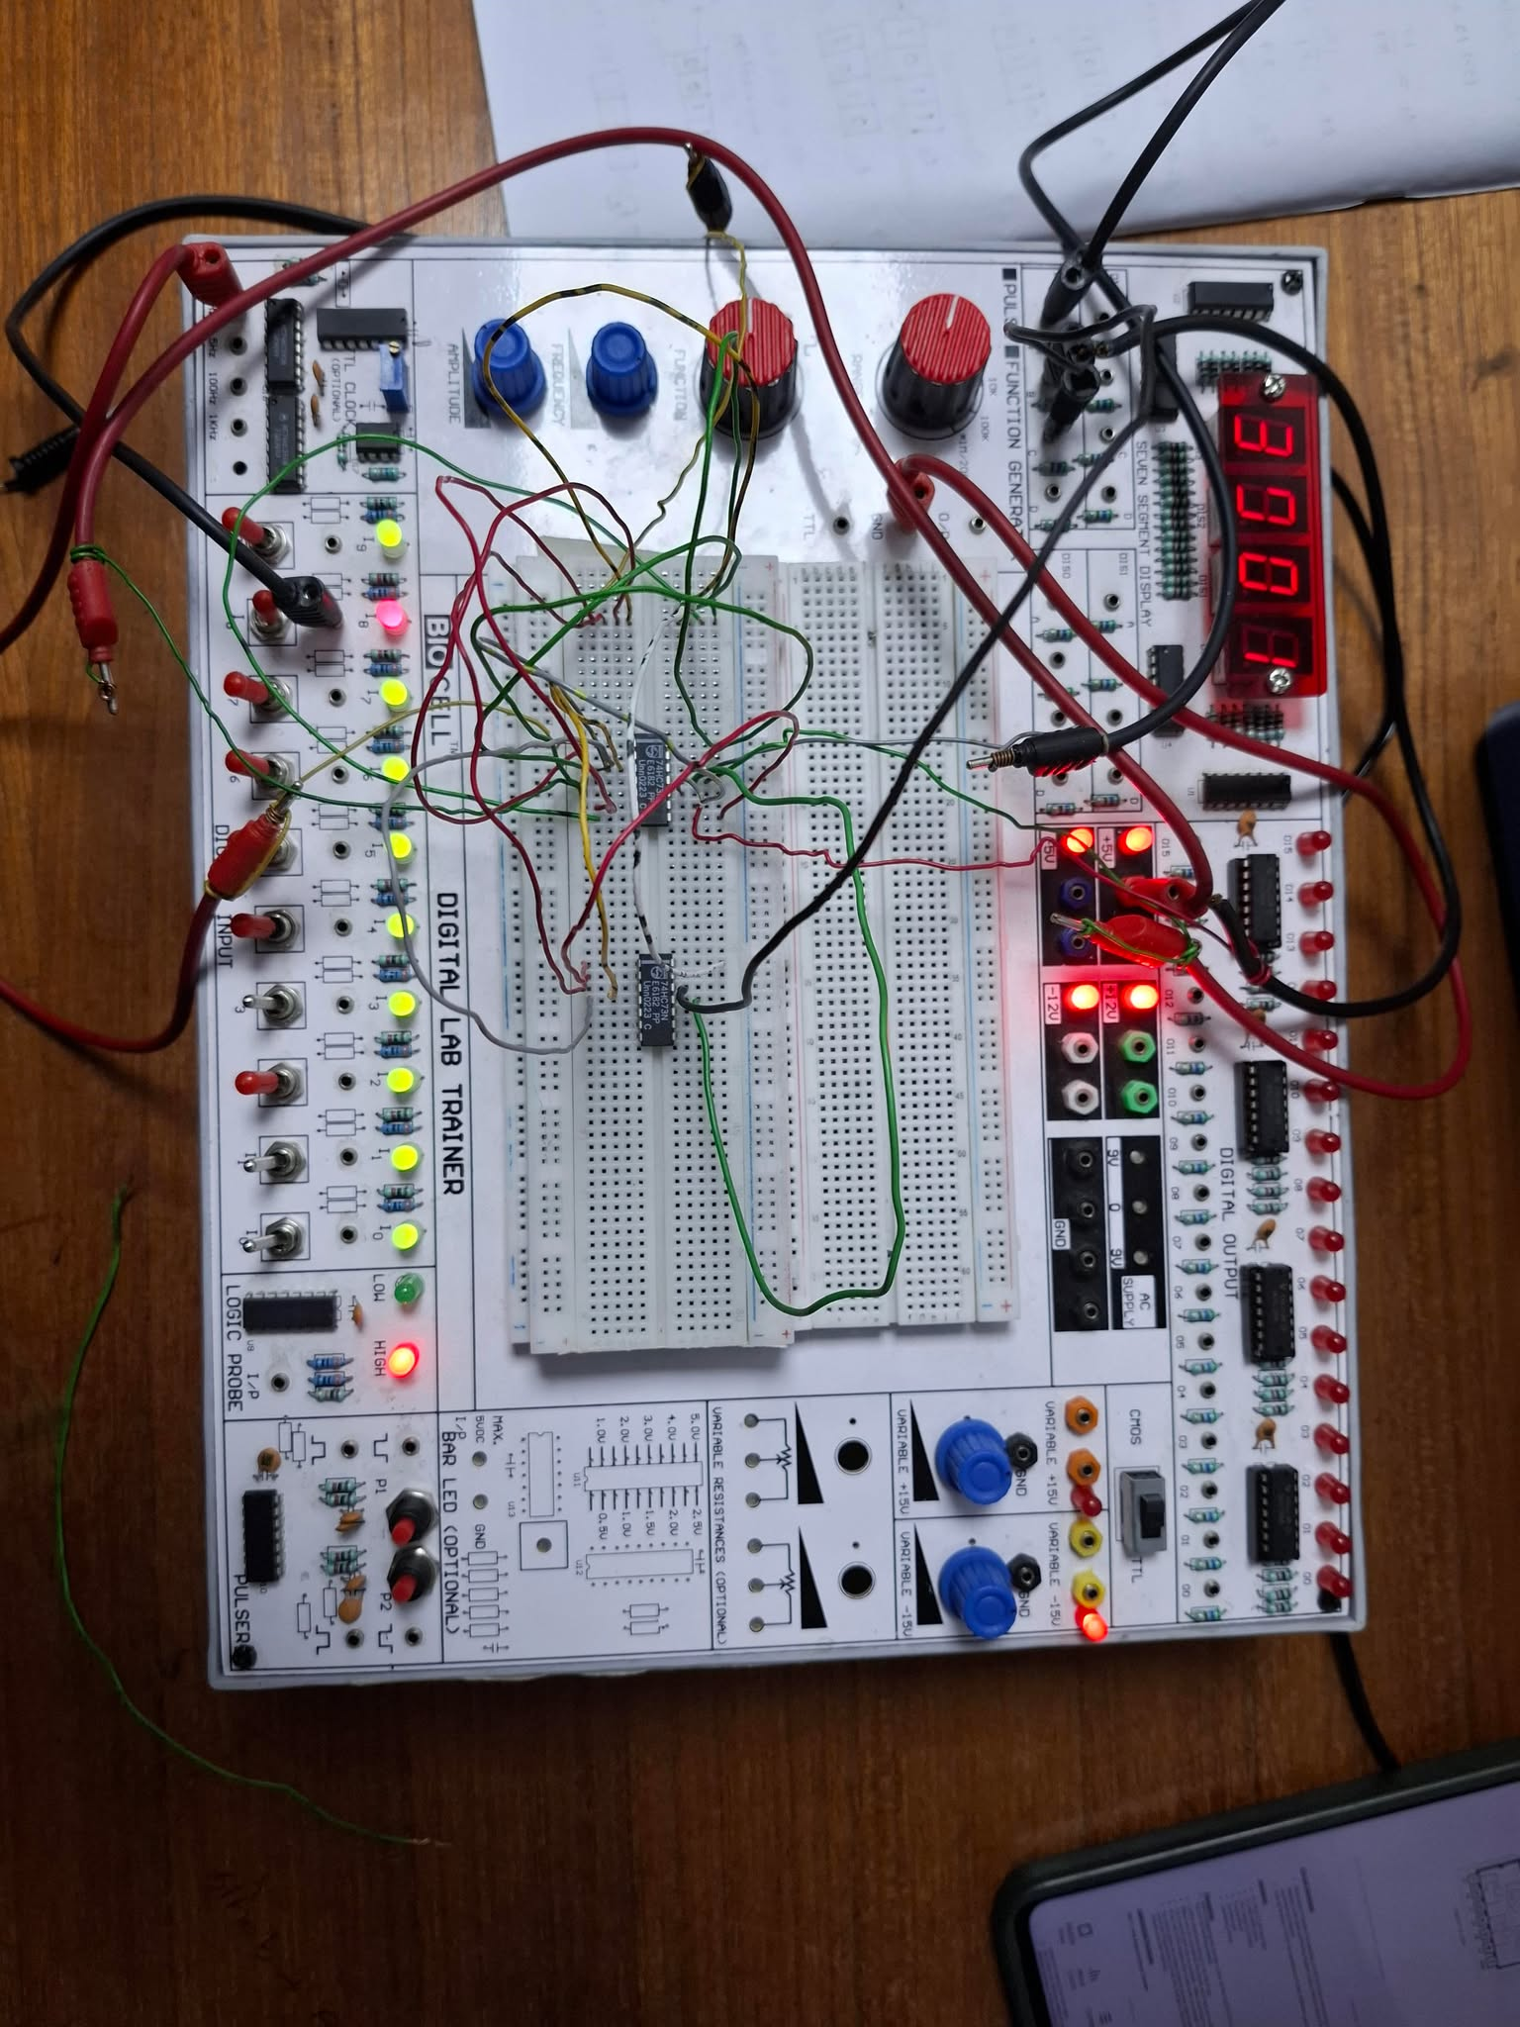

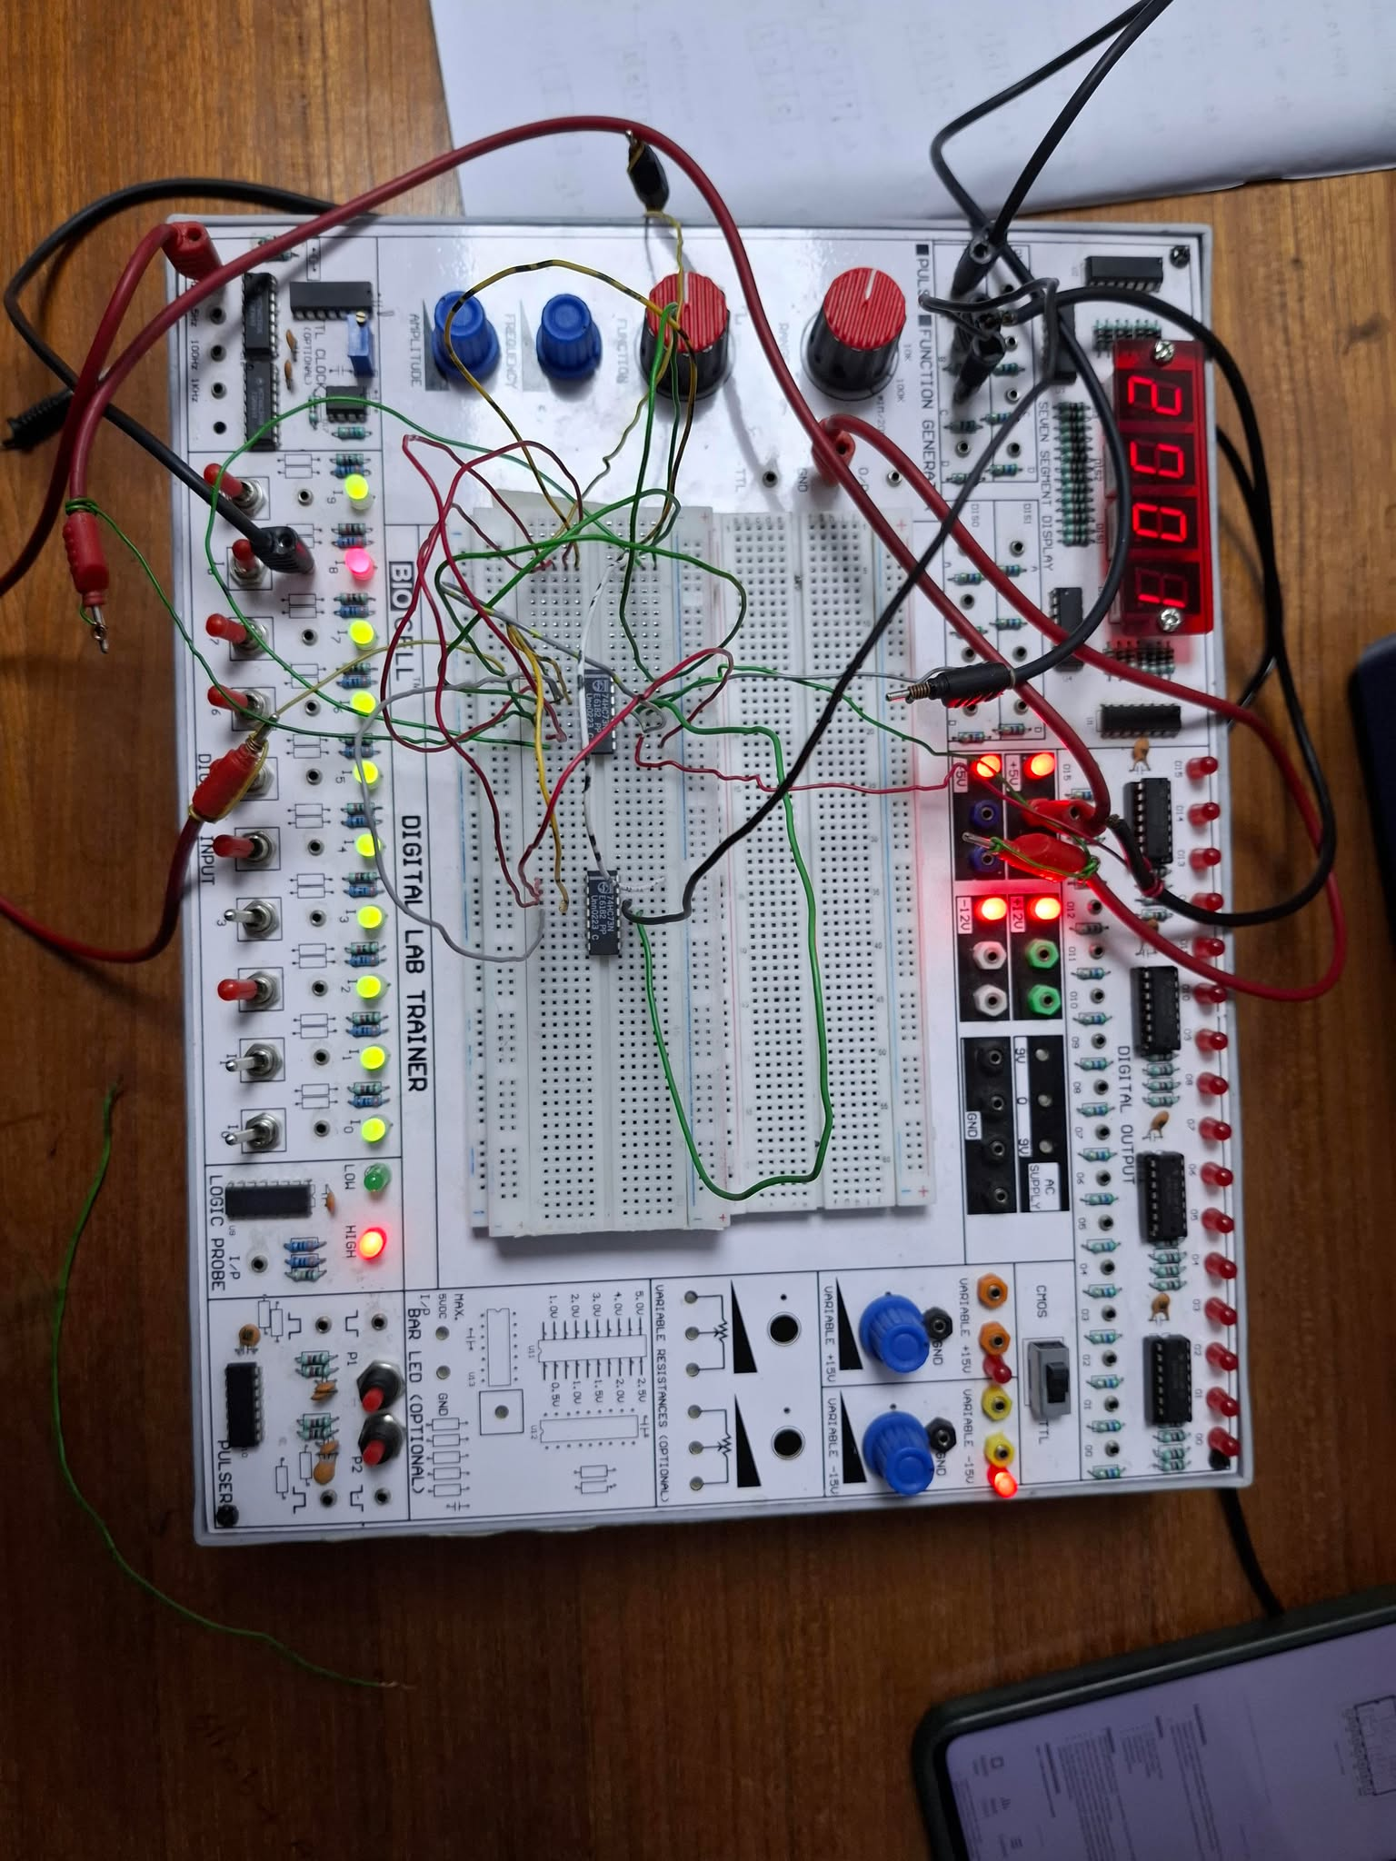

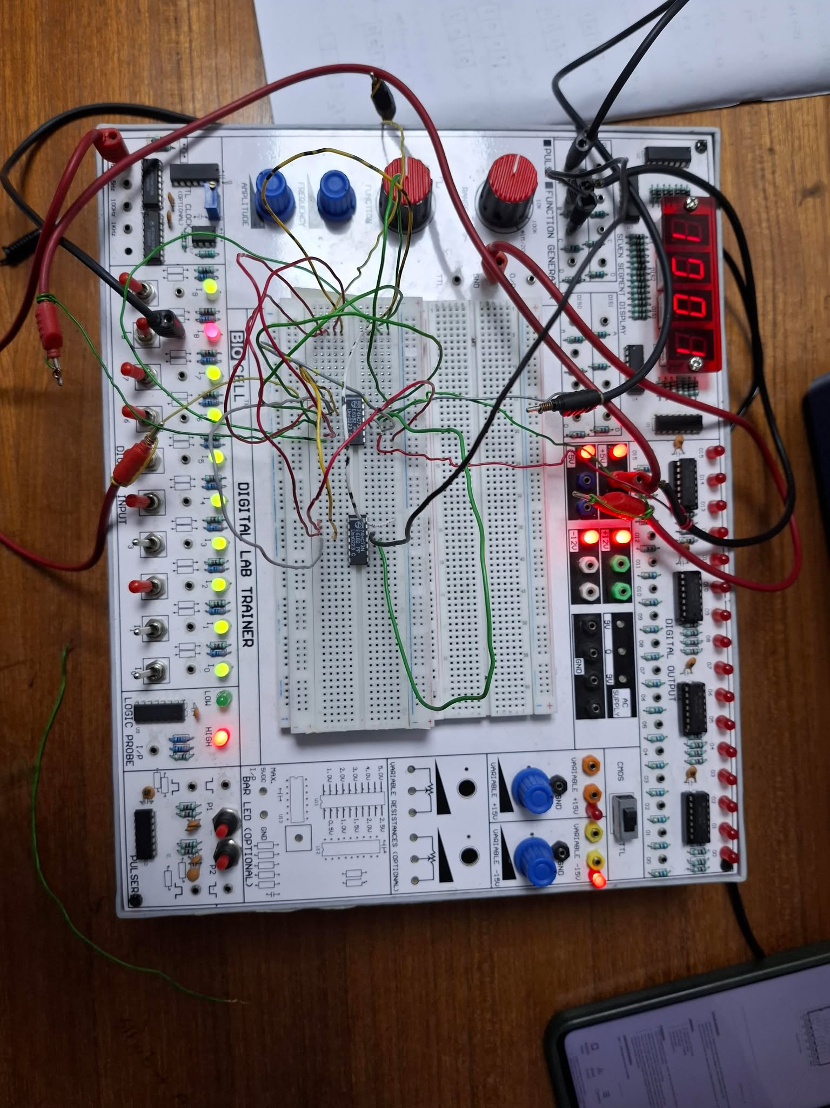

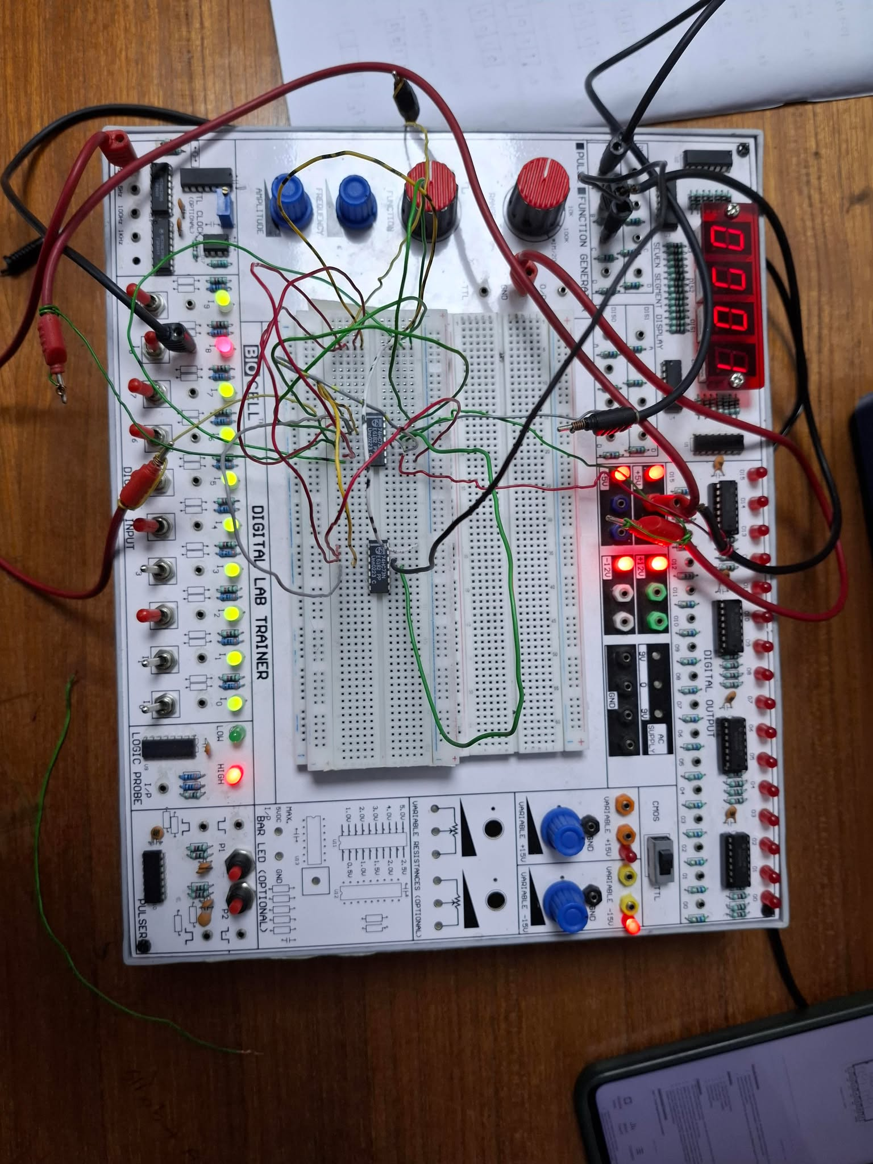

**Simulation:**

2 bit synchronous up counter

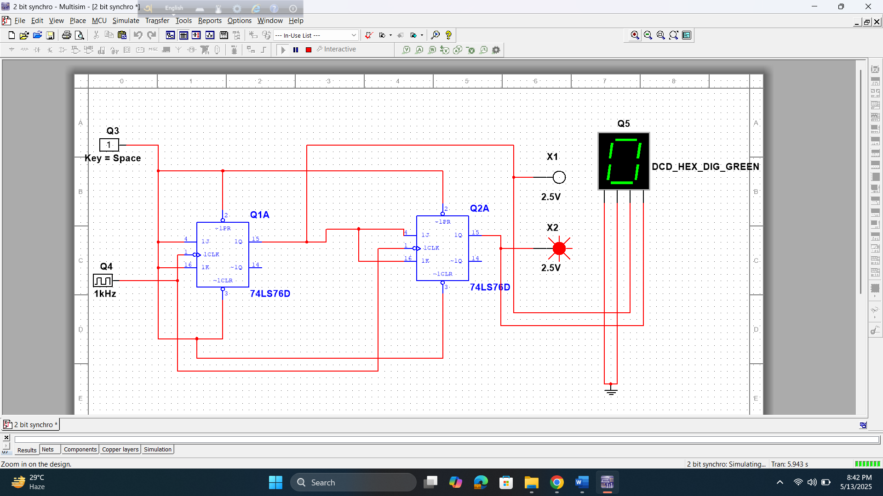

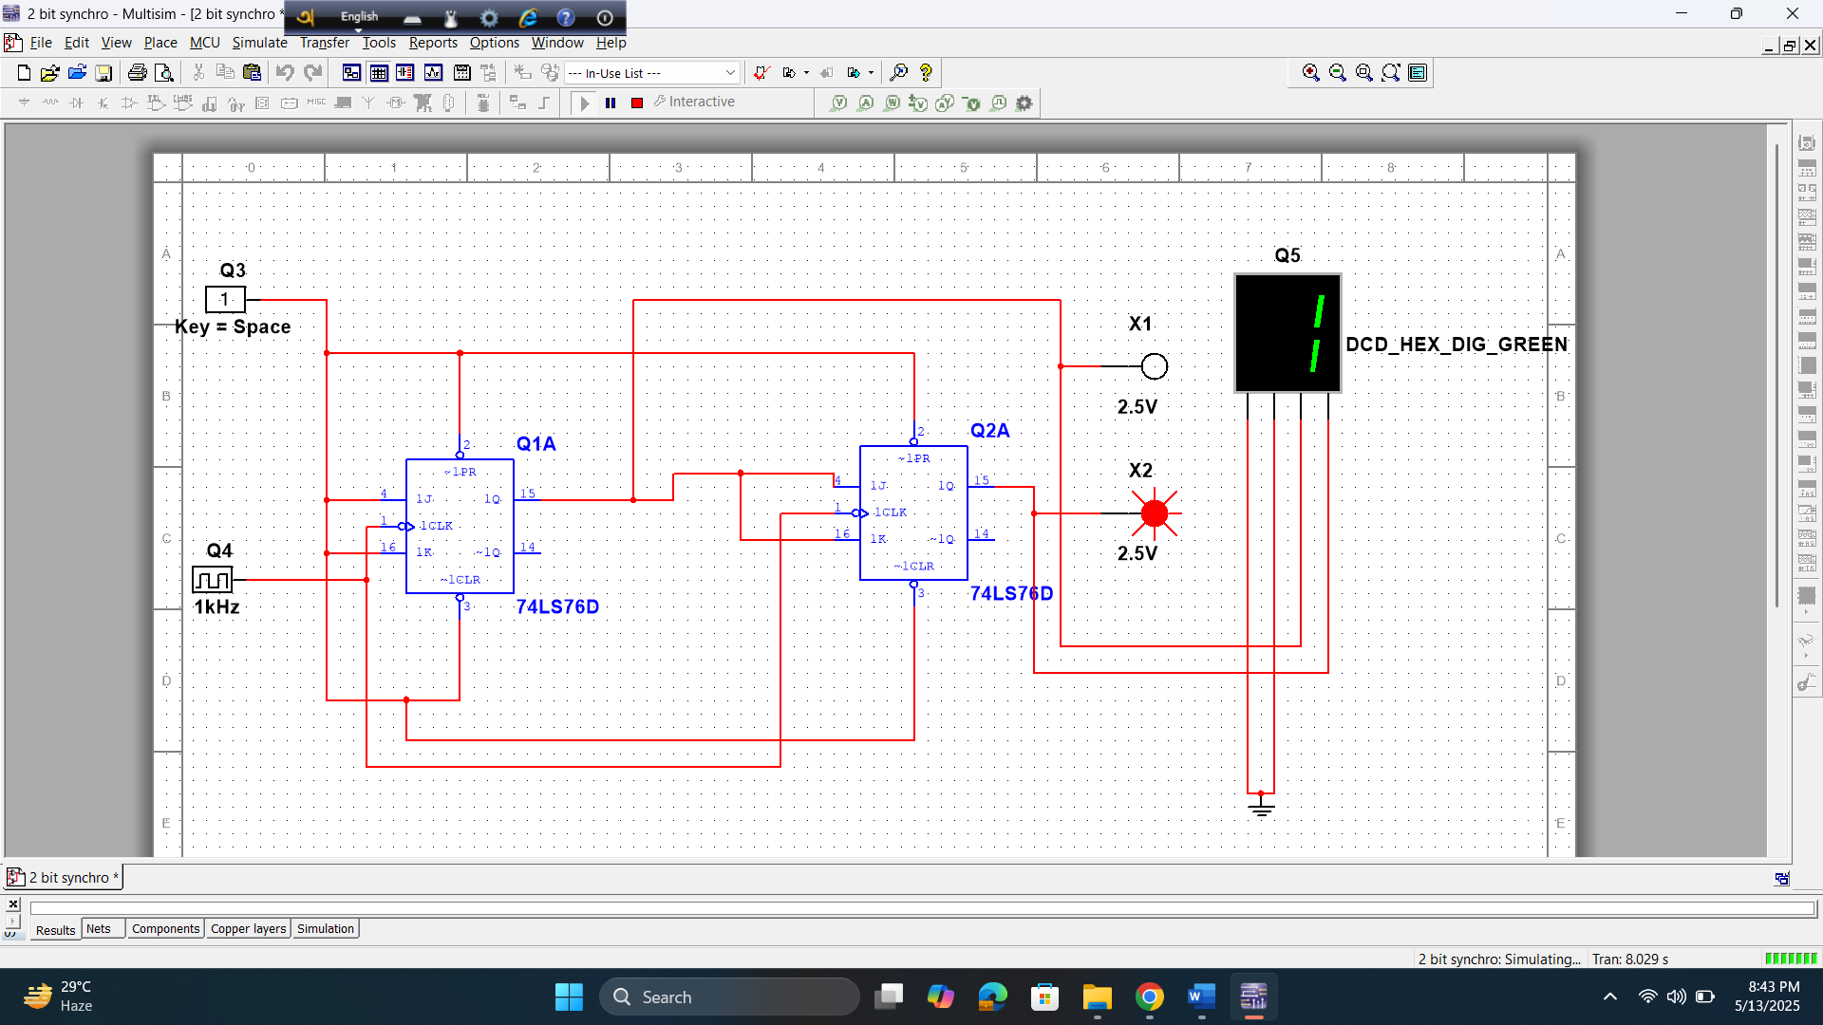

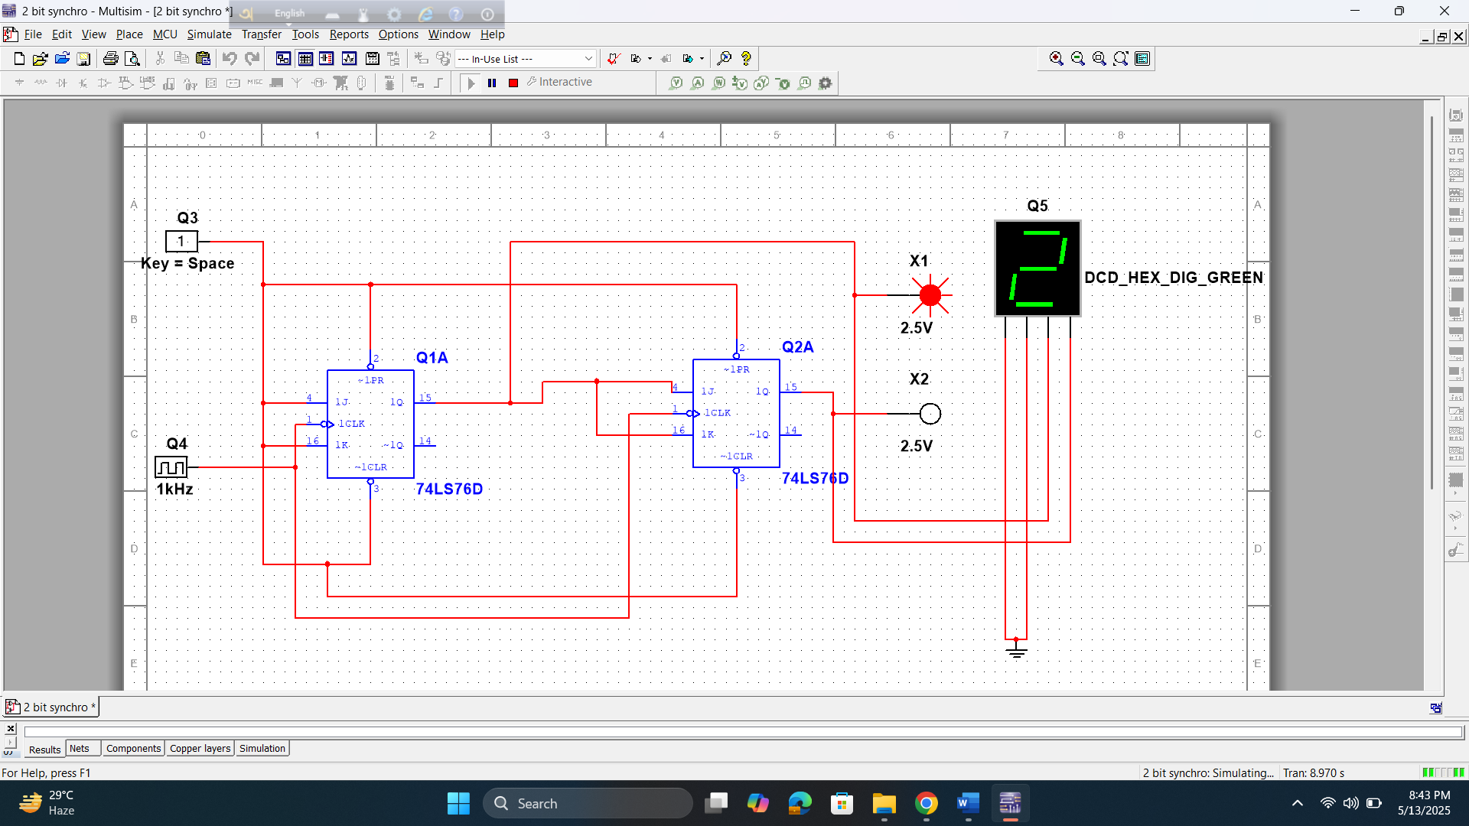

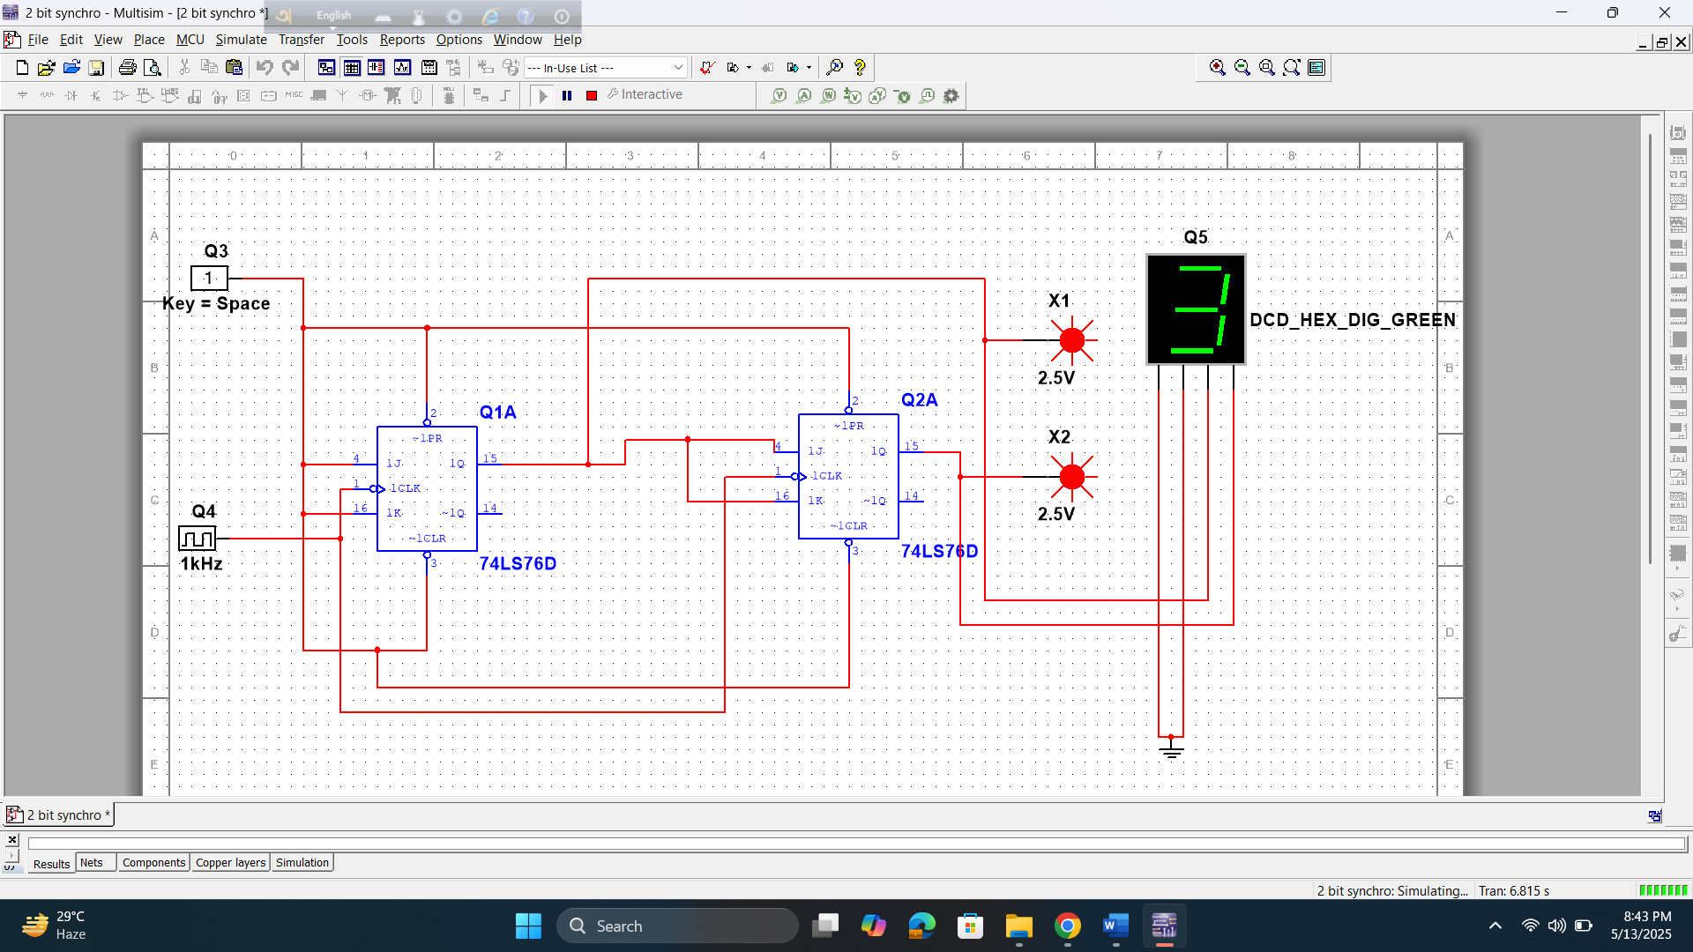

3 bit synchronous counter

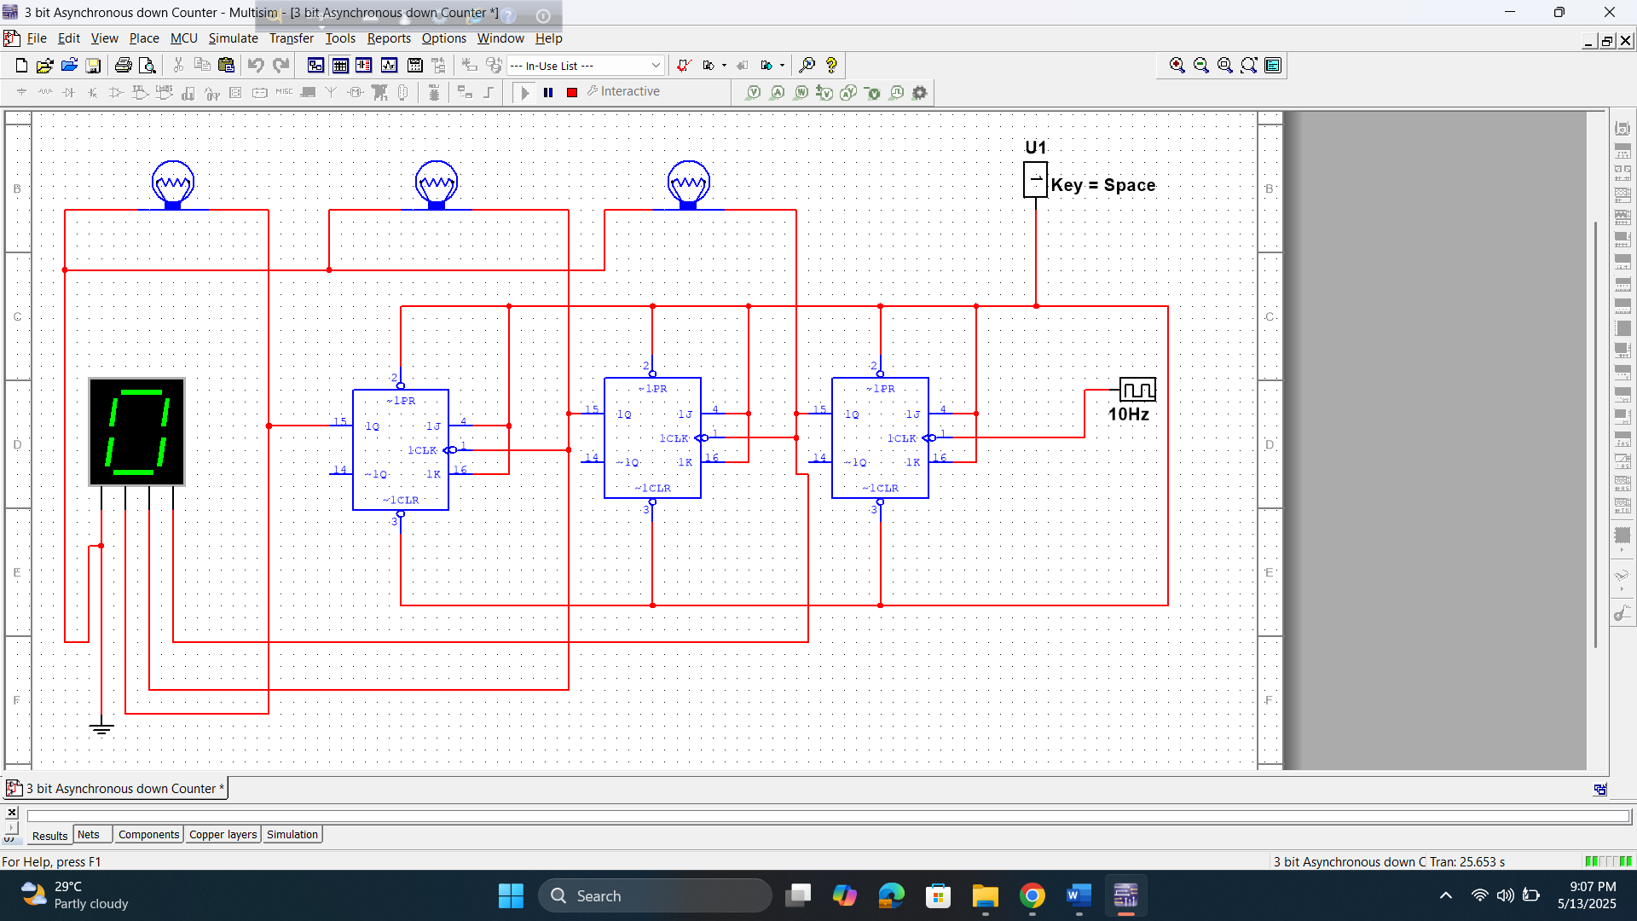

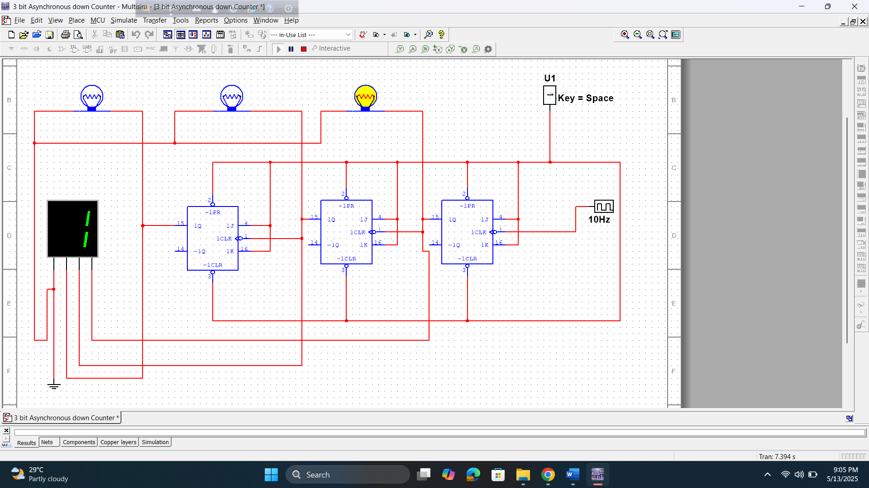

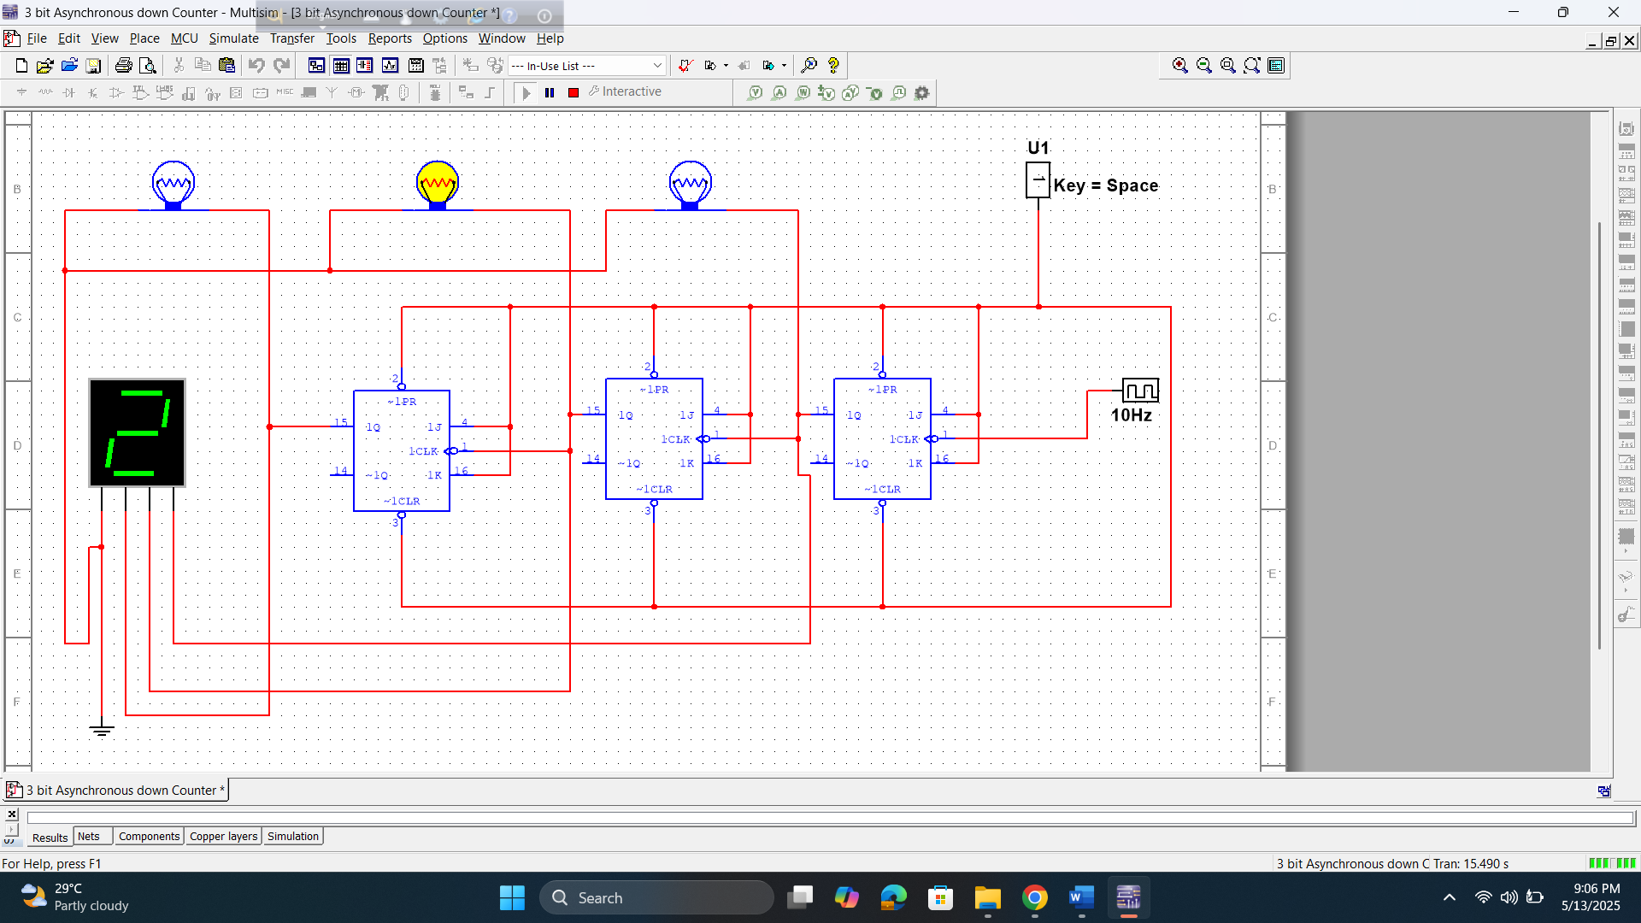

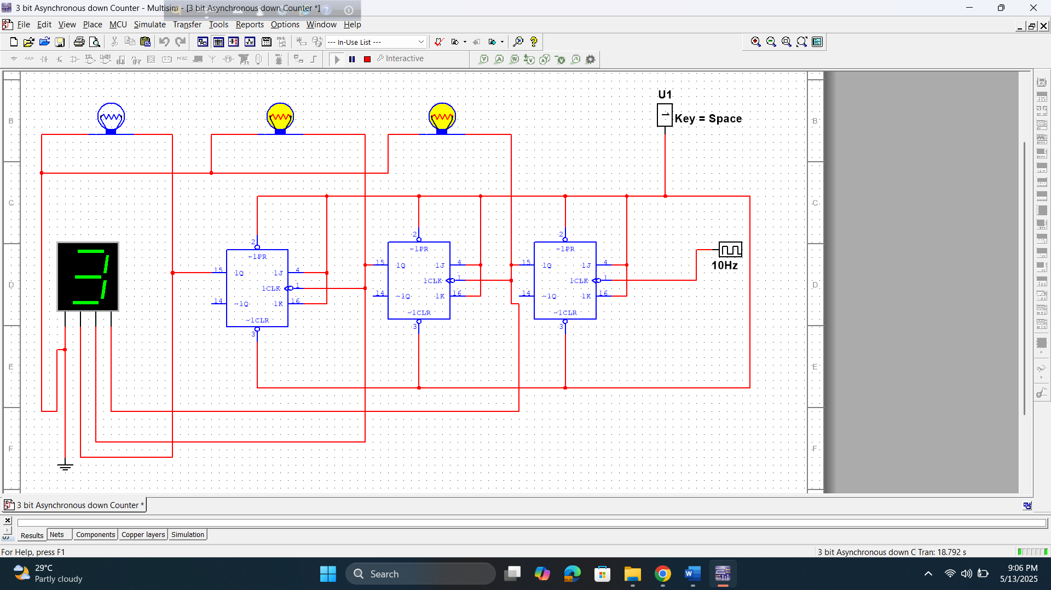

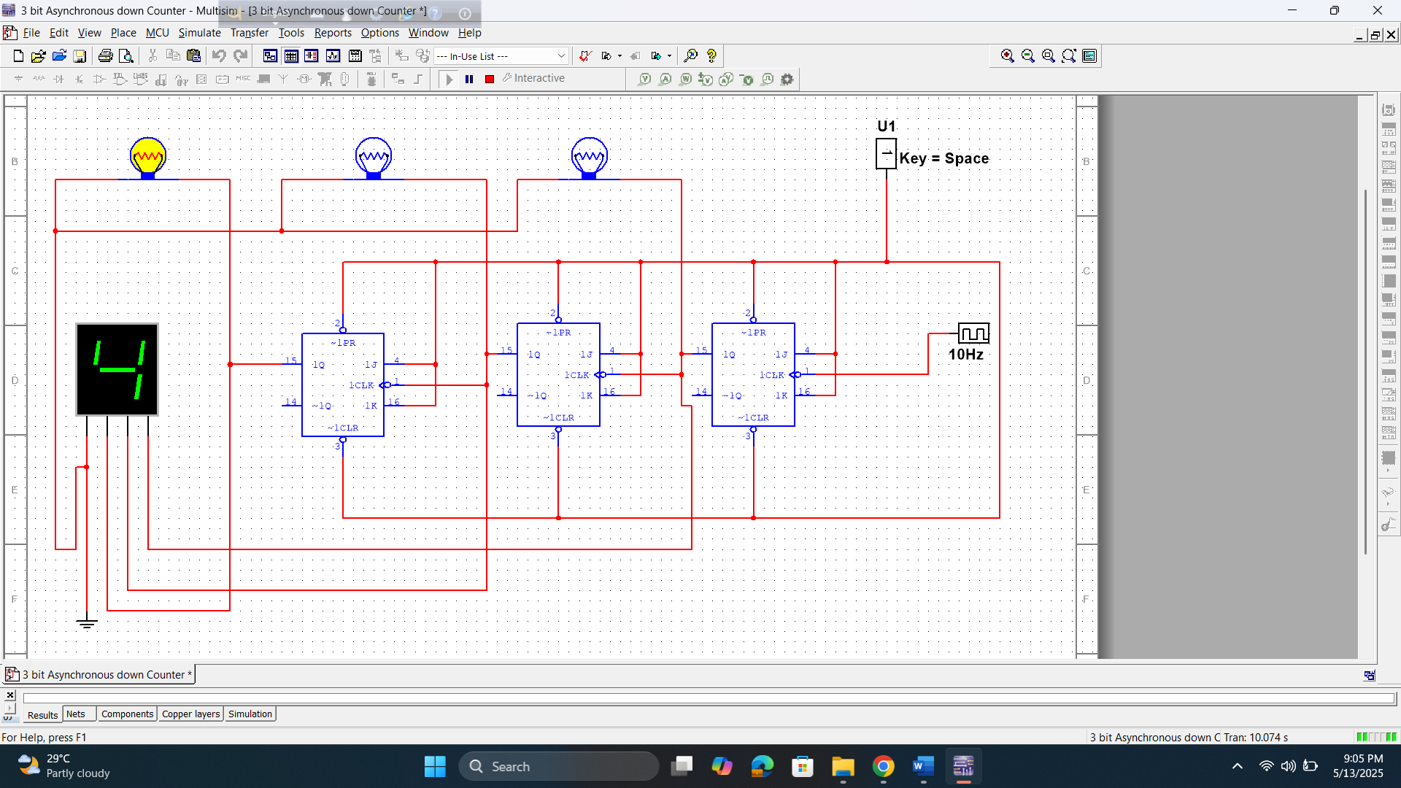

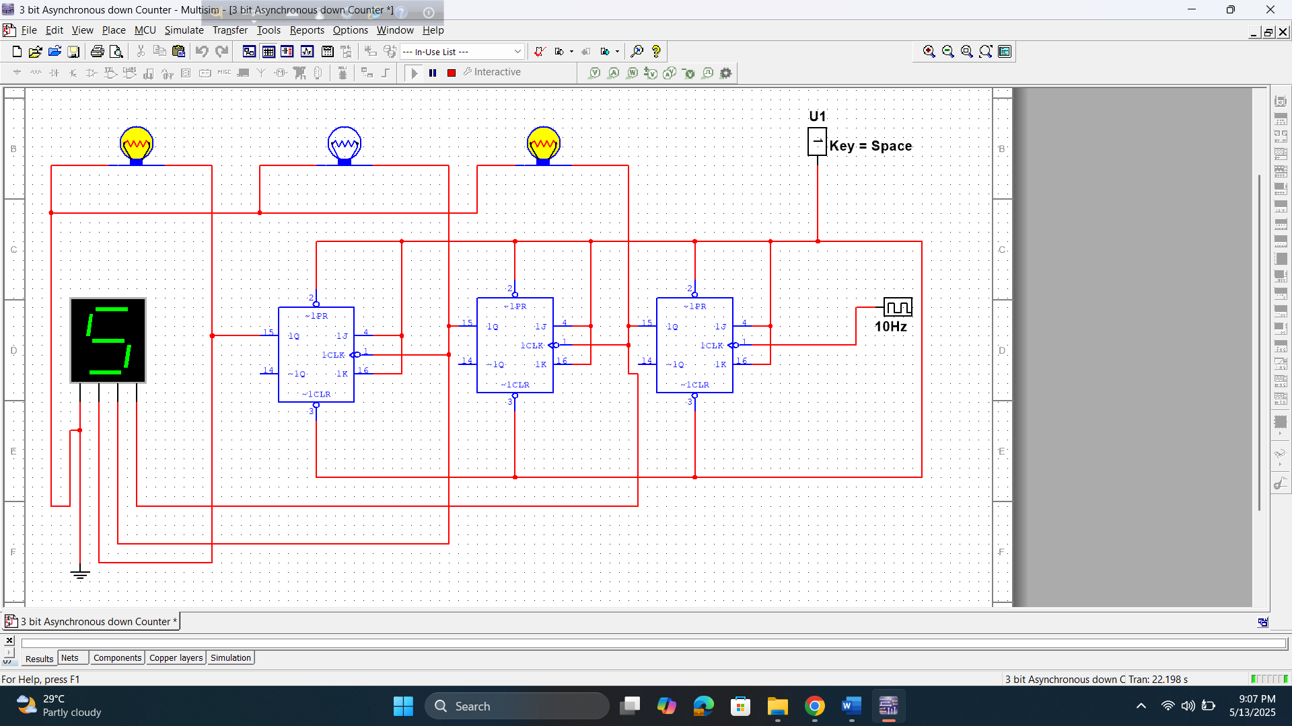

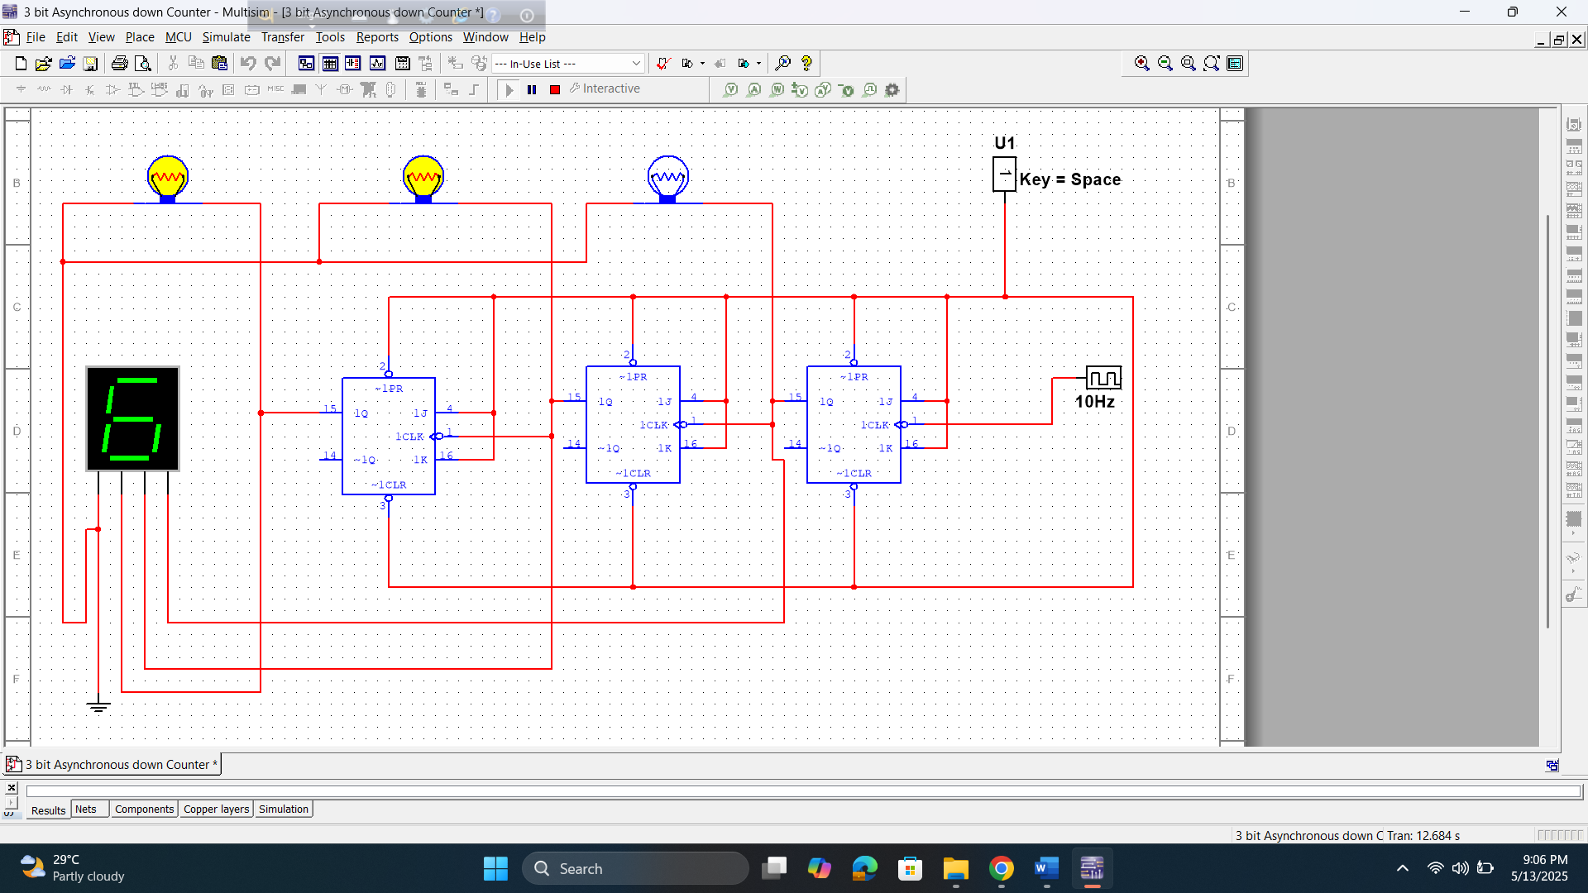

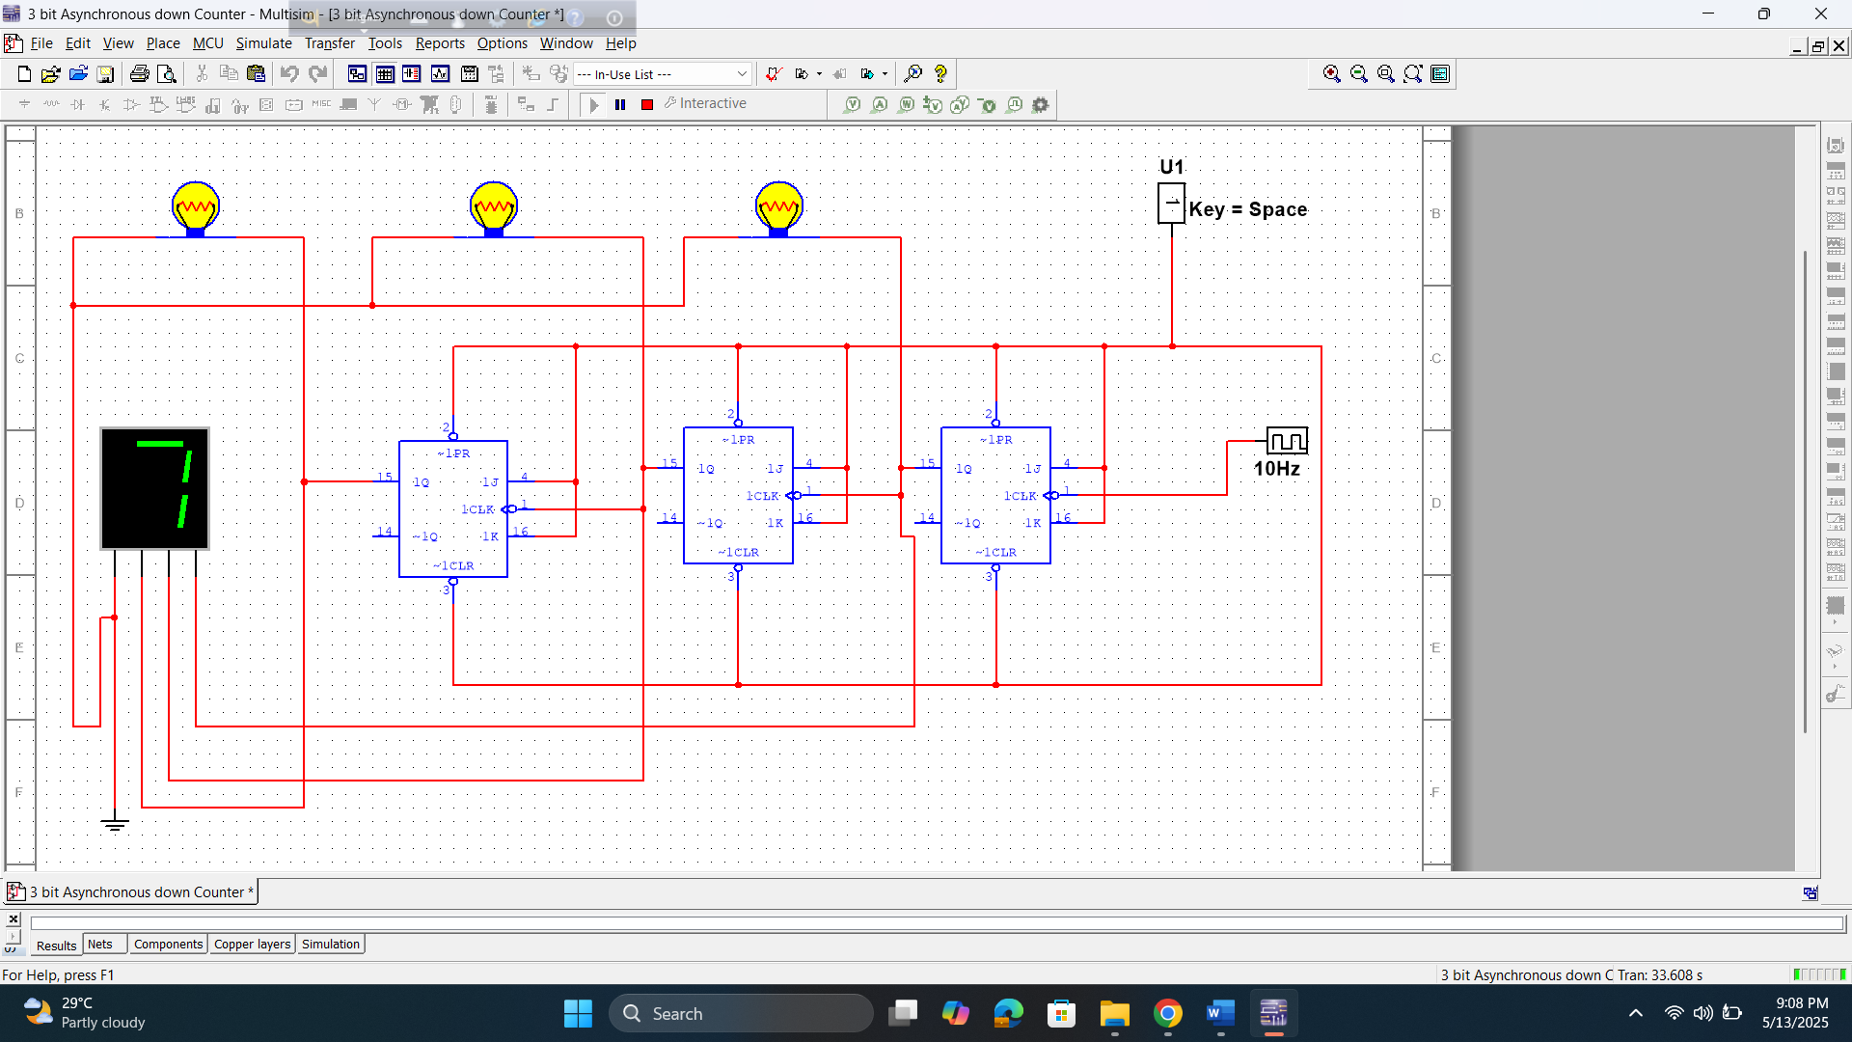

3 bit asynchronous down counter

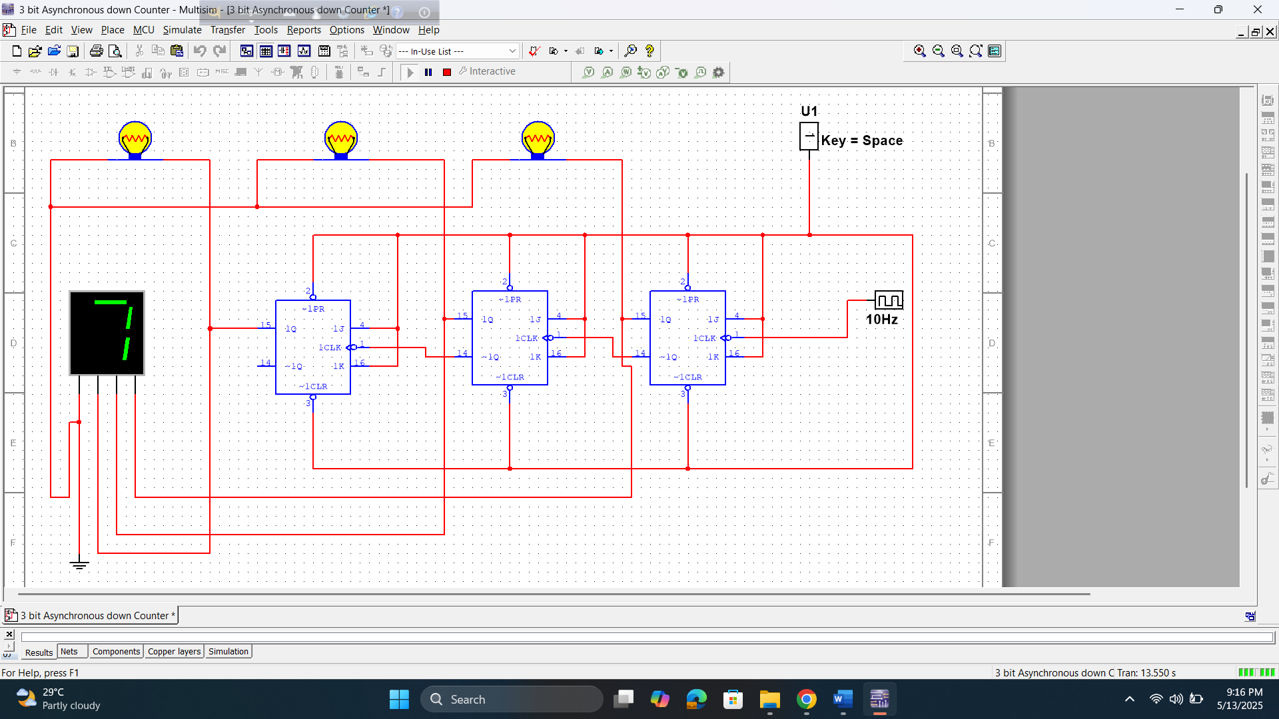

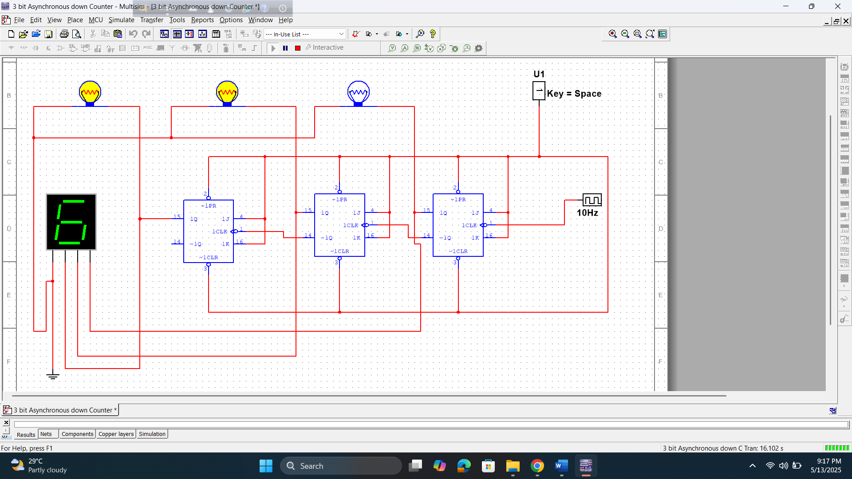

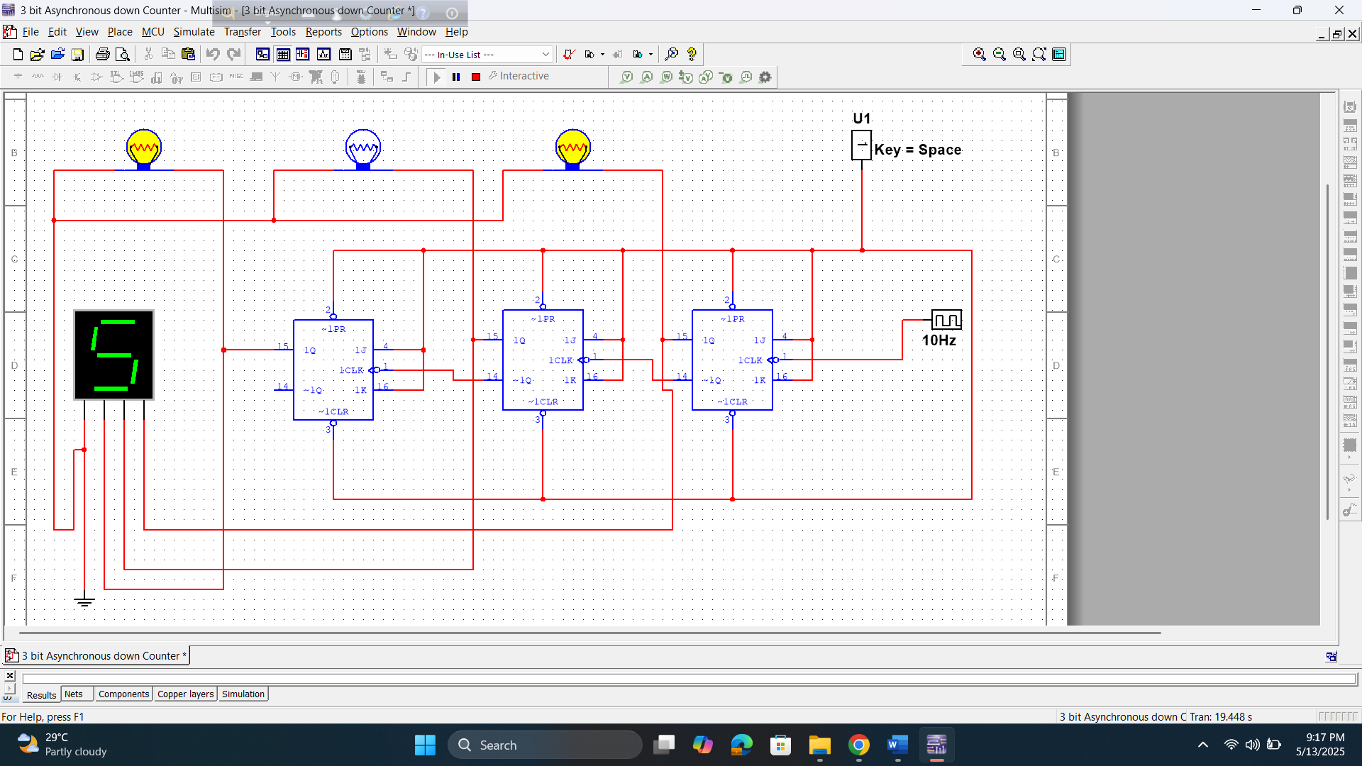

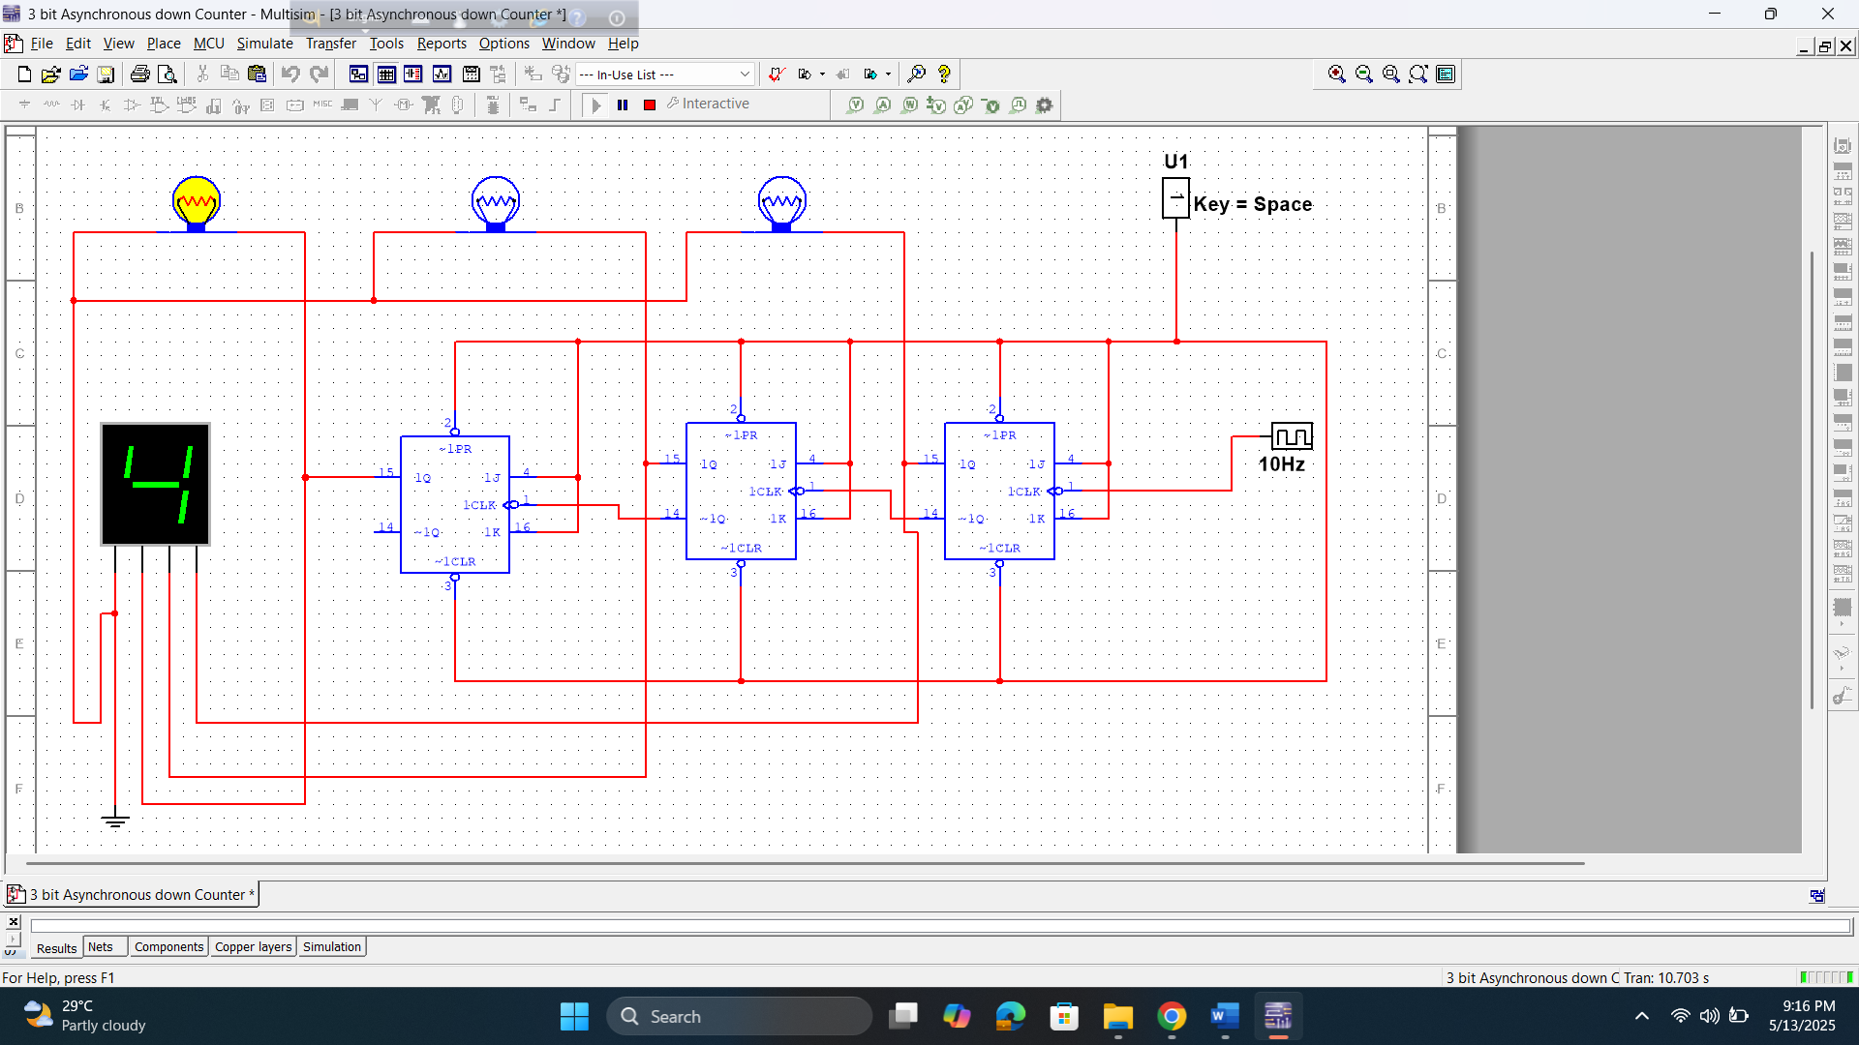

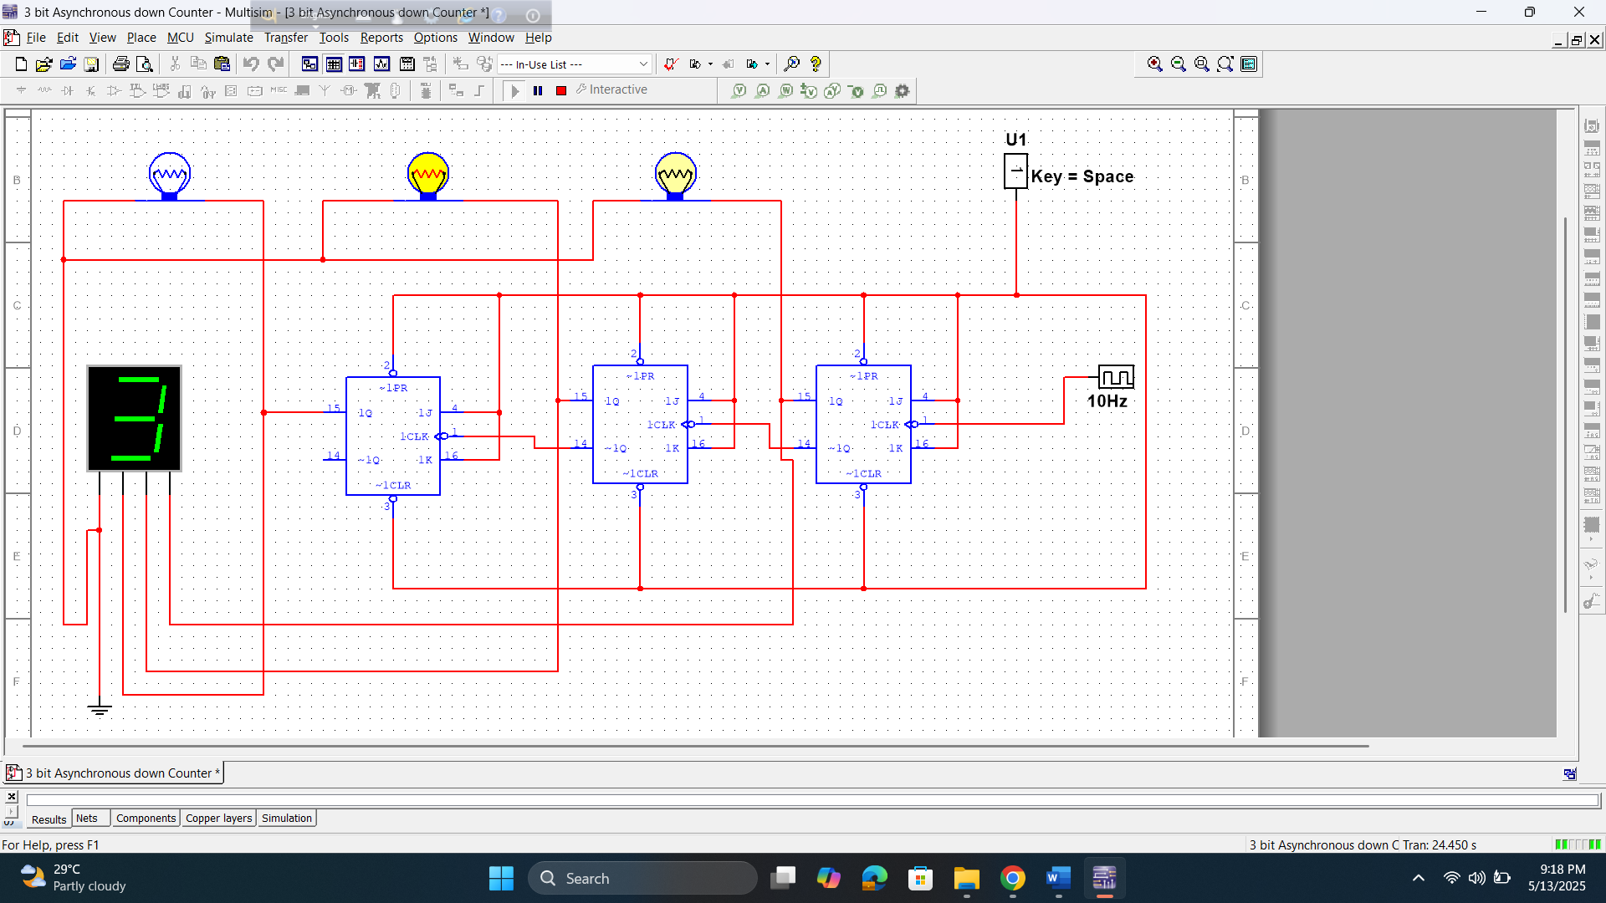

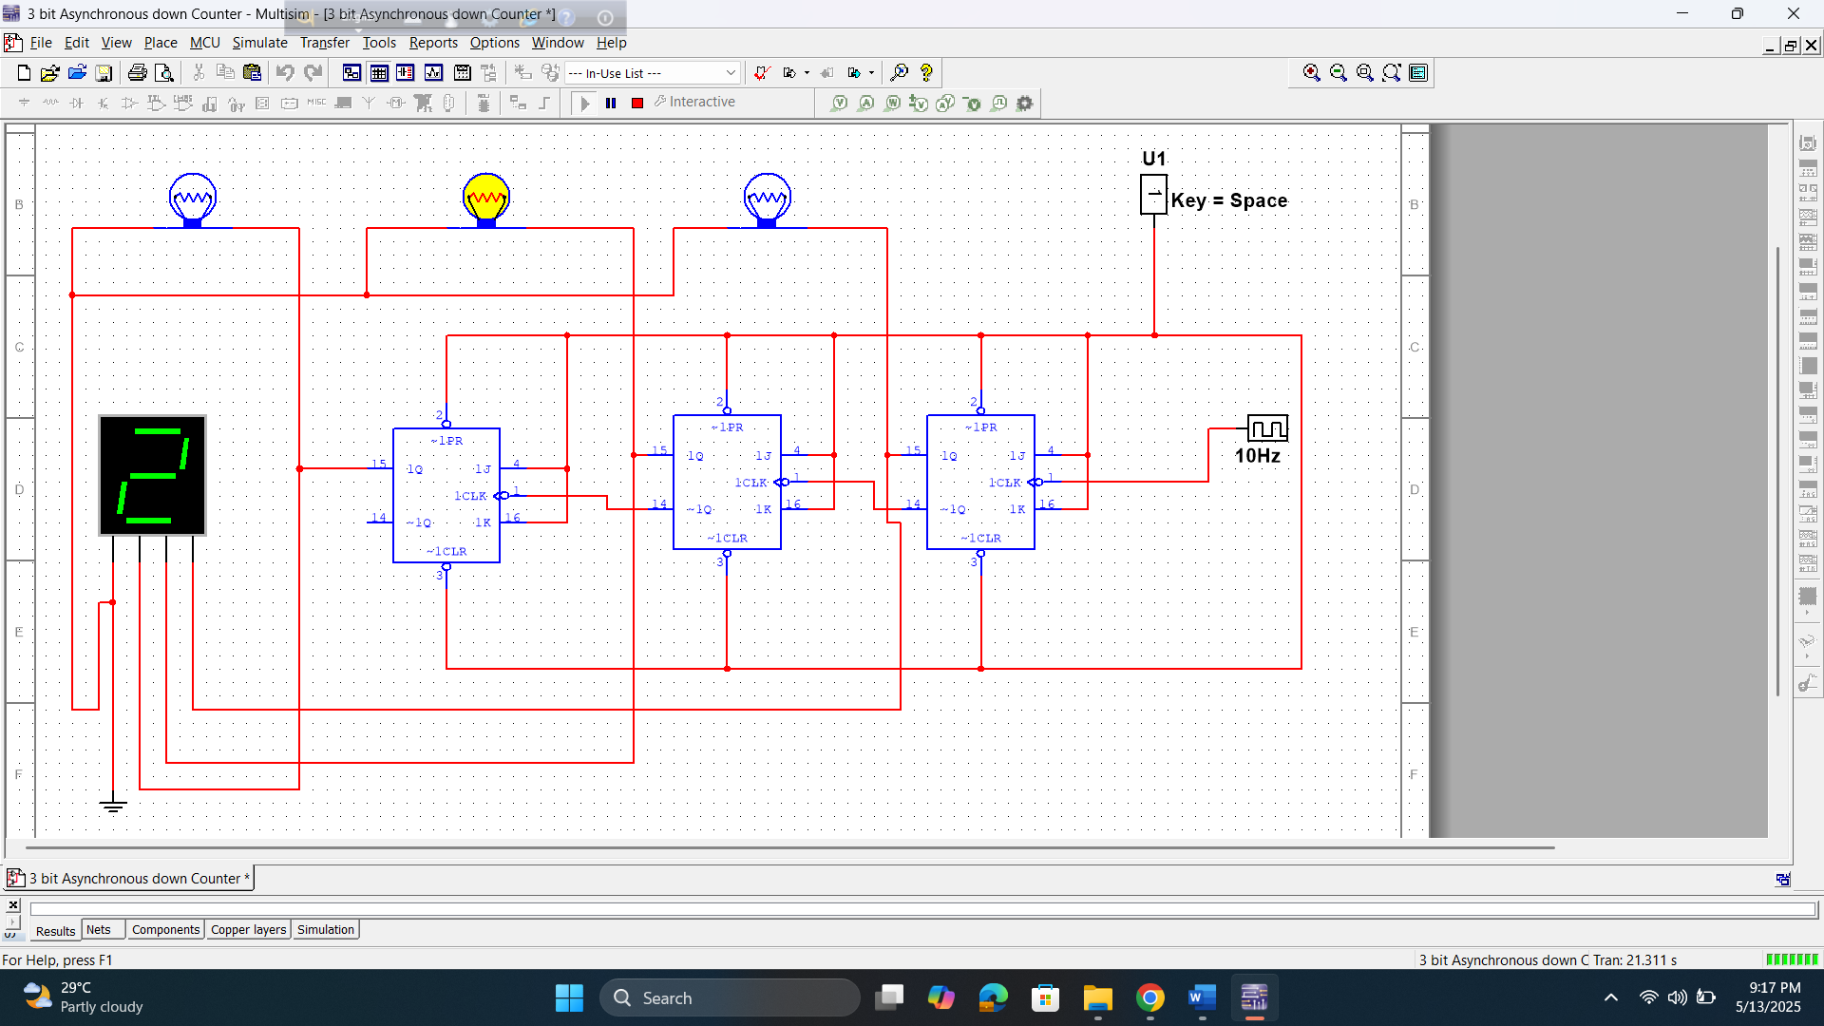

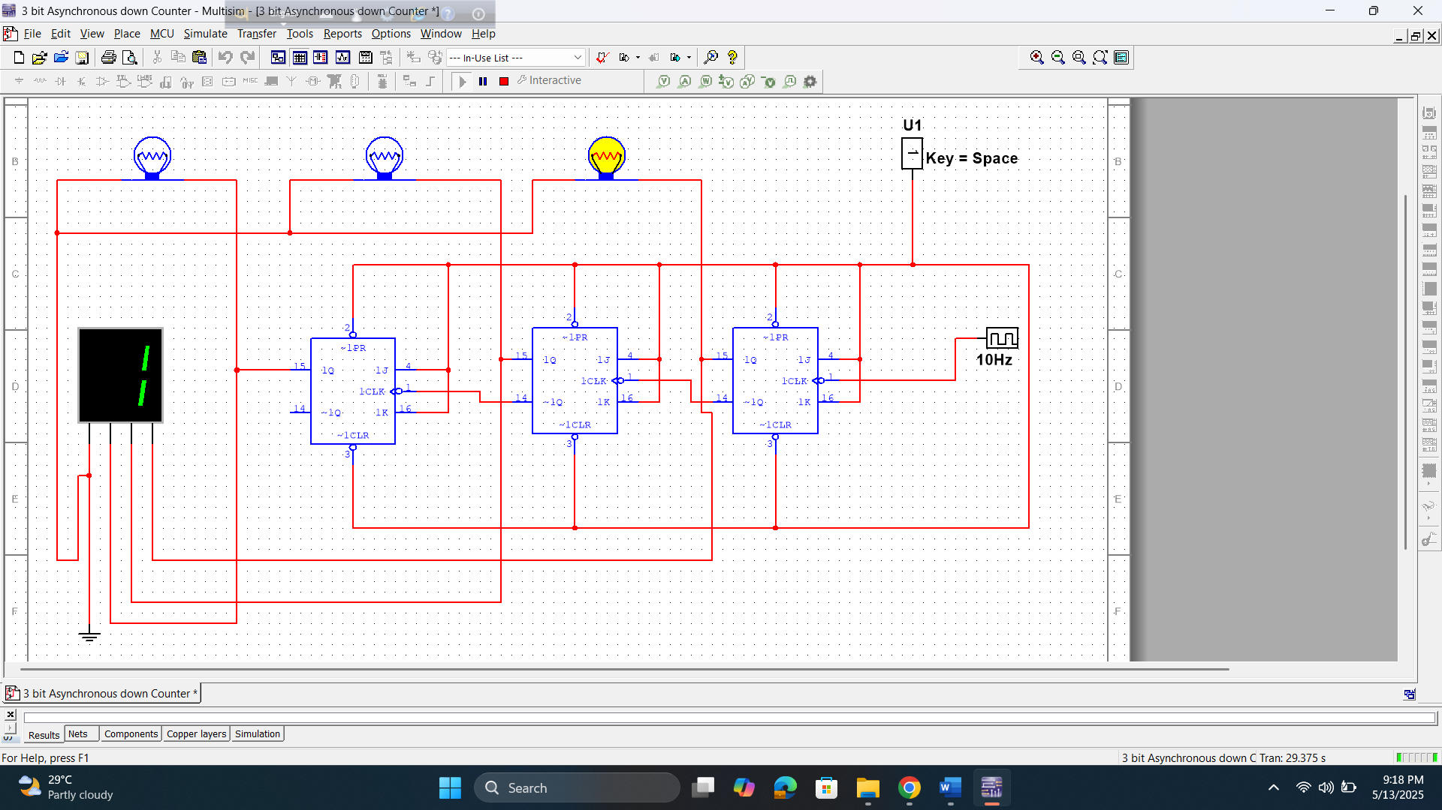

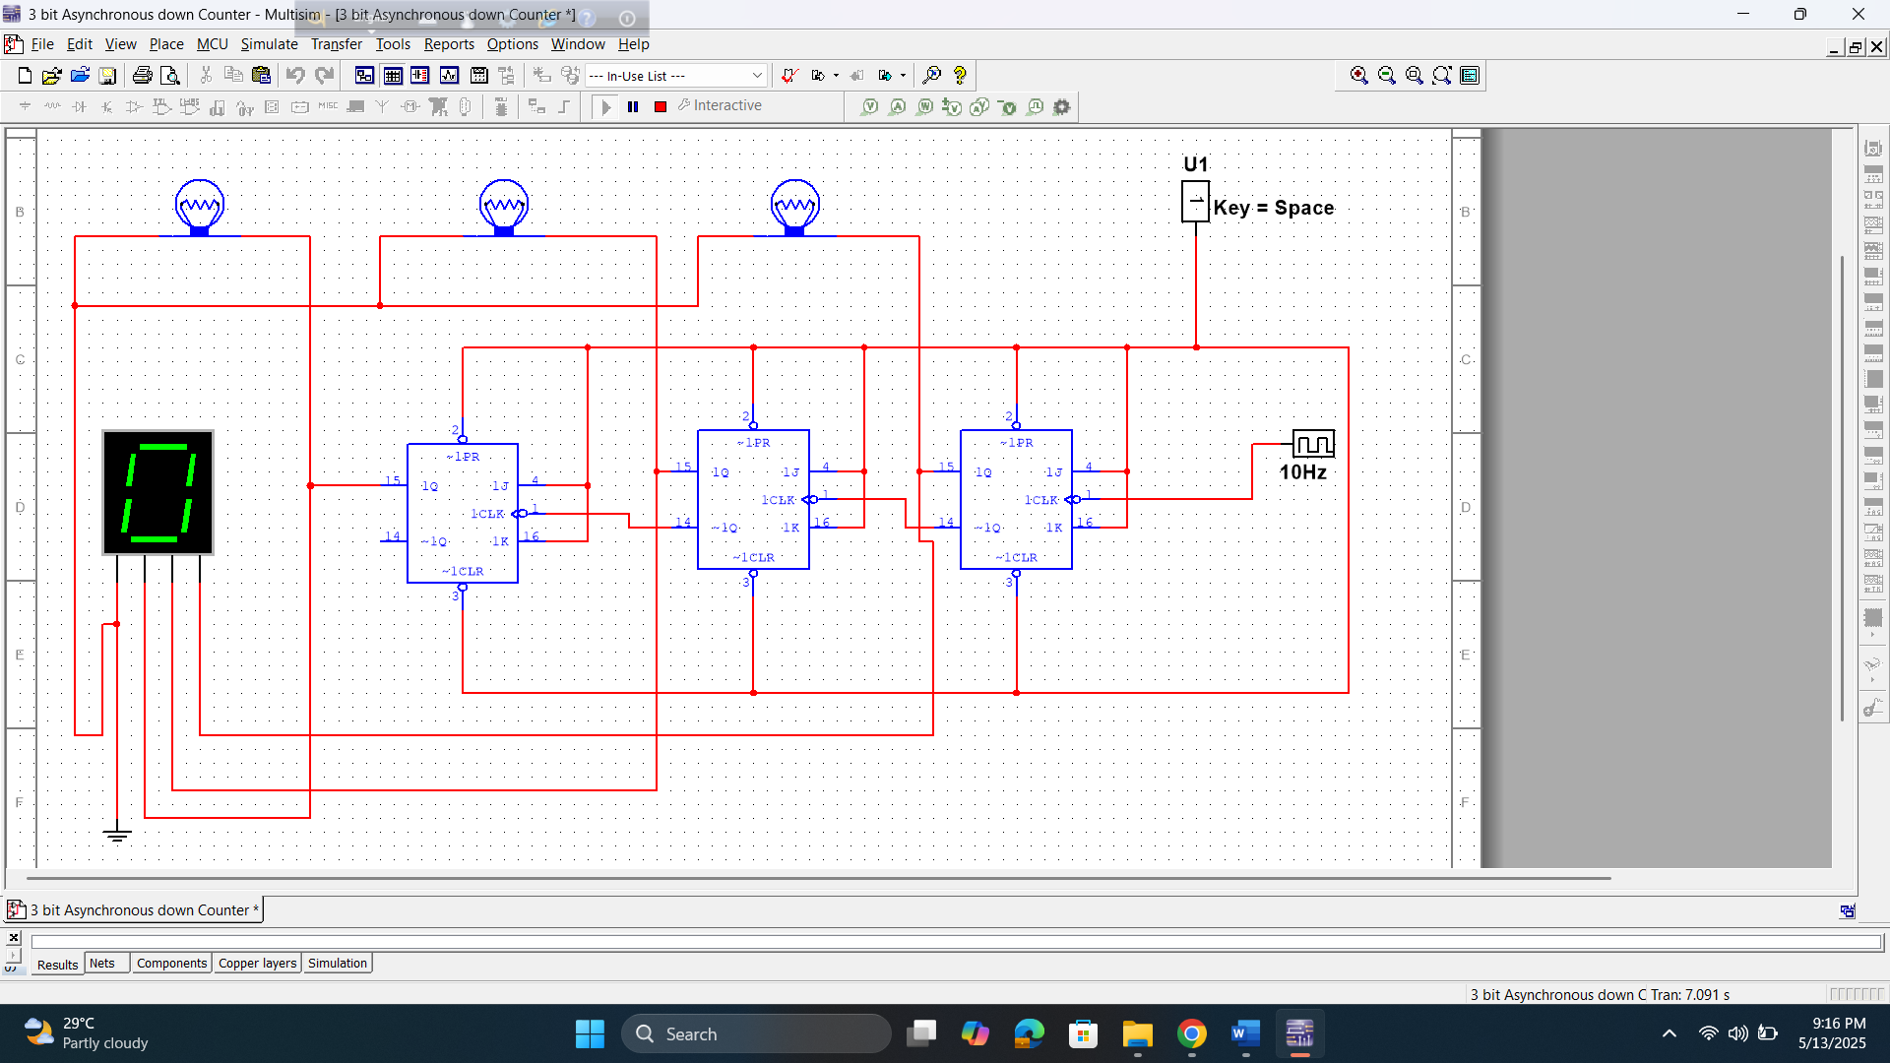

MOD 10 synchronous up counter

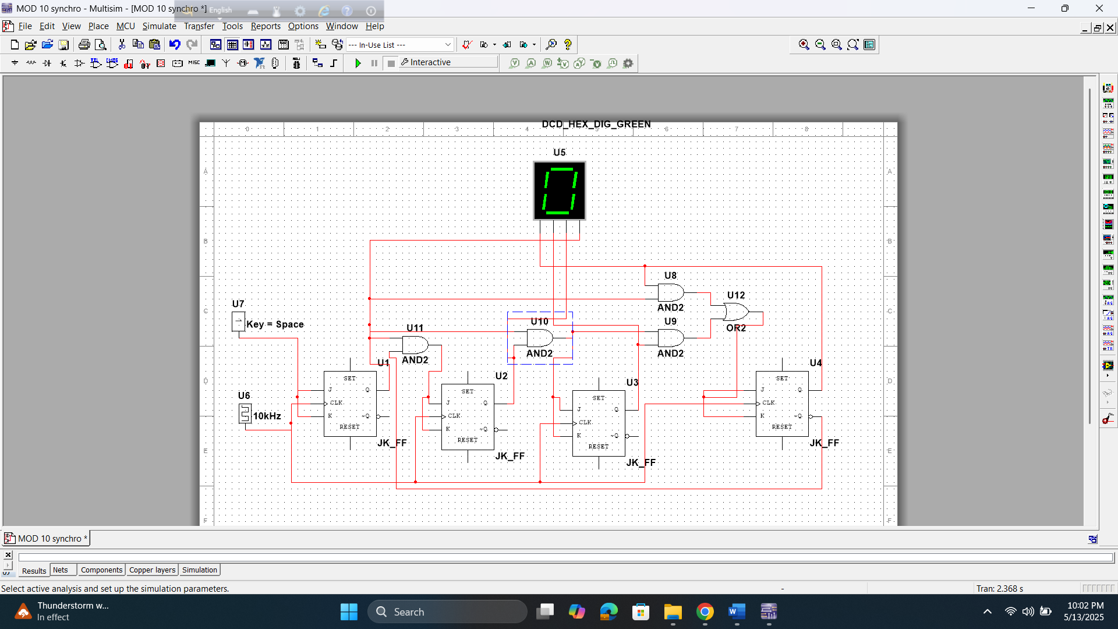

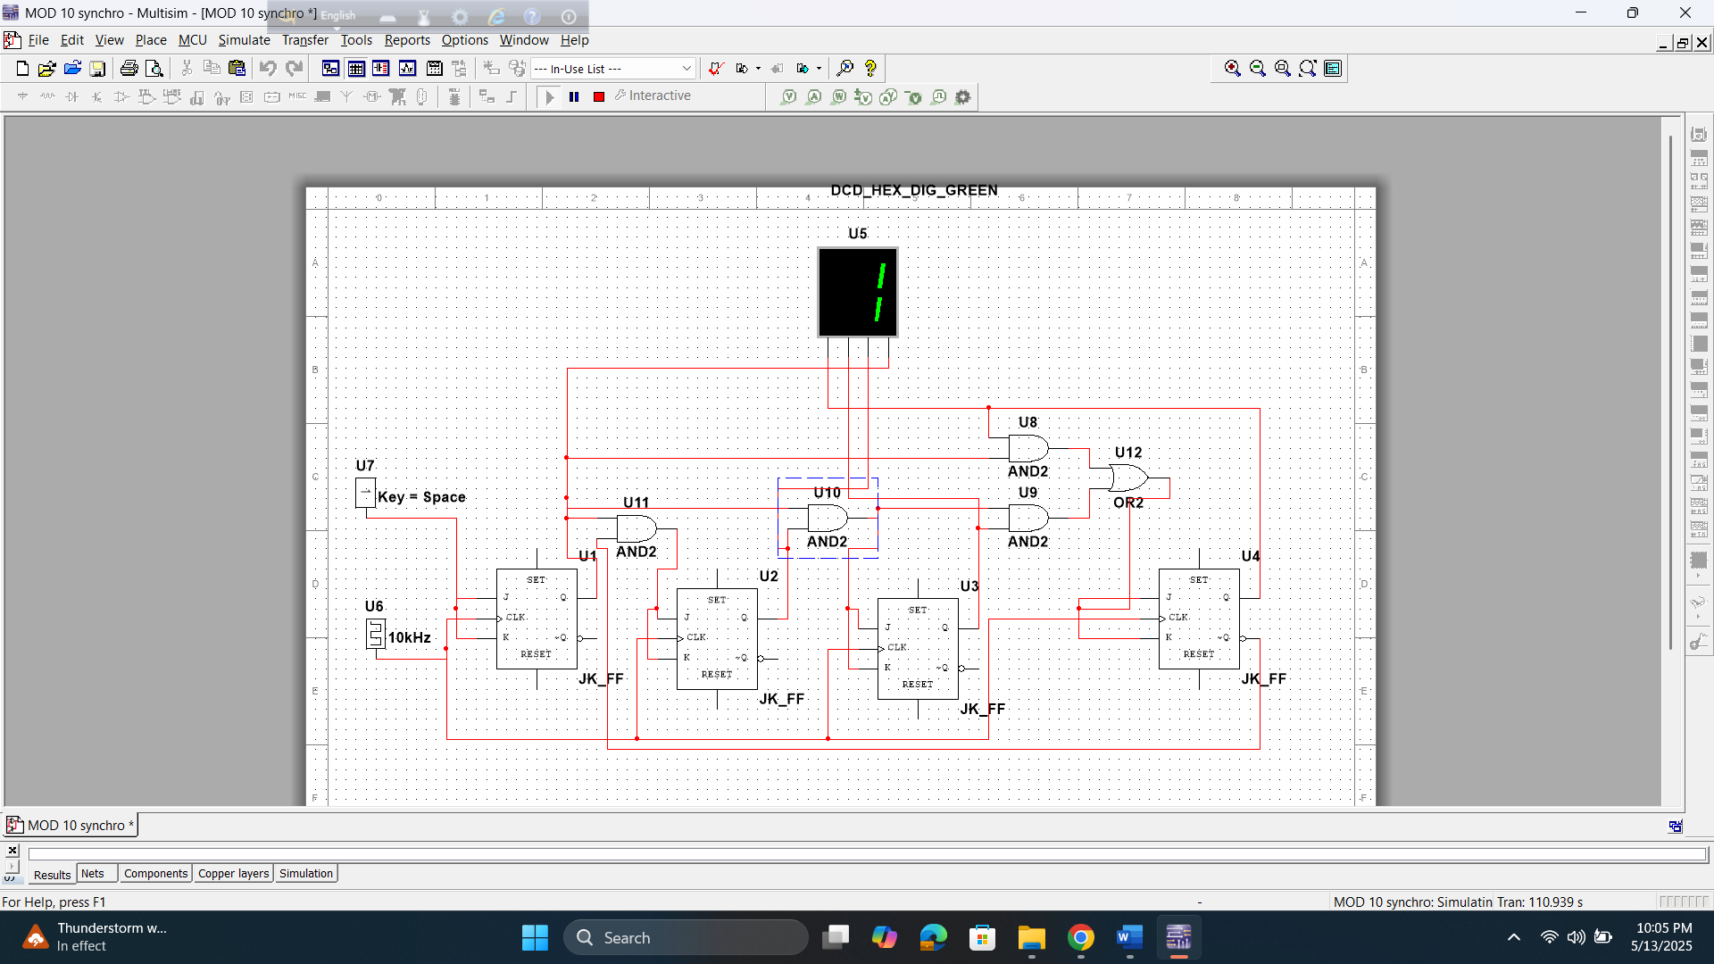

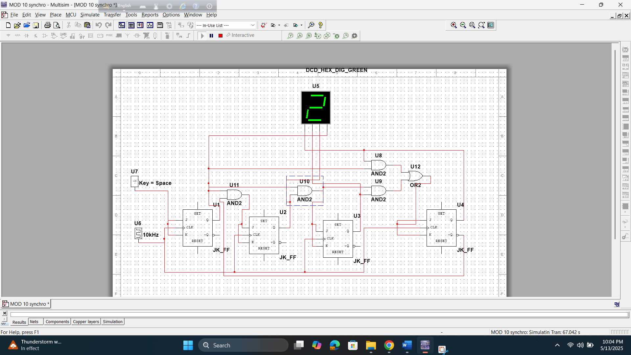

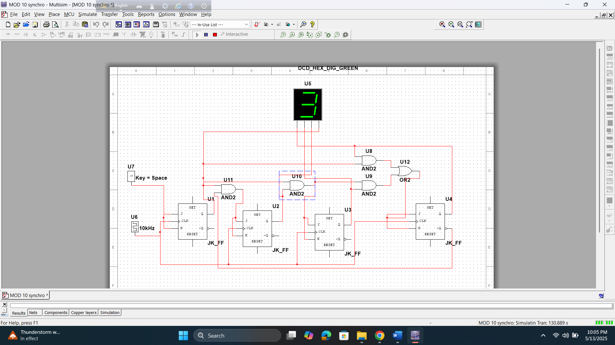

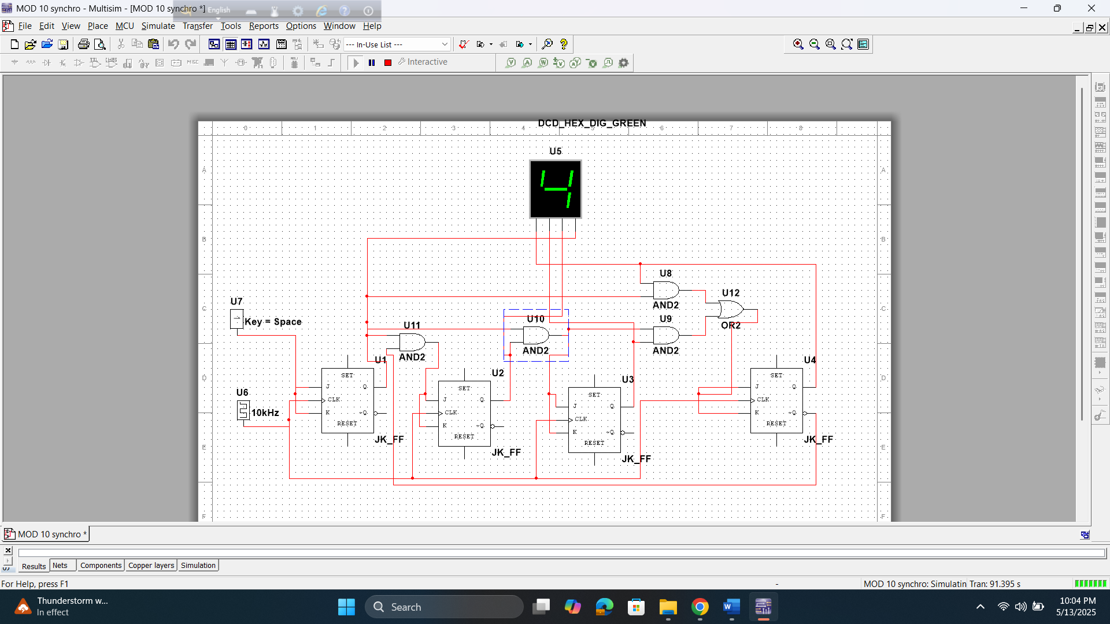

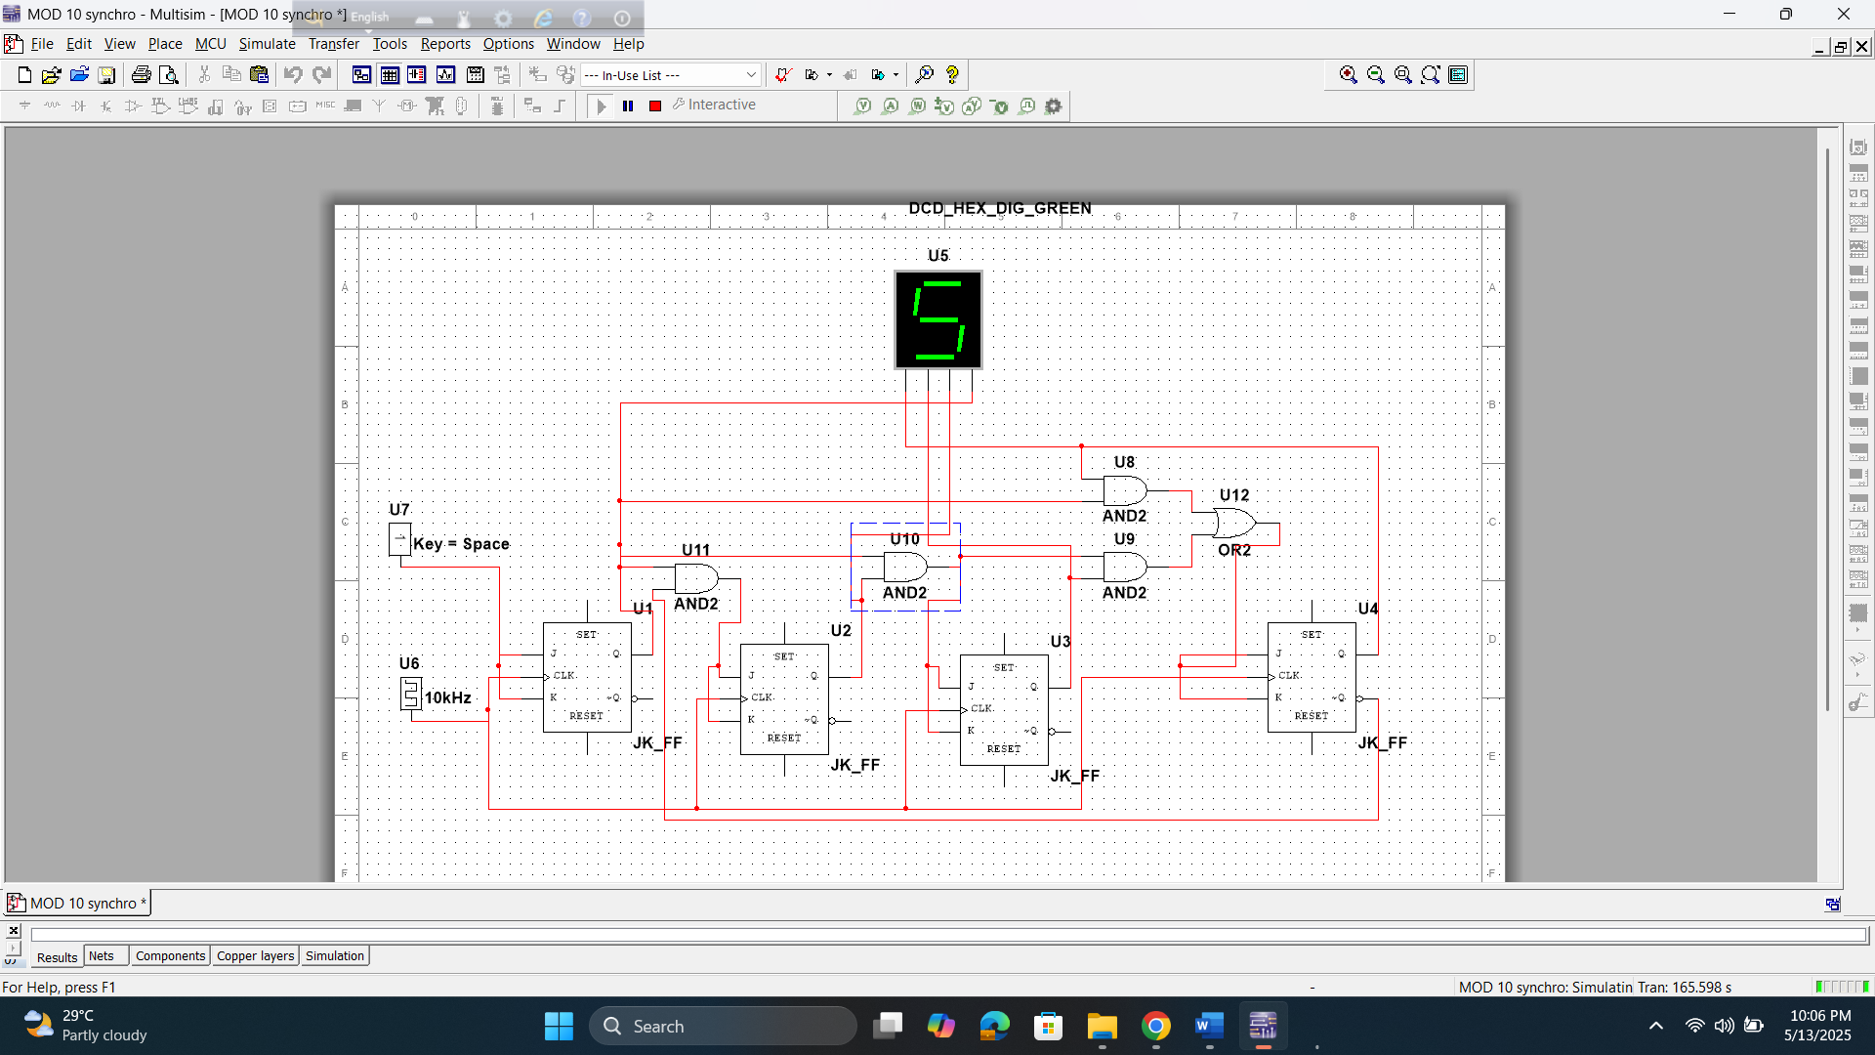

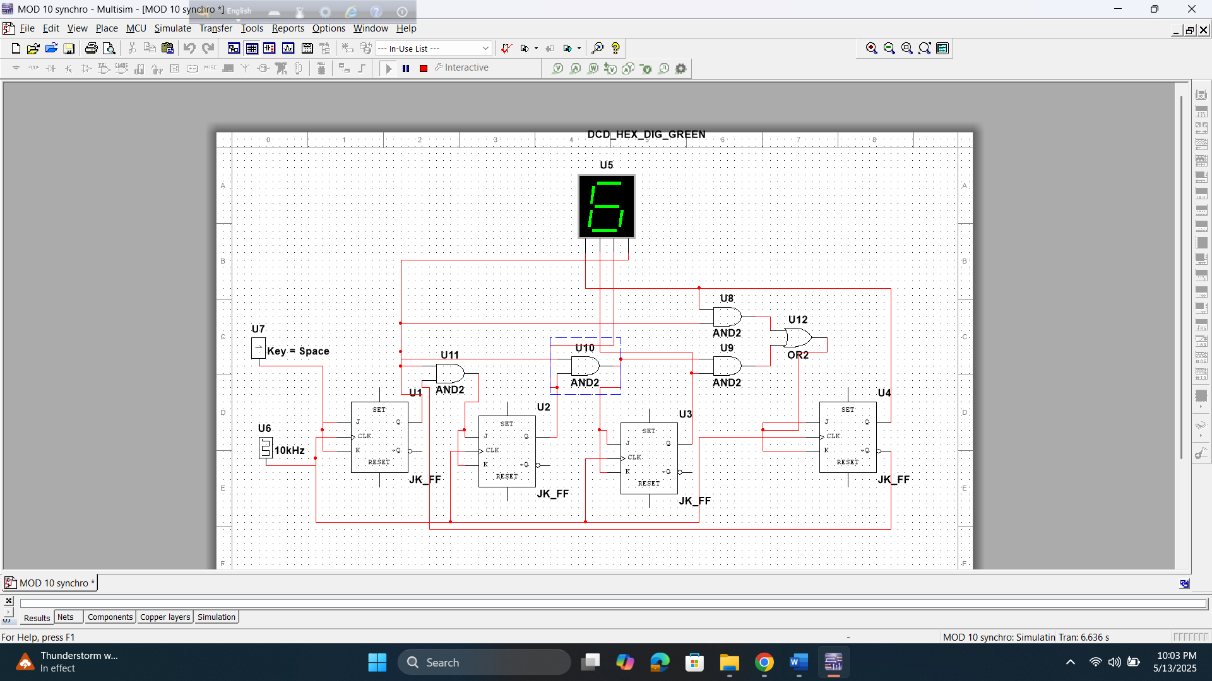

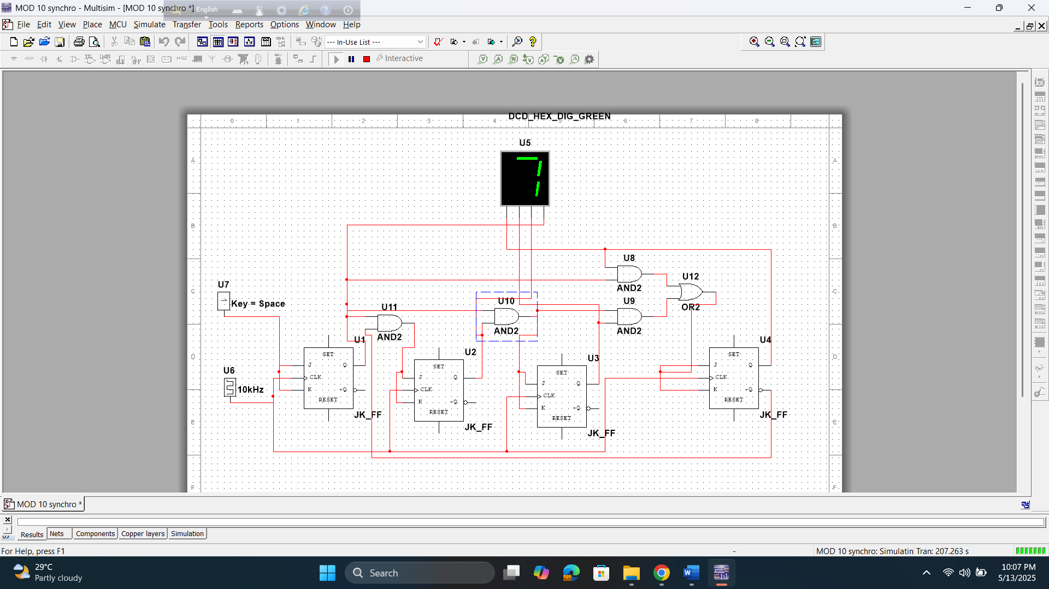

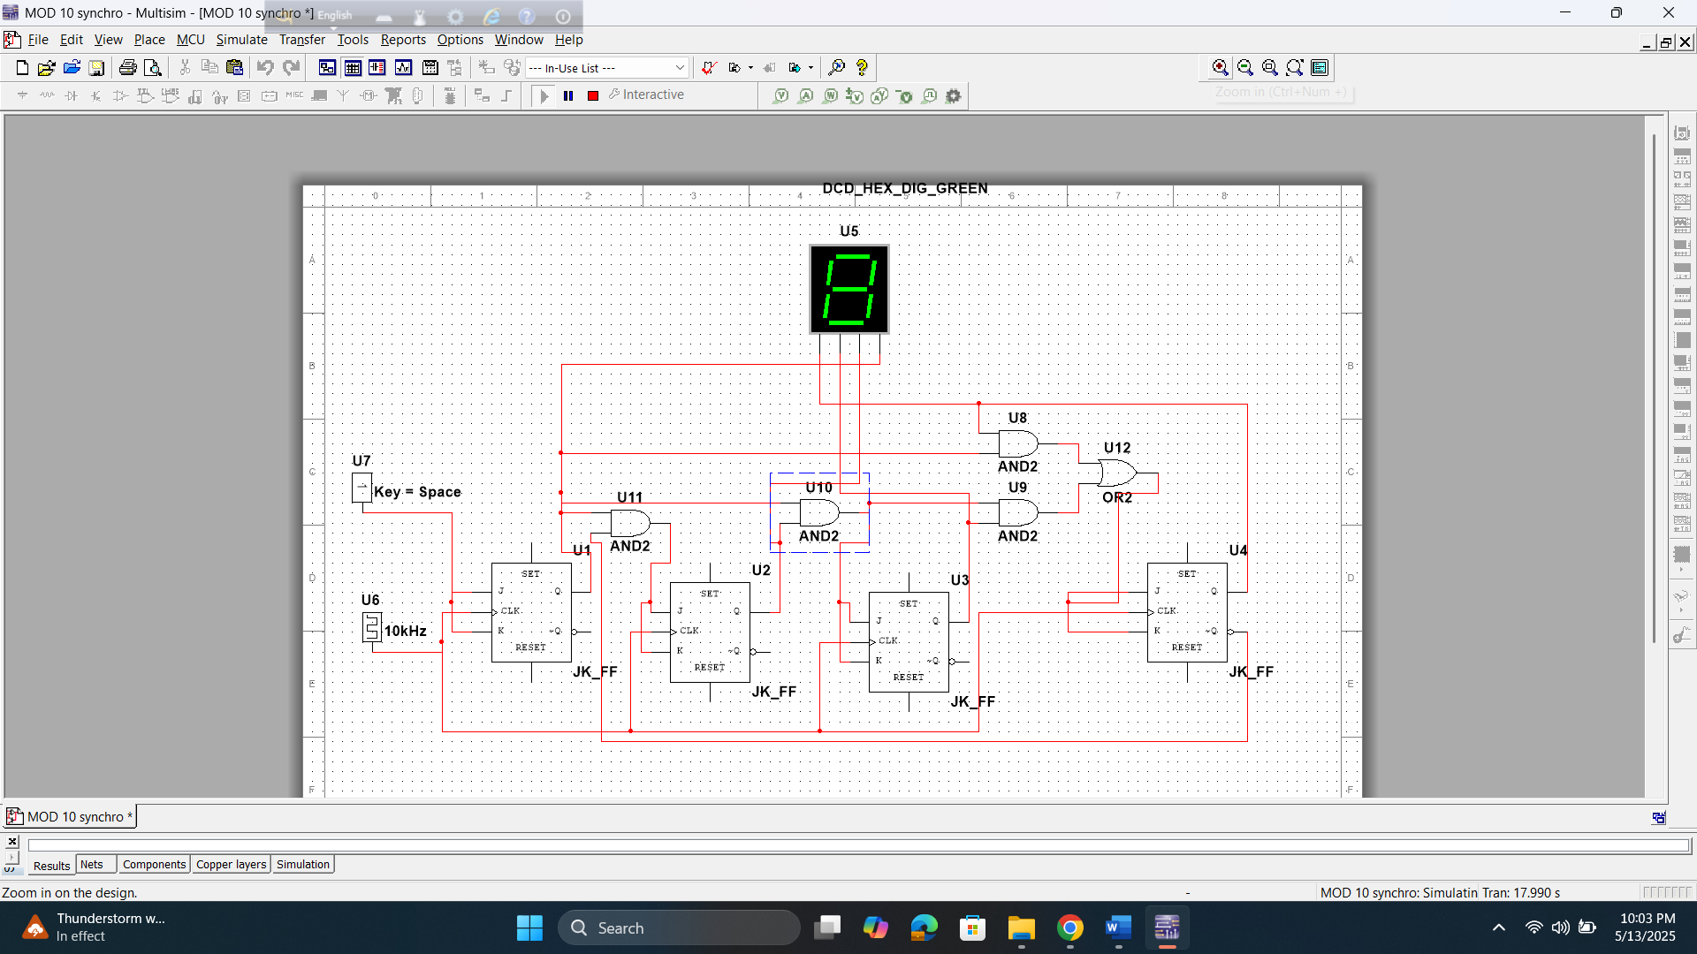

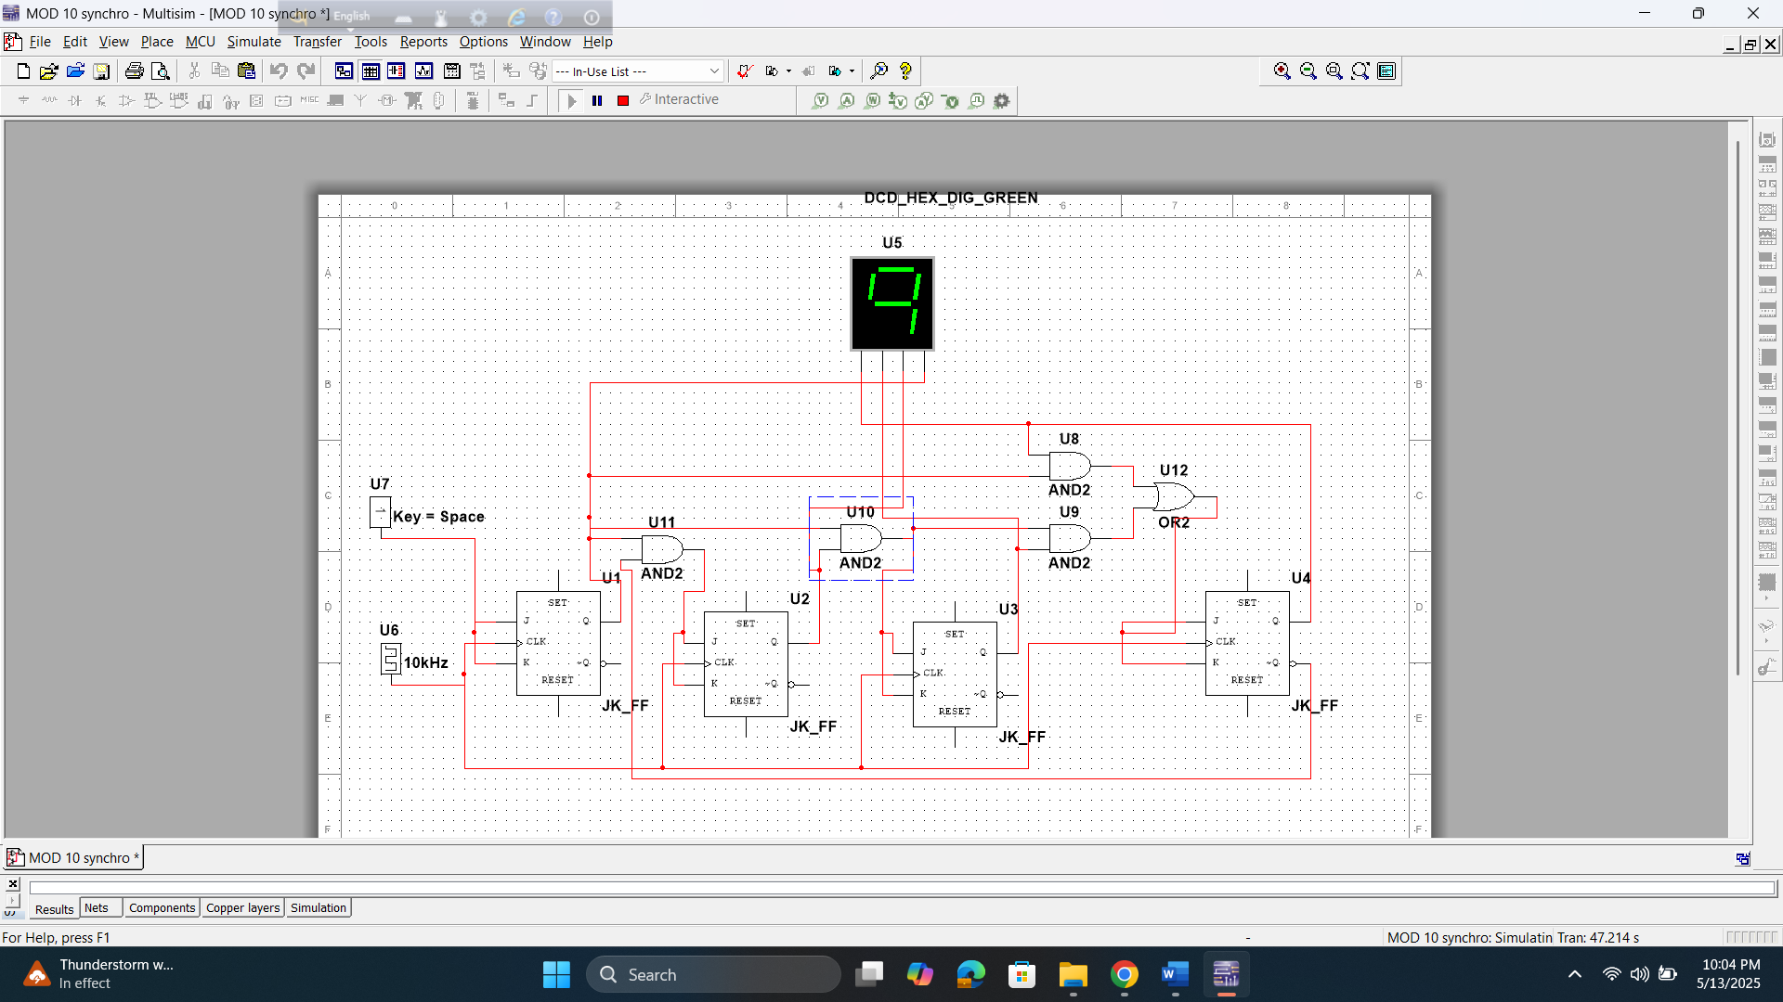

4 bid synchronous up counter

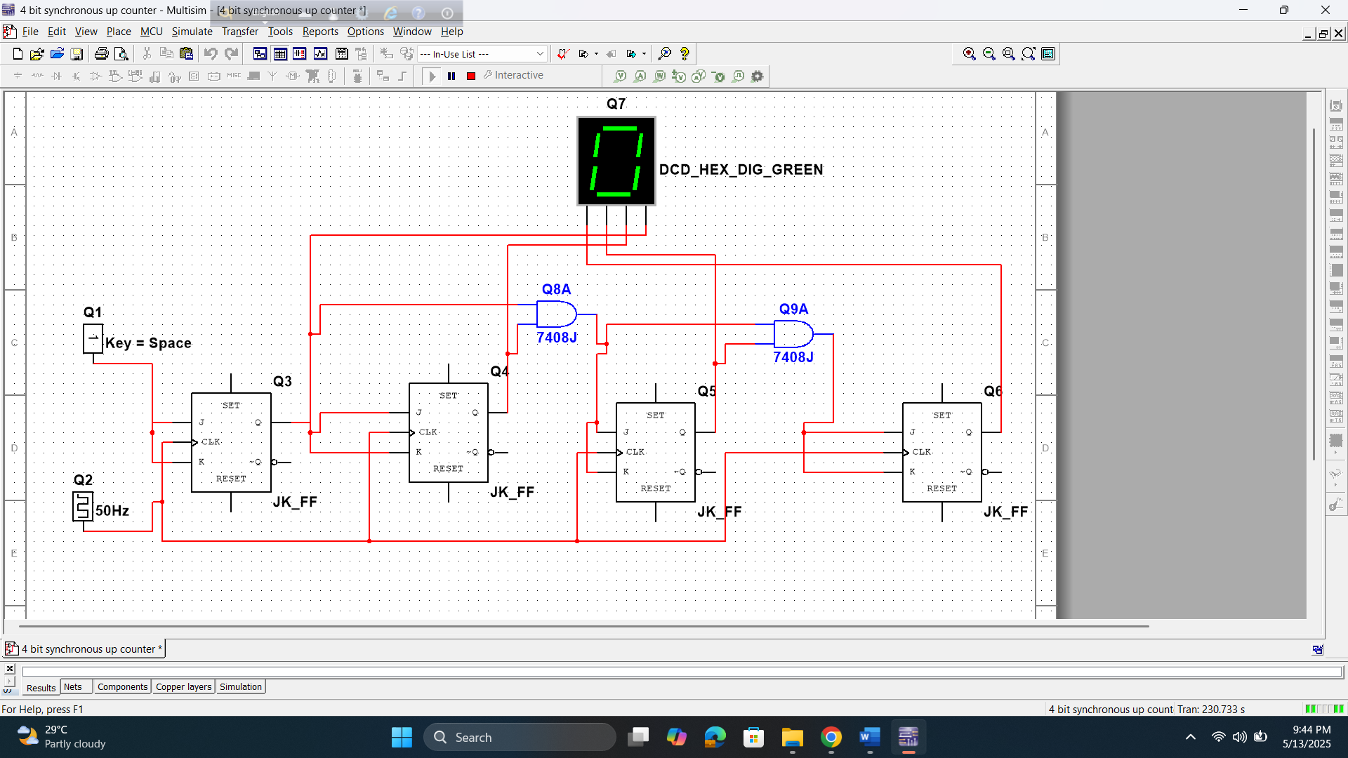

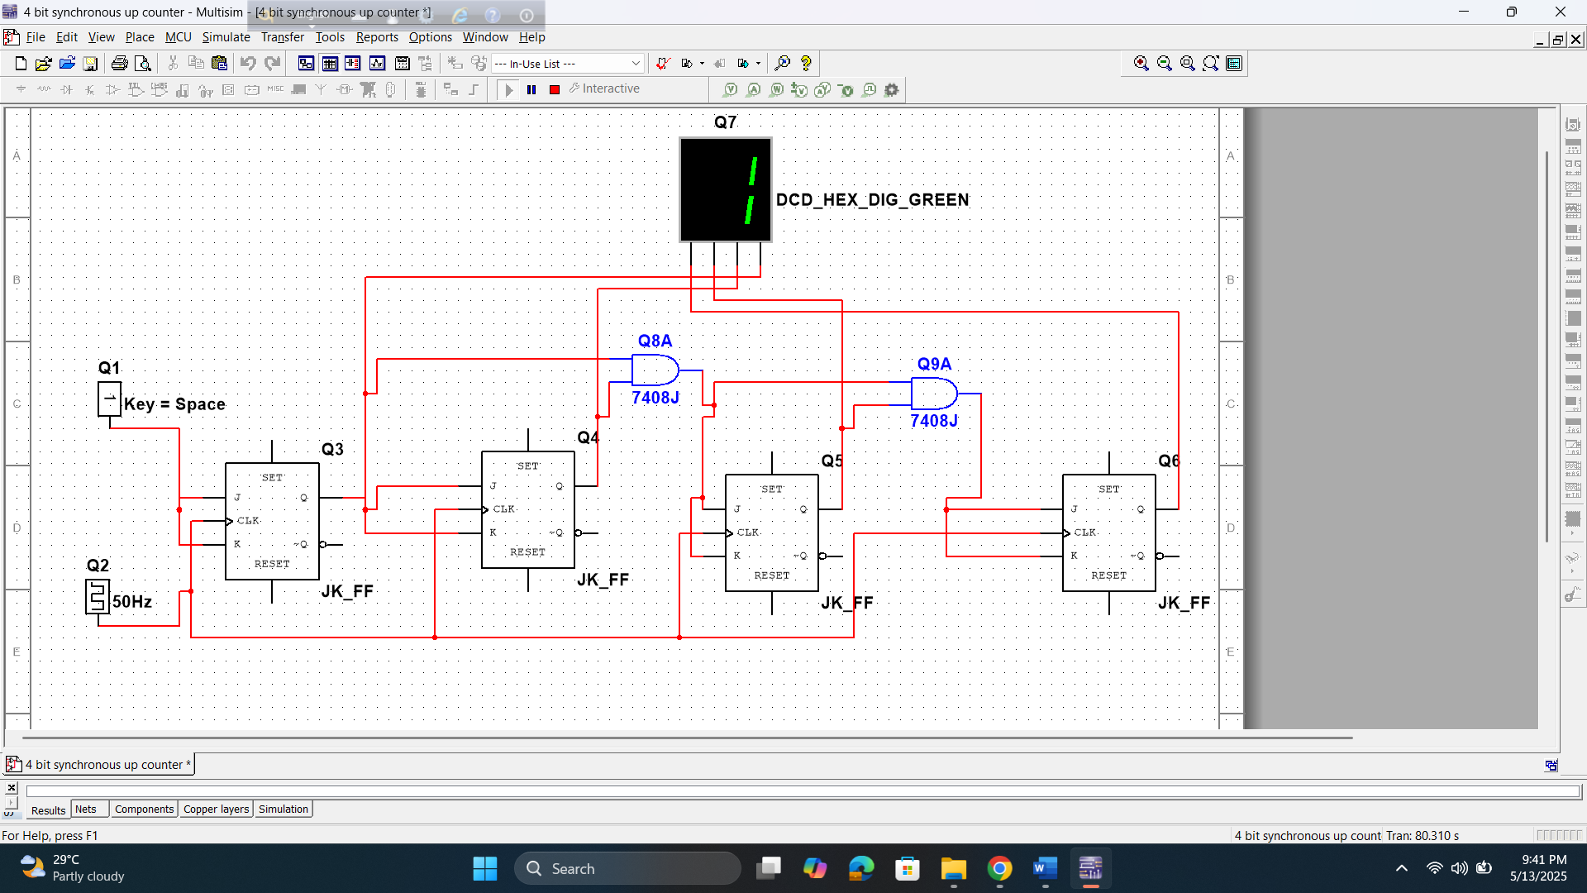

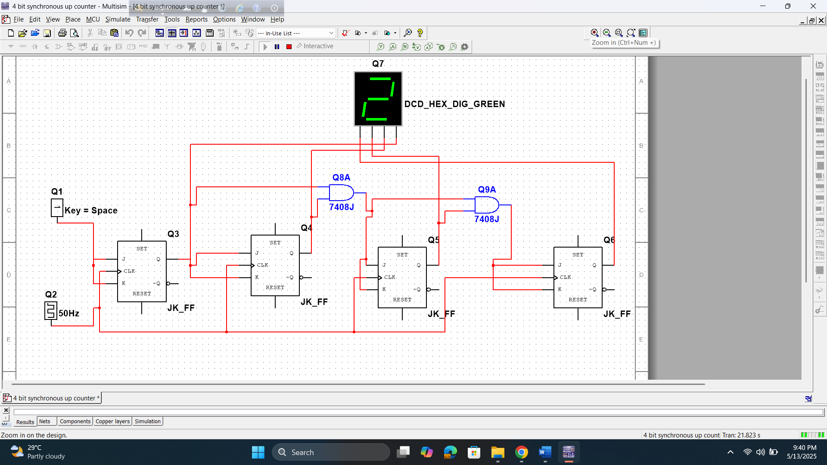

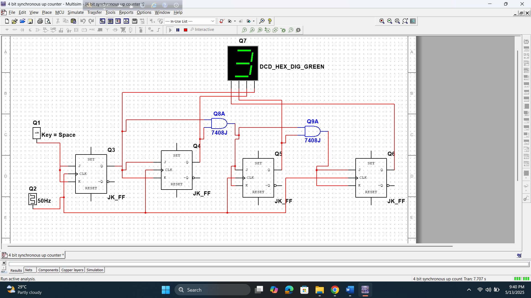

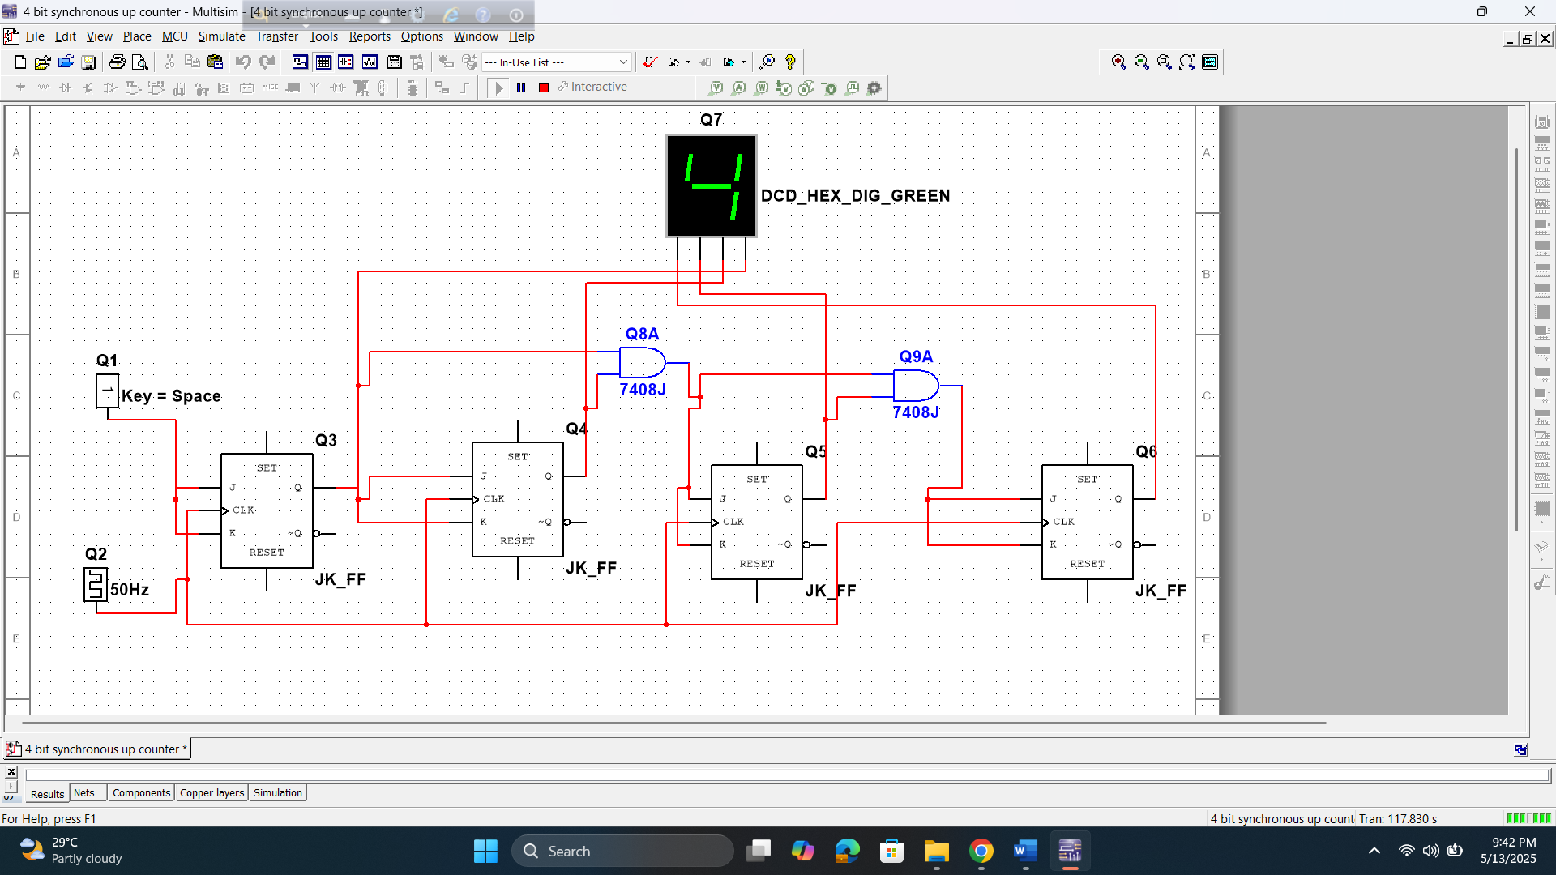

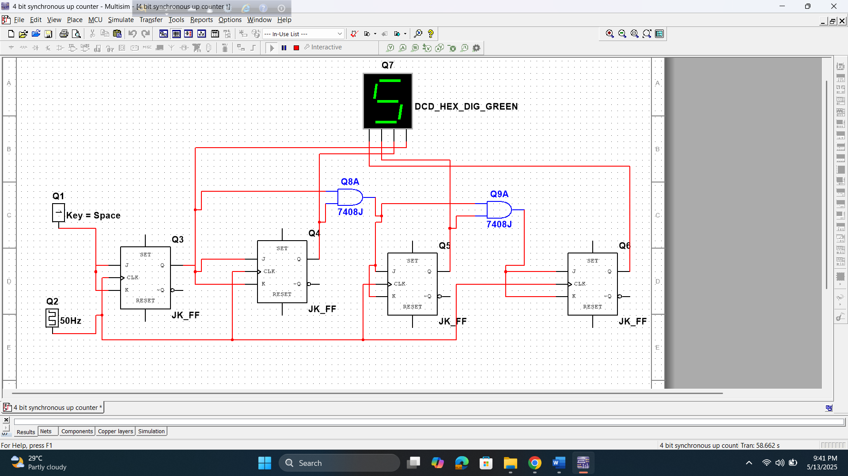

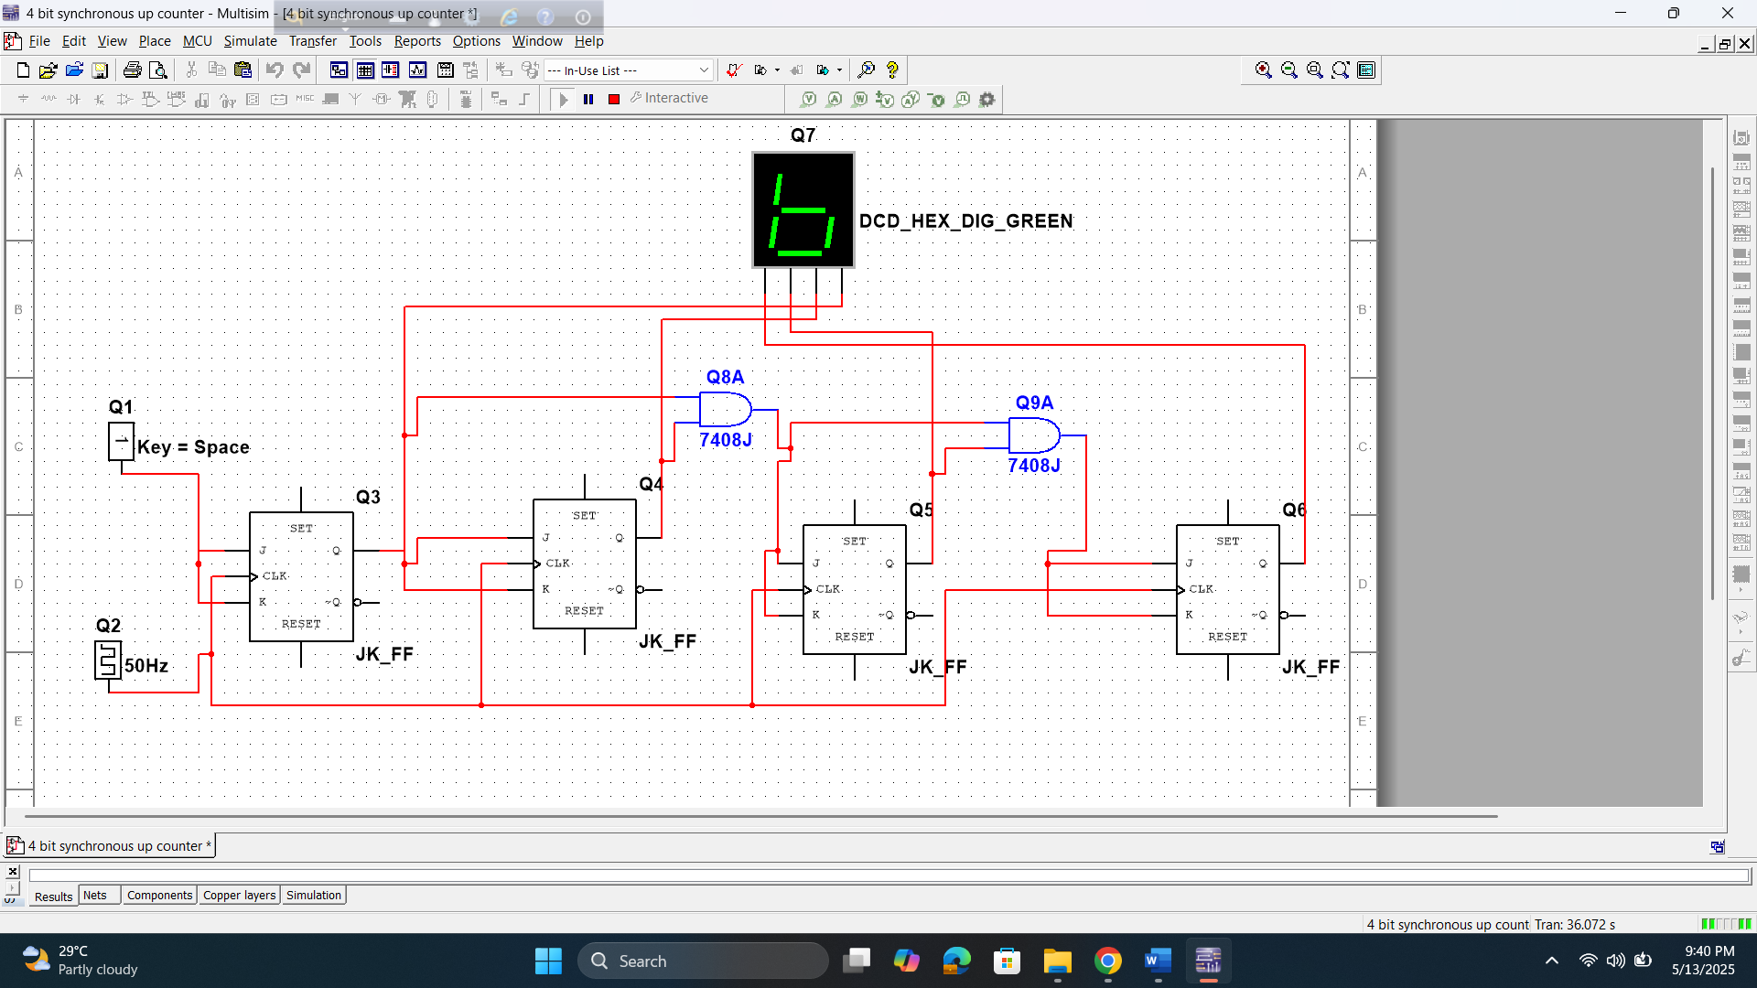

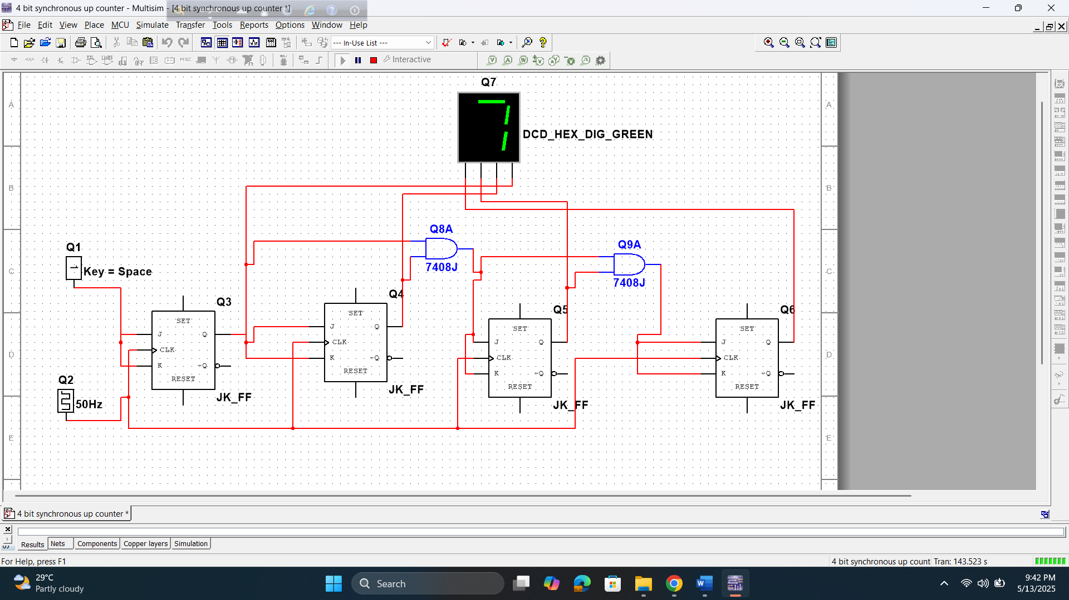

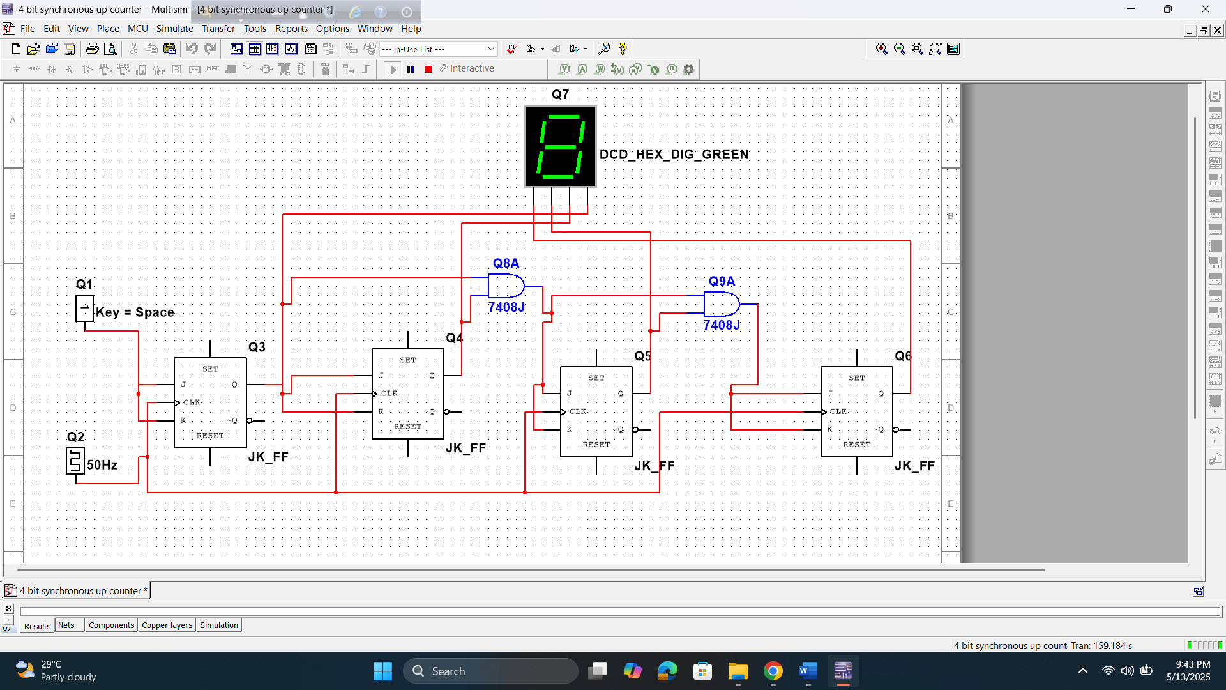

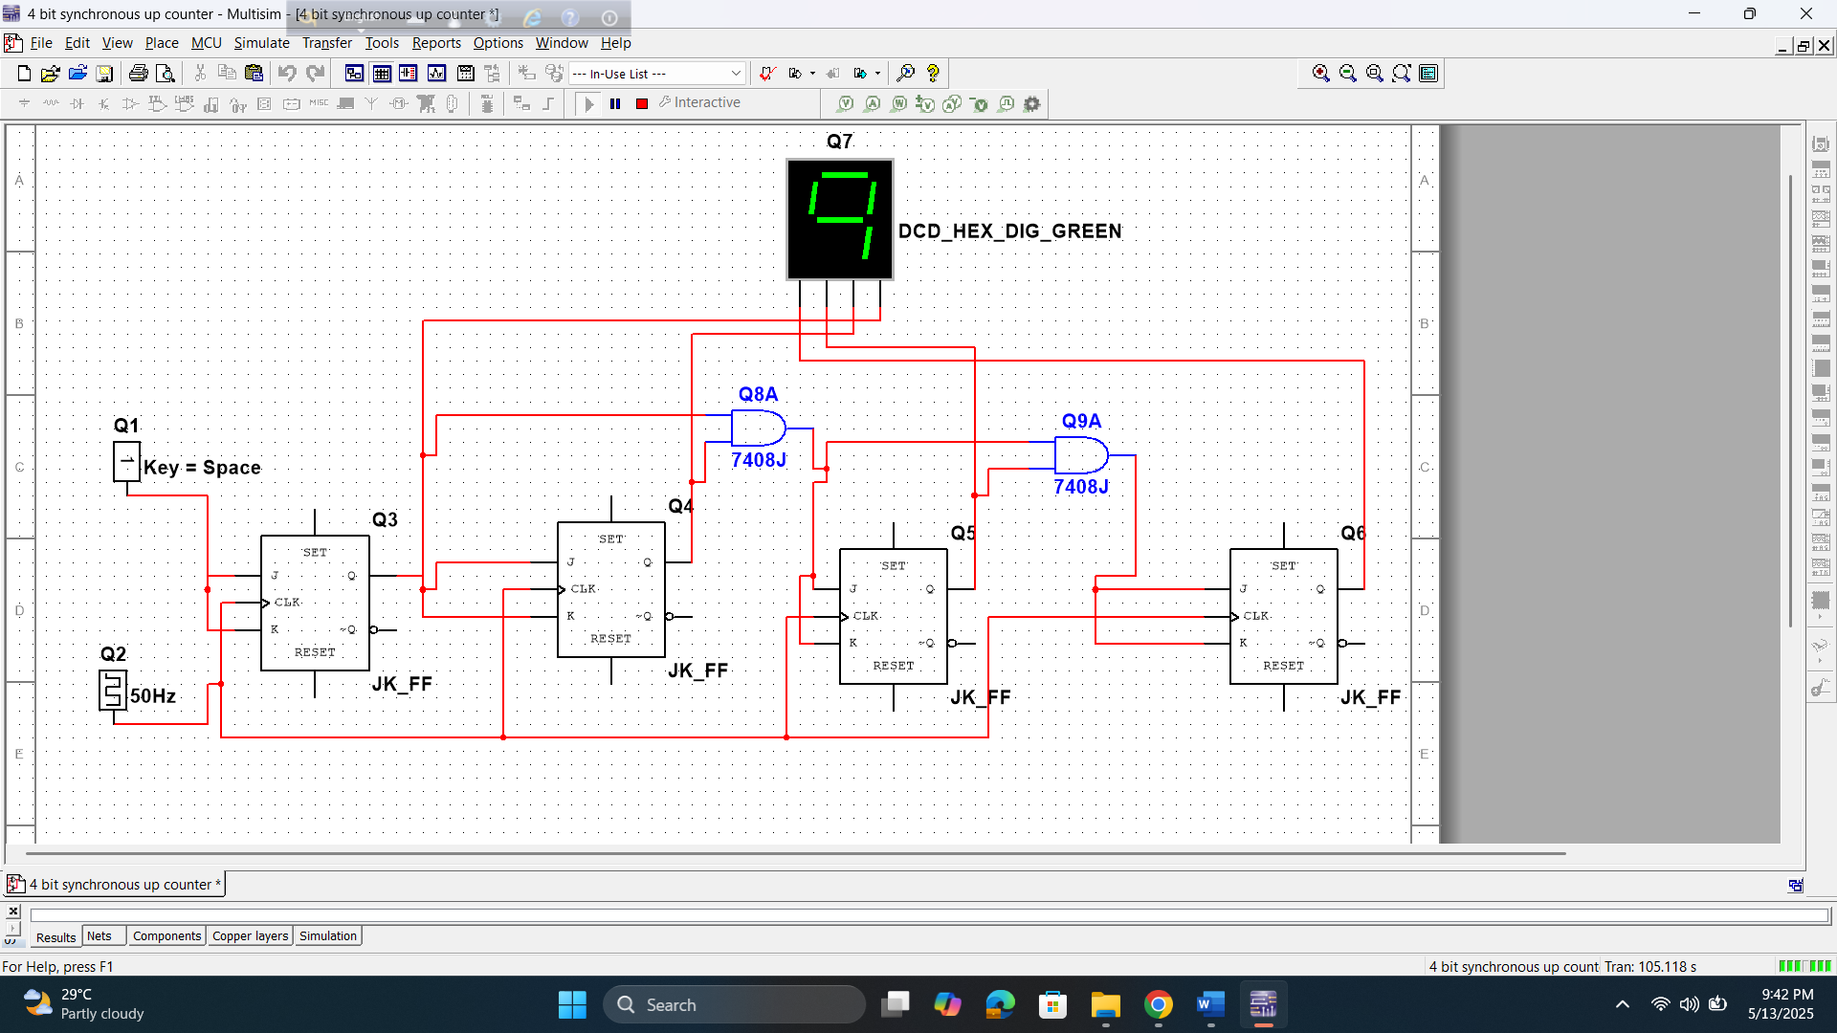

4 bid asynchronous up counter

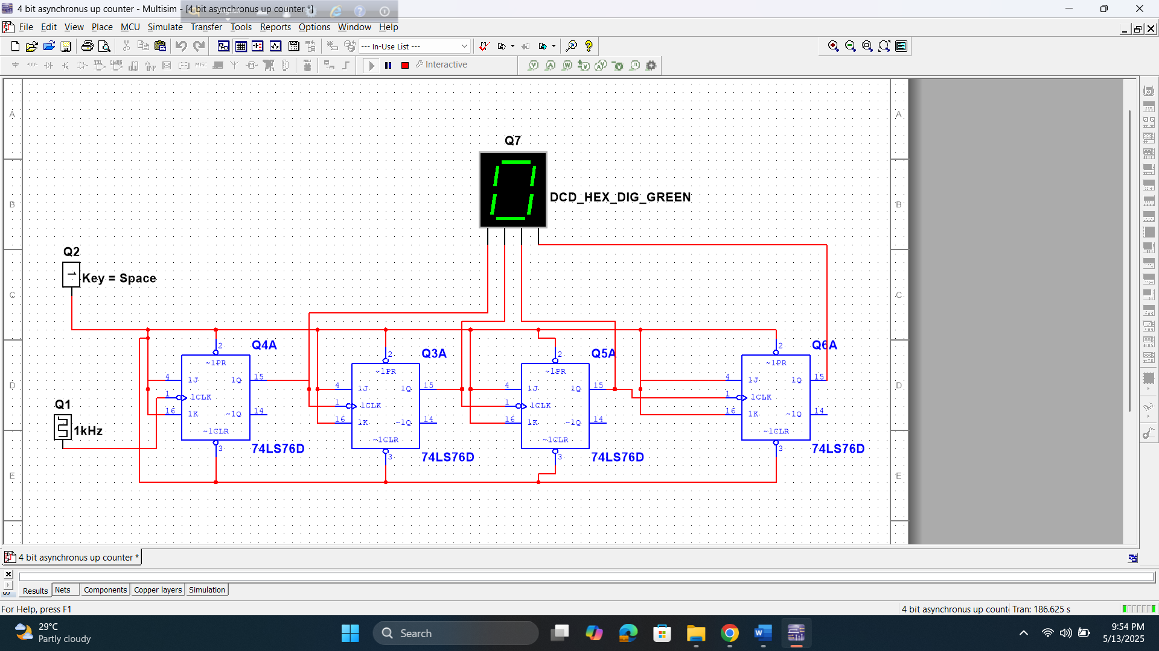

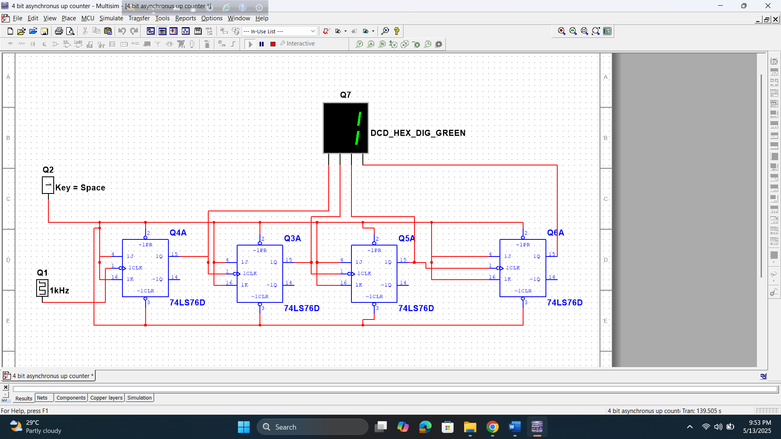

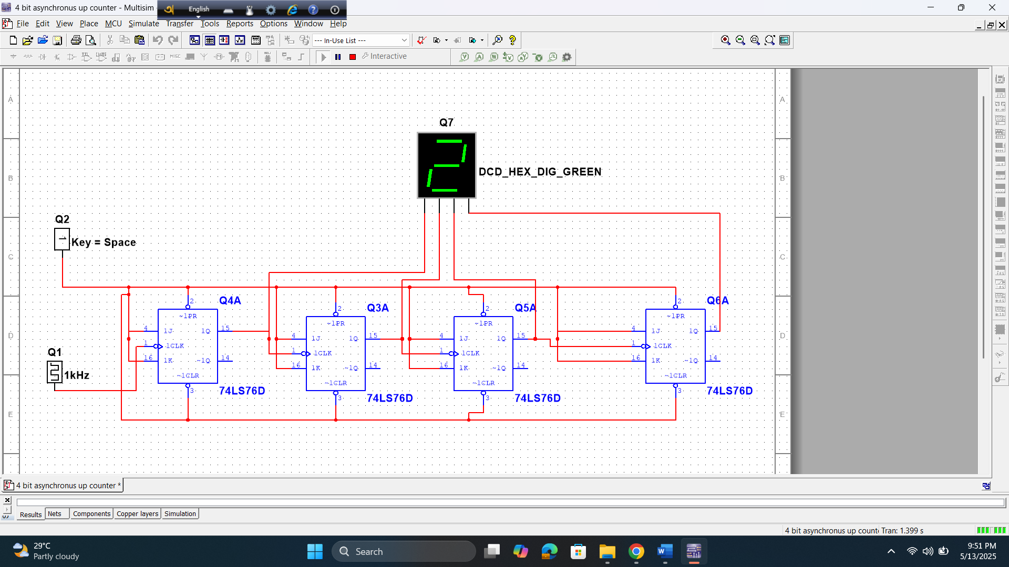

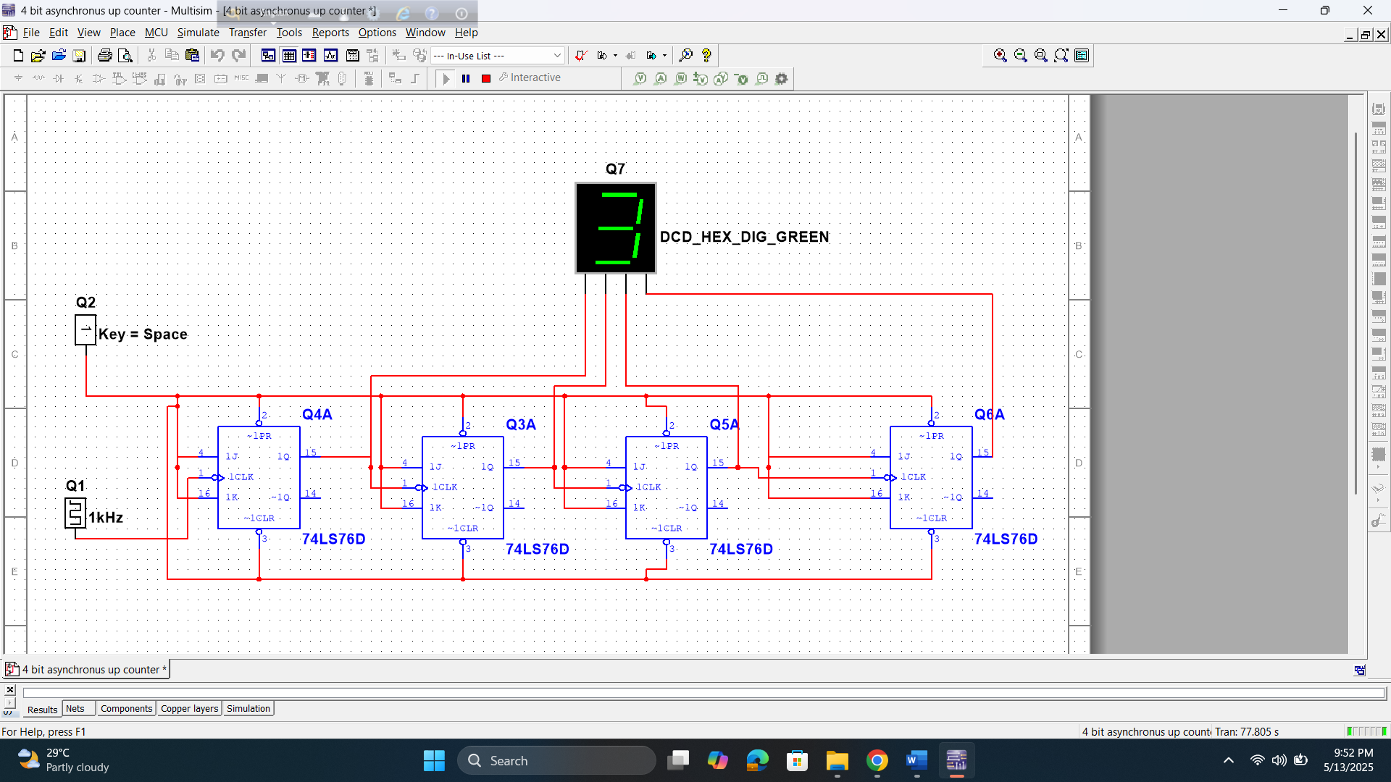

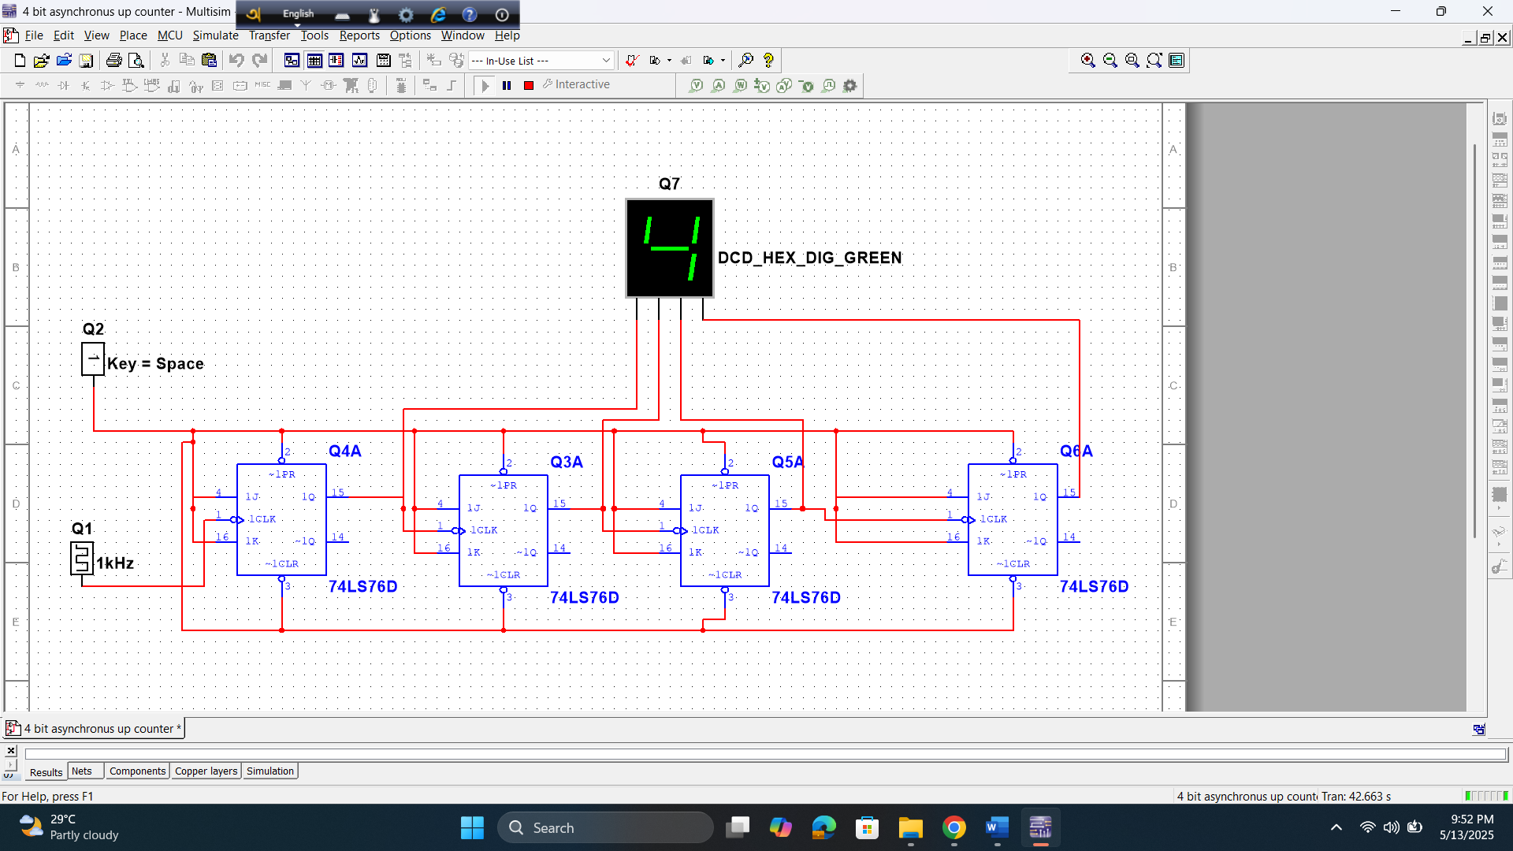

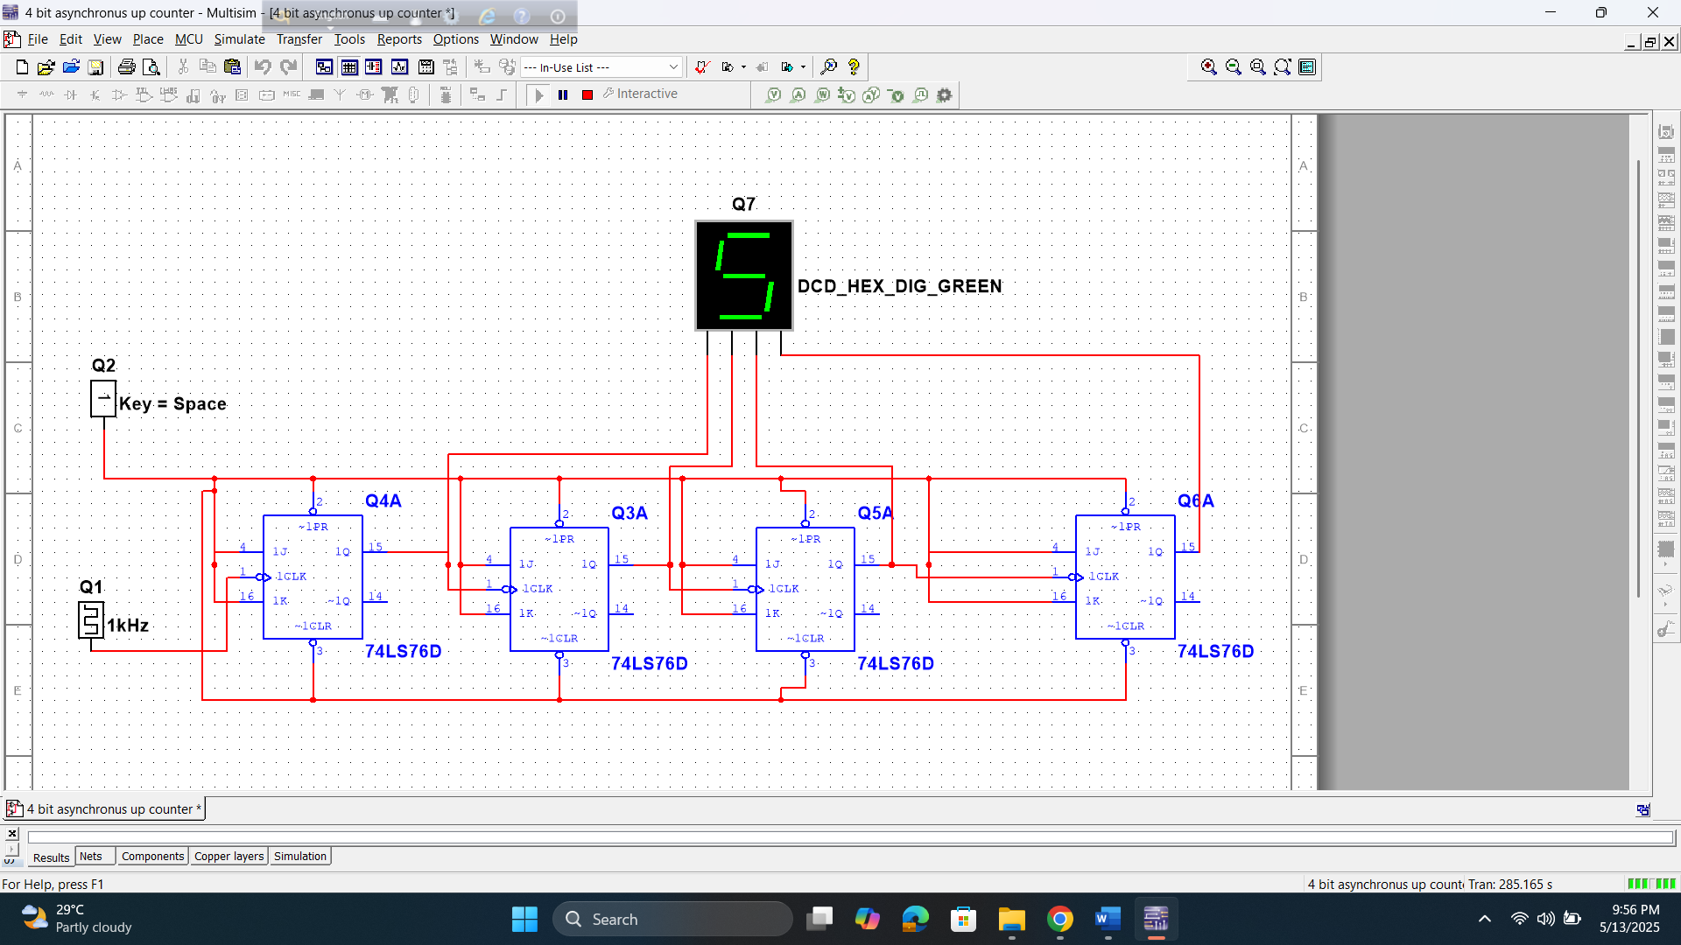

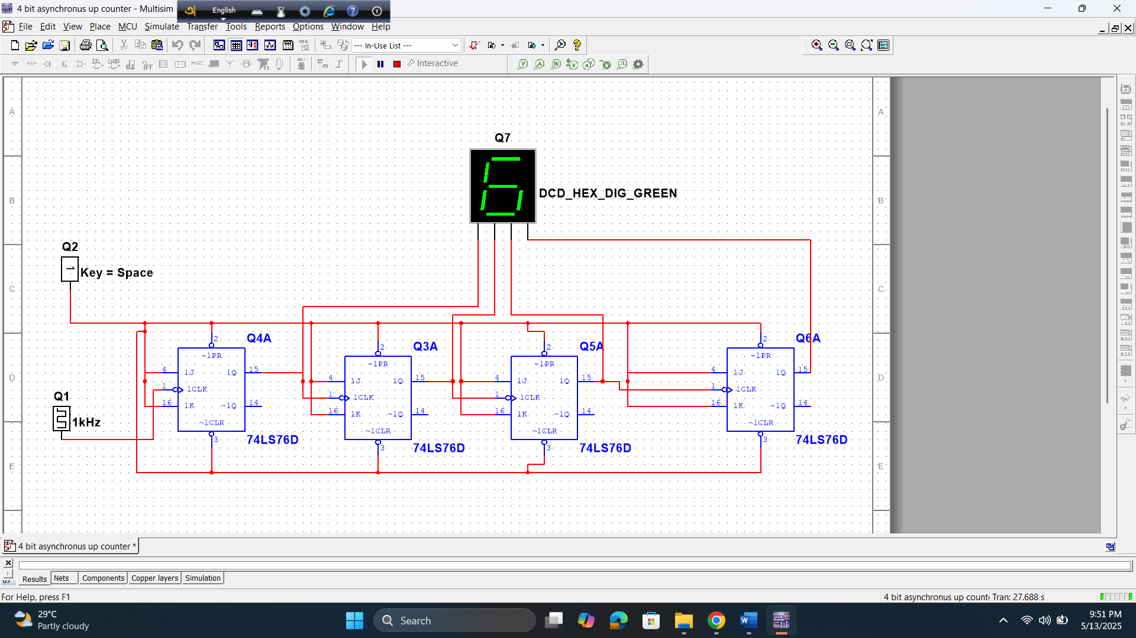

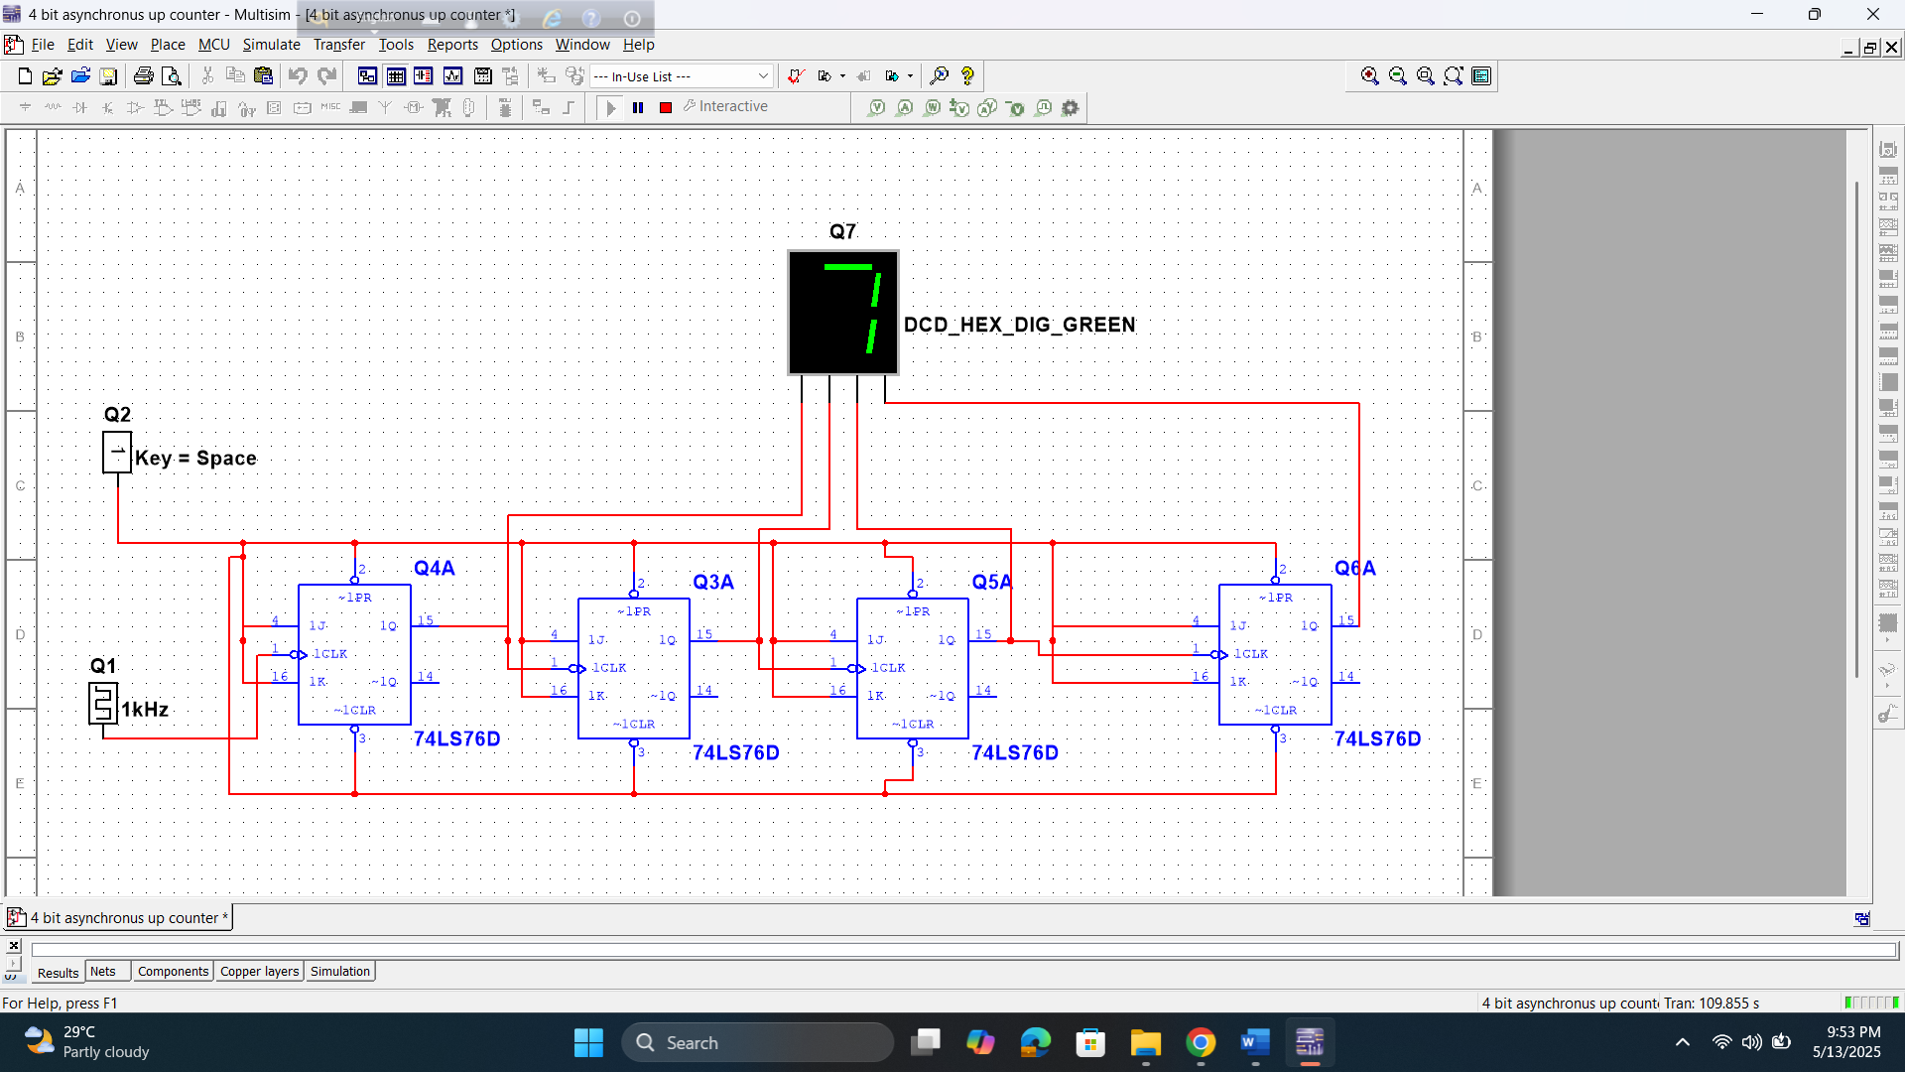

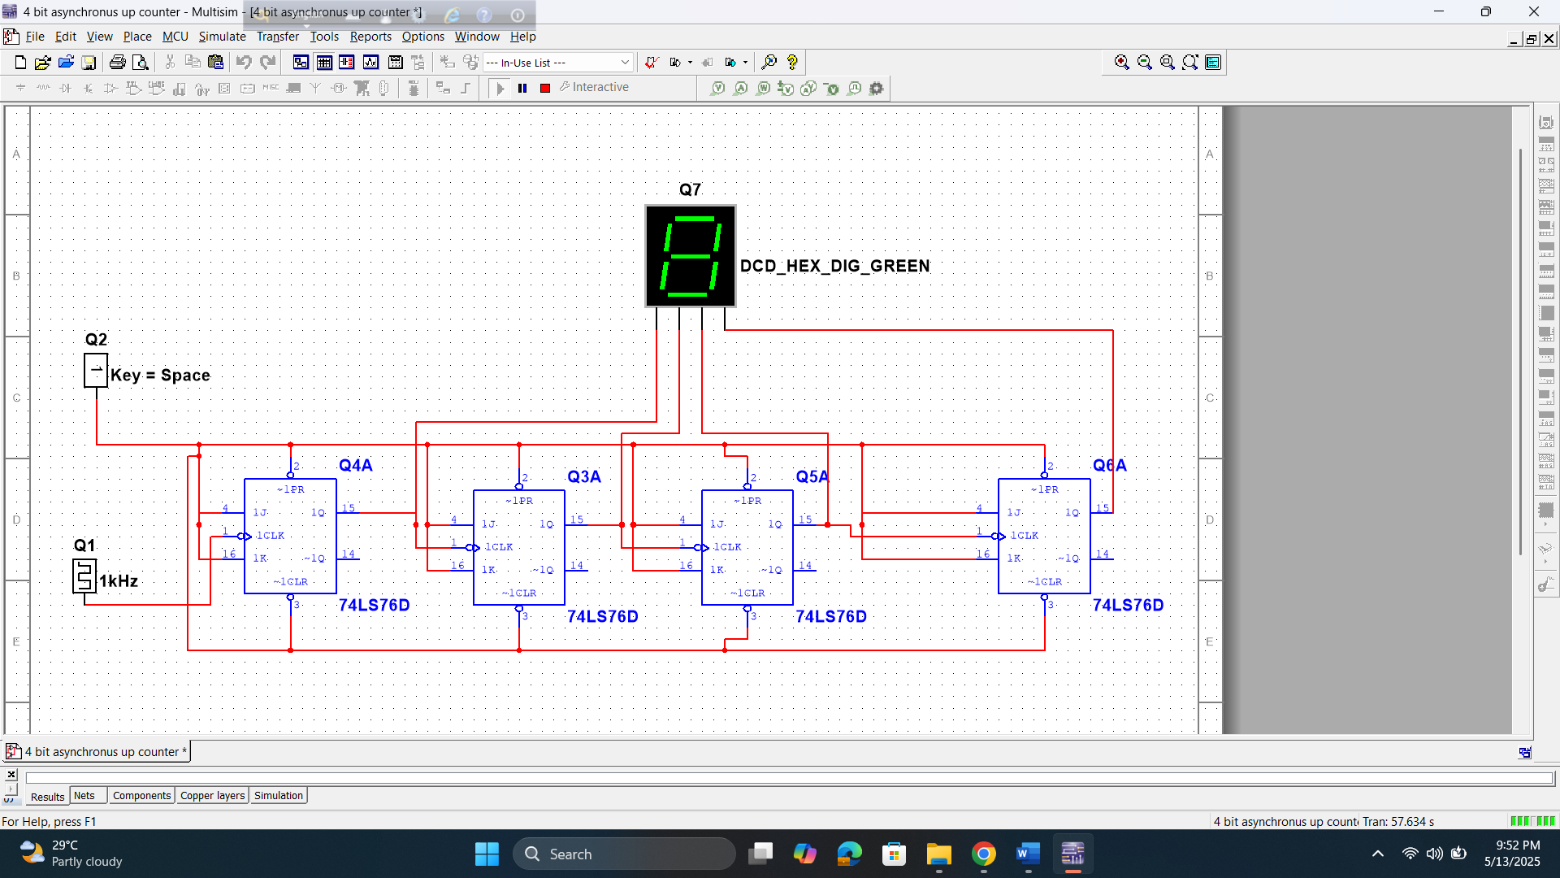

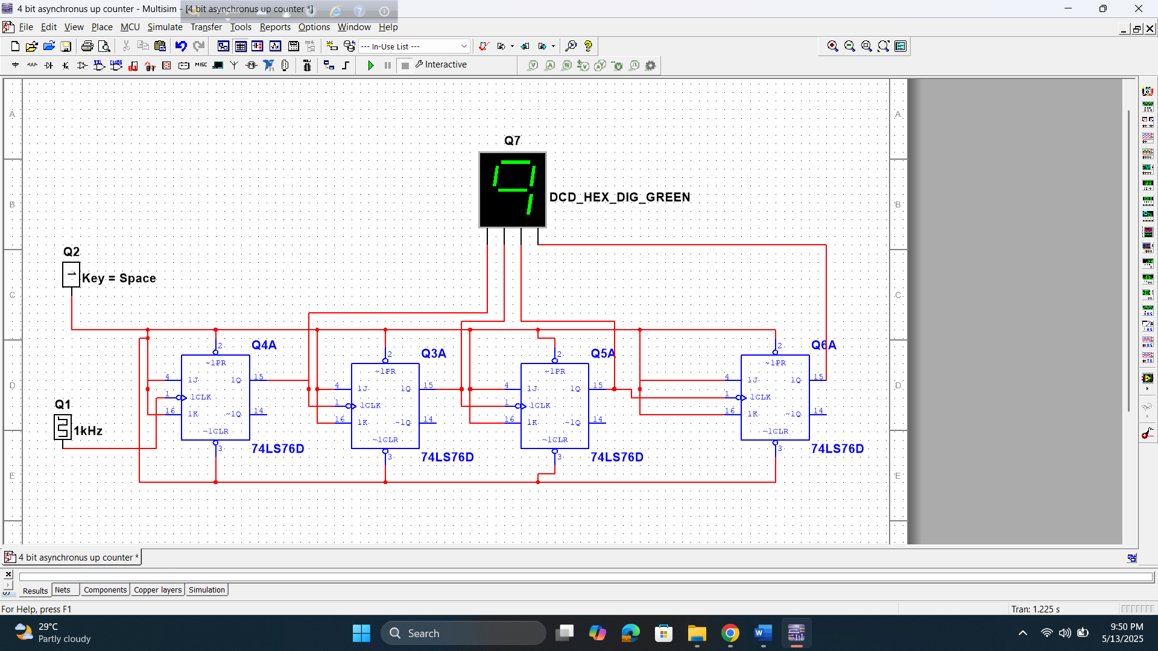

# Discussion and conclusion:

The experiment successfully demonstrated the operation of 3-bit asynchronous and 2-bit synchronous counters using JK Flip Flops. The expected output sequences were observed and verified using an oscilloscope. A picture of the 3-bit counter output was captured for the report.

One mistake occurred during the 3-bit counter setup due to a misconnected clock input, which was later corrected. To improve the experiment, better wire management and careful checking of connections are recommended.

# Reference(s):

1. Thomas L. Floyd, “Digital Fundamentals”, Ninth Edition.